State reporting requires student attendance (Days Attended/Days Enrolled) for exited students in the Fall & Spring General Collections and for all students for the End of Year General Collection.

There are many setup areas in PowerSchool that affect attendance calculations and this document will walk you through verifying that your setup is accurate.

Calendar (school > calendar setup)
- Make sure each month is coded correctly in the Day, Schedule, In Sess, Memb Value, Type fields.

Attendance Codes (school > attendance codes)
- Make sure the appropriate absent code is marked as either Present or Absent.
- Make sure the attendance code is considered in ADA calculations.
- Make sure the attendance code counts towards membership.

Section (school > sections)
Double-check that the section is not excluded from attendance
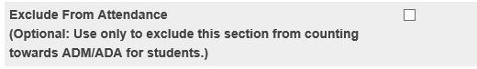

Full-Time Equivalencies (FTE) (school > full-time equivalencies)
- Attendance calculations (ADA/ADM) depend on full-time equivalencies.
- You can setup FTEs to indicate what portion of a school day students attend (full-time, half-time, etc)
- FTEs are school and year specific.
- The system assigns each full-time equivalency a number which is held in the FTE table.
- When a full-time equivalency is assigned to a student upon enrollment, the student is assigned a value of that FTE in their student FTEID field.
- Each student must have a valid FTEID number so it’s important that you search for students with missing or invalid FTEIDs (see the next section titled Student FTEID).

Student FTEID
Before searching for students who may be missing an FTEID, you should first identify the valid FTEIDs for each school.

Note: this search requires using the SchoolID which you can find under District Office > District > Schools/School Info

Search the FTEIDs valid for each school:
- In DDE, search the FTE table(159)
- SchoolID = the school ID
- YearID = XX (XX = the current school year. Example 24 or the 14-15 school year)
- Click on the Table View link
- Click on the SchoolID link for each FTE listed and the ID value will be shown.

This will list all of the FTEIDs that were created for the school specified in the current school year.

Most of your students in a school should have the same Full Time FTEID but you may have other FTEs that you created in your school for partial days, etc., and in those cases those students will have a different FTEID. The most important thing to check is that all students have a valid FTEID which is vital to ADM/ADA calculations.

Search for students with missing FTEIDs:
- Make sure you are in a school building and not the district office
- Start Page
- FTEID= (equal to blank)
- Students with missing FTEIDs will be listed.
- You can select each student and manually assign and FTEID by going into their Transfer Info page.
- Or, if you have many students listed, you may want to mass change their FTEID using the Student Field Value function.

Student Entry/Exit Dates: (transfer info page, field names: entrydate, exitdate)
- Make sure that all students’ entry and exit dates fall within the school’s calendar year.
- Run a search command using the fields entrydate and exitdate.
- Run the School Enrollment Audit Report to identify students with enrollment date overlap or misalignment (system reports > school enrollment audit)
- Correct information in the student’s Transfer Info page.

ADA/ADM by Student Report (system reports > ADA/ADM by student)
- Choose appropriate Attendance Mode
- Choose appropriate Attendance Conversion
- Make sure Begin Date and Ending Date are accurate for the current school year.
- Are values calculating in the Membership and Attendance columns?

Student Attendance Audit (system reports > student attendance audit)
- Choose appropriate Attendance Mode
- Choose appropriate Attendance Conversion
- Make sure Begin Date and Ending Date are accurate for the current school year.
- Scroll down to bottom page and look at the numbers in the Att and Memb columns? Do values seem accurate?

Section Enrollment Audit Report (system reports > section enrollment audit report)
- Use this report to detect possible section enrollment errors such as a student who is enrolled in school but not in any classes or students with course date misalignments with school enrollments.

Refresh Premier Attendance Views Data function: (special functions > attendance functions)
- The PowerSchool nightly process automatically updates the attendance views but if you want to ensure that attendance for students is correctly calculated and updated for the current day, then run the Refresh Premier Attendance Views Data function.
- This function should be run at the building level.
- Make sure the Begin Date and Ending Date are accurate for the current school year.
- After running this function, attendance should be as up-to-date as possible so reports such as ADA/ADM and the General Collection will pull accurate days attended/days enrolled.

Michigan General Collection Report (system reports > state tab)
- The PowerSchool General Collection report will automatically calculate and export the days.
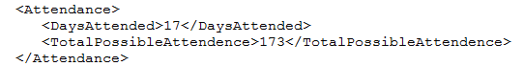
- It is a best practice to run the Refresh Premier Attendance Views Data function prior to running the General Collection.
- Reporting Period: make sure you have the appropriate reporting period selected.
- First Day of School, Previous Count Date, Current Count Date – double-check that these days are accurate for the current school year.

Manual Attendance – Days Attended/Days Enrolled (Attendance Component > MSDS Reported tab)
- As mentioned earlier, the General Collection report will automatically calculate and export the days in attendance and days enrolled.
- It will not fill the Days Attended during the reporting period field or the Days enrolled during the reporting period field on the General Ed 5-19 tab of the state/province page in PowerSchool. These fields are manual entry fields that will override the automatic calculation.
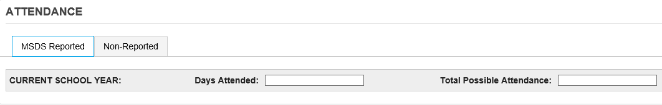

To ensure that PowerSchool properly exports the days attended/days enrolled for the end of year MSDS submission, you will need to make sure that these fields are blank for any students who are active or have exited your school since the previous count date.

We recommend the following procedure to ensure that these fields are blank.

Run the following search:
/exitdate>MM/DD/20YY; S_MI_STU_GC_X.attDays#
/exitdate>MM/DD/20YY; S_MI_STU_GC_X.attDaysEnroll#

This can be run from the school or district level. These searches will give you a listing of all students who have any value in either field and who have an exit date later than the previous count date. This will include all active students because they have an exit date at the end of the school year.
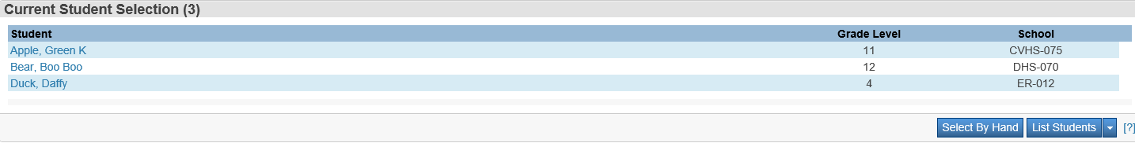

Select the List Students function from the drop-down list
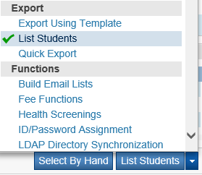

Enter in field names as show below. Click Submit.
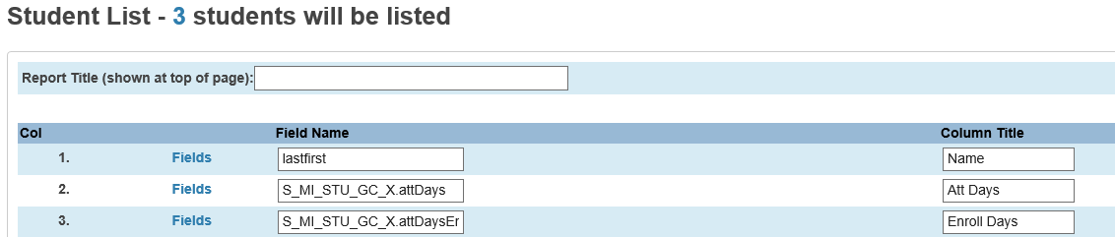

Student Last, First name and Days Attended data will display.
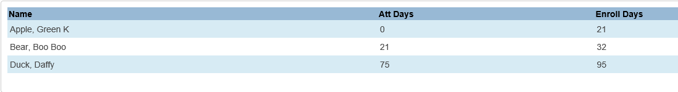

You can manually clear the fields or you go back to Group Functions and run the Student Field Value function to mass clear the S_MI_STU_GC_X.attDays and S_MI_STU_GC_X.attDaysEnroll fields.
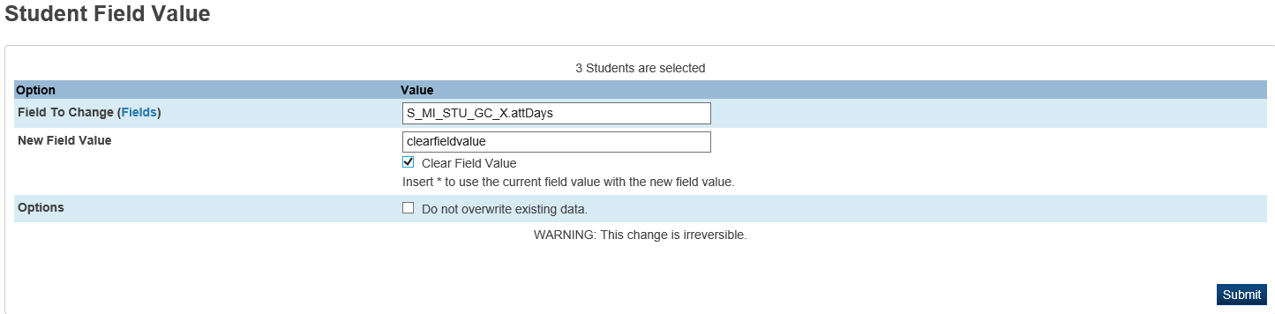

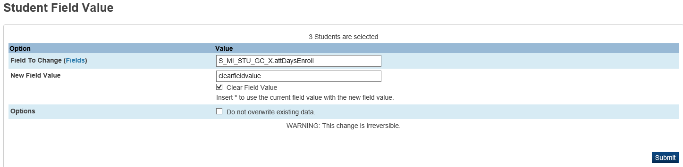

**ATTENDANCE CONVERSION SETUP – VERY IMPORTANT**

Attendance conversions greatly affect ADA/ADM reports and how the days attended/days enrolled are calculated by the General Collection report.
For 2017-18, state reporting requirements for Days Attended/Days Enrolled has changed to only count a student as present if they are present for half of their scheduled day or more.
The calculation for 75 Percent Reporting has not changed – a student is counted as present if they are present for any portion of the day. Because student attendance will be calculated differently based on the state reporting requirements, it is very important that your Attendance Conversions are defined as recommended below. The incremental values are necessary to count students who absent more than half of the day as present for 75 Percent Reporting purposes.

Schools taking attendance once a day may want to change their policy to taking attendance multiple times a day to account for students who are absent for only a portion of the day.

Full-Time Equivalencies – FTE (School > Full-Time Equivalencies – FTE)
A Full-Time Equivalency needs to be created for all of the different types of students in your school – Full-Time Students, as well as an FTE for any students on a reduced schedule based on the number of periods that the students attend.
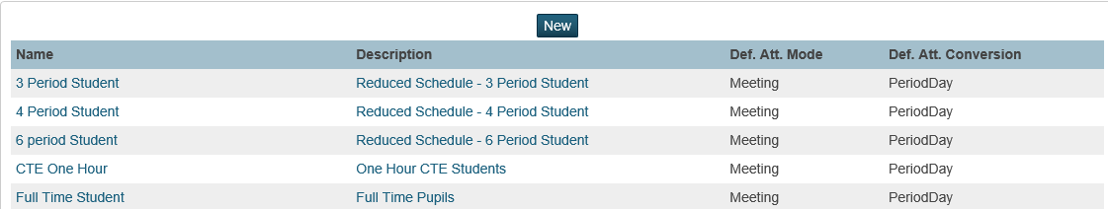

Once the FTEs are created, they will show under all attendance conversions in your school.
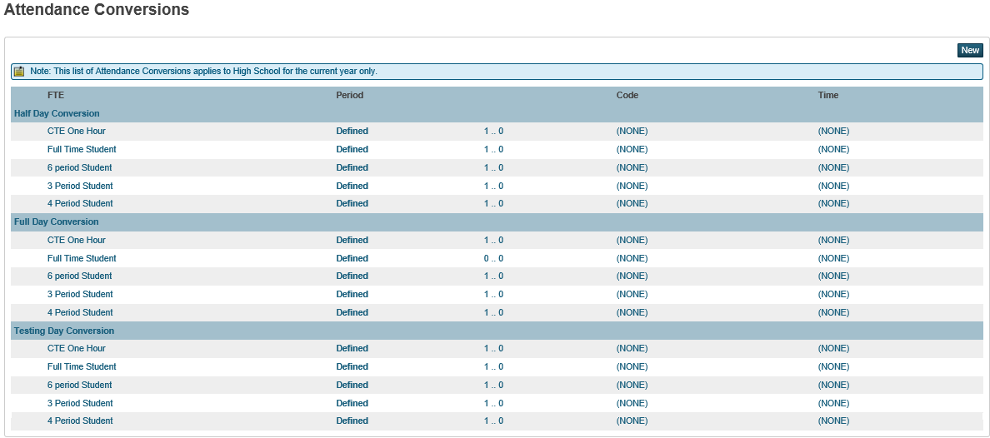

Bell Schedules (School > Bell Schedules)
You need to create an Attendance Conversion for each Bell Schedule in your school that has a unique number of periods in the day. For example, if you have an A Day and a B Day that both have 7 periods, you can use the same Attendance Conversion for both Bell Schedules. However, if your school has a Bell Schedule for Testing Days that only meets for 2 periods, then you need to create a Testing Day Attendance Conversions to ensure that student attendance is properly calculated based on the number of periods in the day.
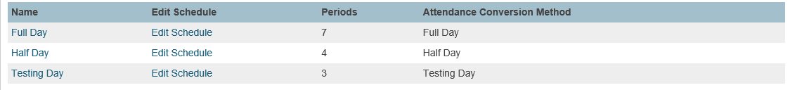

Now that you have the Full-Time Equivalencies and Bell Schedules defined, you can set up the Attendance Conversions for your school.

Attendance Conversions (School > Attendance Conversions)
- Make there is a conversion for every Bell Schedule with a unique number of periods.
- Make sure all conversions are defined for the appropriate periods of the day.
- Make sure the proper attendance conversion is assigned to the proper bell schedule.
- The ADA/ADM reports will not match the days attended/days enrolled calculated by the General Collection.

For state reporting purposes, if a student is present for half of their scheduled day or more, they are considered present for the whole day. A student that is present half of their scheduled day will be reported with a value of 0.50 on the ADA/ADM report, but will be reported with a full day of attendance for state reporting purposes.

If the student has a value 0.50 or greater for any given day, it is considered as a day present for state reporting purposes.

Full Time Students – Full Day Conversion
Example of how a school counting periods absent would figure out the value for each period of a 7 period day for a full day:
- 7 periods in the day.
- To figure out the value for each period, take the number one and divide it by 7.

1 divided by 7 = 0.143 (Rounded)
1 (enter this value for Periods Absent 0)
Subtract 0.143 from 1 = 0.857 (enter this value for Periods Absent 1)
Subtract 0.143 from 0.857 = 0.714 (enter this value for Periods Absent 2)
Subtract 0.143 from 0. 714 = 0.571 (enter this value for Periods Absent 3)
Subtract 0.143 from 0.571 = 0.428 (enter this value for Periods Absent 4)
Subtract 0.143 from 0.428 = 0.285 (enter this value for Periods Absent 5)
Subtract 0.143 from 0.285 = 0.142 (enter this value for Periods Absent 6)
Subtract 0.142 from 0.142 = 0 (enter this value for Periods Absent 7)
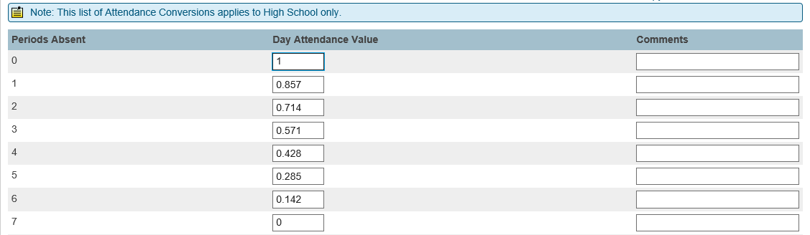

Example of how a school counting periods present would figure out the value for each period of an 7 period day for a full day:
- 7 periods in the day.
- To figure out the value for each period, take the number one and divide it by 7.

1 divided by 7 = 0.143 (Rounded)
0 (enter this value for Periods Present 0)
Add 0.143 to 0 = 0.143 (enter this value for Periods Present 1)
Add 0.143 to 0.143 = 0.286 (enter this value for Periods Present 2)
Add 0.143 to 0.286 = 0.429 (enter this value for Periods Present 3)
Add 0.143 to 0.429 = 0.572 (enter this value for Periods Present 4)
Add 0.143 to 0.572 = 0.715 (enter this value for Periods Present 5)
Add 0.143 to 0.715 = 0.858 (enter this value for Periods Present 6)
Add 0.142 to 0.858 = 1 (enter this value for Periods Present 7)
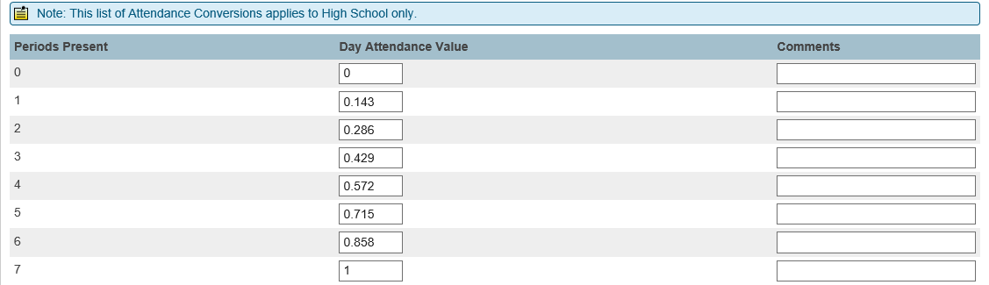
Full Time Students – Half Day Conversion
Students only attend for half of the regularly scheduled periods on a half day, so if the Half Day Attendance Conversion is not set up properly, students will have to be present for the entire half day to be considered present for the day. For example, using the Regular Day Attendance Conversion for a 7 period day, students must be present for at least 4 periods to be considered present. On a half day, there are only 4 periods. Therefore if a student is absent for 1 period on a half day, they would not meet the half day requirement and be considered absent. Setting up the Half Day Attendance Conversion as indicated below will resolve this issue and students will be counted as present if they attend at least half of the scheduled periods on a half day.

Example of how a school counting periods absent would figure out the value for each period of a 7 period day on a half day:
- 7 periods in the day, but students only attend 4 periods on a half day.
- To figure out the value for each period, take the number one and divide it by 4.

1 divided by 4 = 0.25
1 (enter this value for Periods Absent 0)
Subtract 0.25 from 1 = 0.75 (enter this for value Periods Absent 1)
Subtract 0.25 from 0.75 = 0.5 (enter this value for Periods Absent 2)
Subtract 0.25 from 0.5 = 0.25 (enter this value for Periods Absent 3)
Subtract 0.25 from 0.25 = 0 (enter this value for Periods Absent 4 through 7)
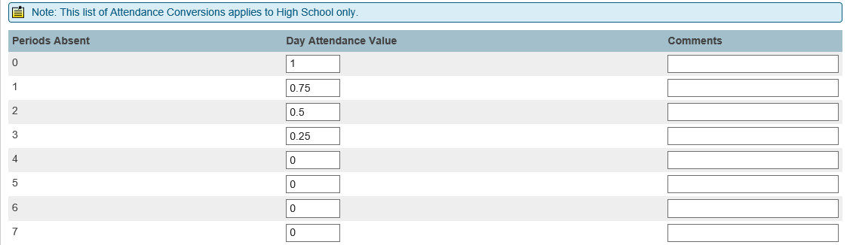

Example of how a school counting periods present would figure out the value for each period of a 7 period day on a half day:
- 7 periods in the day, but students only attend 4 periods on a half day.
- To figure out the value for each period, take the number one and divide it by 4.

1 divided by 4 = 0.25
0 (enter this value for Periods Present 0)
Add 0.25 to 0 = 0.25 (enter this value for Periods Present 1)
Add 0.25 to 0.25 = 0.5 (enter this value for Periods Present 2)
Add 0.25 to 0.5 = 0.75 (enter this value for Periods Present 3)
Add 0.25 to 0.75 = 1 (enter this value for Periods Present 4 through 7)
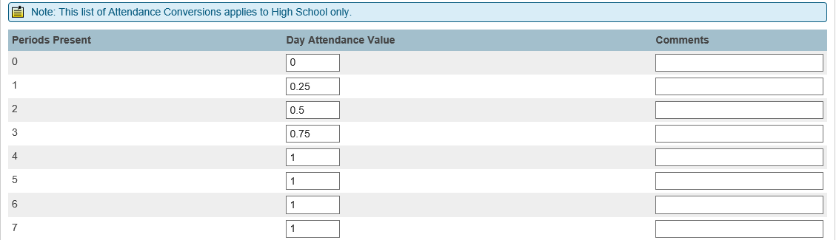

Reduced Schedule Students
Students who are on a reduced schedule will need to have a separate FTE and Attendance Conversion to ensure that their attendance is properly reported to the state. For example, using the Regular Day Attendance Conversion for a 7 period day, students must be present for at least 4 periods to be considered present. A student on a reduced schedule may only attend 4 periods. Therefore if the student is absent for 1 period during the day, they would not meet the full day requirement and be considered absent, even though the student was in attendance for more than half of their scheduled day. Setting up the Reduced Schedule FTE and Attendance Conversion as indicated below will resolve this issue and students will be counted as present if they attend at least half of their scheduled periods.

Create an FTE for the number of periods the reduced schedule students attend.
School>Full Time Equivalencies (FTE)
- Select New
- Enter the information for the Reduced Schedule Student FTE and click Submit
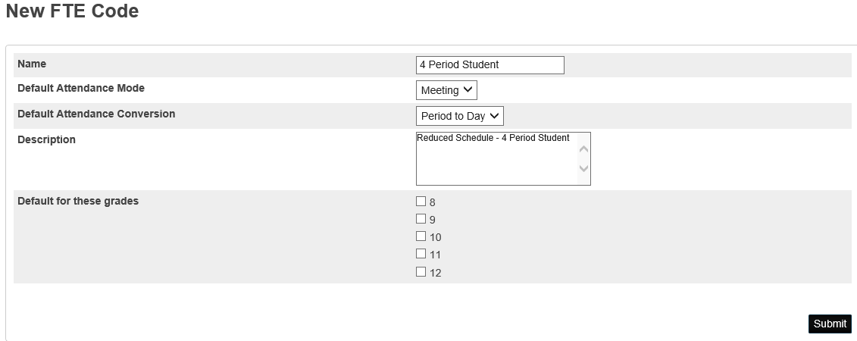

Now that the FTE is created, you can go to the Attendance Conversion and set it up based on the number of periods that the student attends on Regular and Half Days.

Example of how a school counting periods absent would figure out the value for each period of a 7 period day for students with a reduced schedule:
- 7 periods in the day, but students only attend 4 periods because of the reduced schedule.
- To figure out the value for each period, take the number one and divide it by 4.

1 divided by 4 = 0.25
1 (enter this value for Periods Absent 0)
Subtract 0.25 from 1 = 0.75 (enter this for value Periods Absent 1)
Subtract 0.25 from 0.75 = 0.5 (enter this value for Periods Absent 2)
Subtract 0.25 from 0.5 = 0.25 (enter this value for Periods Absent 3)
Subtract 0.25 from 0.25 = 0 (enter this value for Periods Absent 4 through 7)

Example of how a school counting periods present would figure out the value for each period of a 7 period day for students with a reduced schedule:
- 7 periods in the day, but students only attend 4 periods because of the reduced schedule.
- To figure out the value for each period, take the number one and divide it by 4.

1 divided by 4 = 0.25
0 (enter this value for Periods Present 0)
Add 0.25 to 0 = 0.25 (enter this value for Periods Present 1)
Add 0.25 to 0.25 = 0.5 (enter this value for Periods Present 2)
Add 0.25 to 0.5 = 0.75 (enter this value for Periods Present 3)
Add 0.25 to 0.75 = 1 (enter this value for Periods Present 4 through 8)

Alternate Bell Schedules
If your school has alternate bell schedules that have a different number of periods than either the Full Day or Half Day Bell Schedules, you will need to create an Attendance Conversion for those days as well.
For example, if you have a Testing Day Bell Schedule where students only attend for 3 periods on that day. If the Testing Day Bell Schedule is using the Full Day Attendance Conversion, then full time students could be marked absent for all 3 periods, but still be considered present because based on the attendance conversion they need to be absent for 4 periods or more to be considered absent. Creating an Attendance Conversion for any Alternate Bell Schedules as indicated below will resolve this issue and students will be counted as present if they attend at least half of the scheduled periods on that day.

Example of how a school counting periods absent would figure out the value for each period of a 7 period day for an Alternate Bell Schedule with less than 7 periods:
- 7 periods in the day, but students only attend 3 periods for the Testing Day Bell Schedule.
- To figure out the value for each period, take the number one and divide it by 3.

1 divided by 3 = 0.333
1 (enter this value for Periods Absent 0)
Subtract 0.333 from 1 = 0.667 (enter this for value Periods Absent 1)
Subtract 0.333 from 0.667 = 0.334 (enter this value for Periods Absent 2)
Subtract 0.334 from 0.334 = 0 (enter this value for Periods Absent 3 through 7)
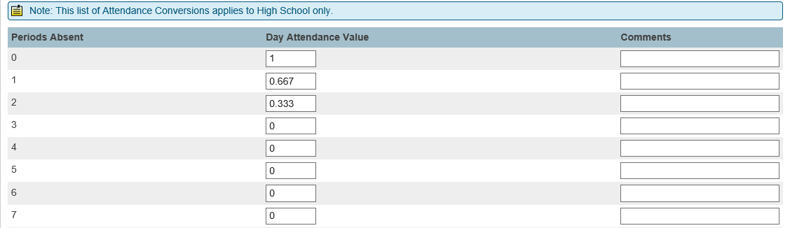
Example of how a school counting periods present would figure out the value for each period of a 7 period day for an Alternate Bell Schedule with less than 7 periods:
- 7 periods in the day, but students only attend 3 periods for the Testing Day Bell Schedule.
- To figure out the value for each period, take the number one and divide it by 3.

1 divided by 3 = 0.333
0 (enter this value for Periods Present 0)
Add 0.333 to 0 = 0.333 (enter this for value Periods Present 1)
Add 0.334 to 0.333 = 0.667 (enter this value for Periods Present 2)
Add 0.333 to 0.667 = 1 (enter this value for Periods Present 3 through 7)
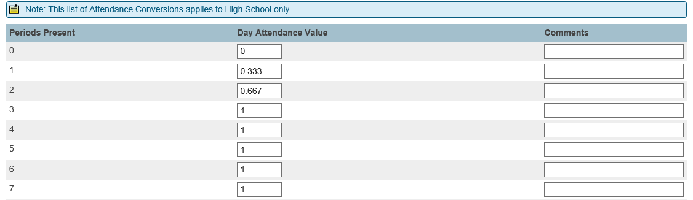
Once you have created and defined the Attendance Conversions for any alternate Bell Schedules in your school, you need to make sure that you assign the Attendance Conversion to the Bell Schedule. Select the Bell Schedule (School > Bell Schedules), select the proper Attendance Conversion from the dropdown menu, and click Submit.
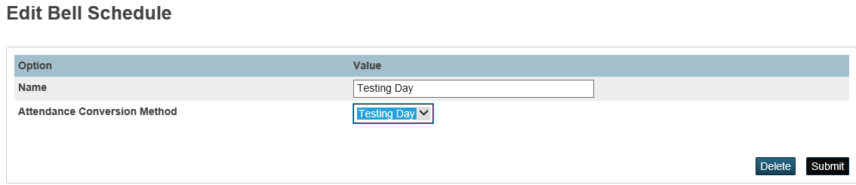

For students that change the number of periods that they attend, you will need to create a New School Enrollment in PowerSchool to ensure that the student attendance is properly calculated. For example, if a student goes from a 7 period student to a 3 period student, the attendance calculations will be different for each period of time, therefore you need to create the new enrollment.

You will want to modify the student’s current schedule to align with new number of periods that the student will be attending.

To create the New School Enrollment, select the student and click on the Functions link in the Enrollments section of the left menu, then select Create New School Enrollment.
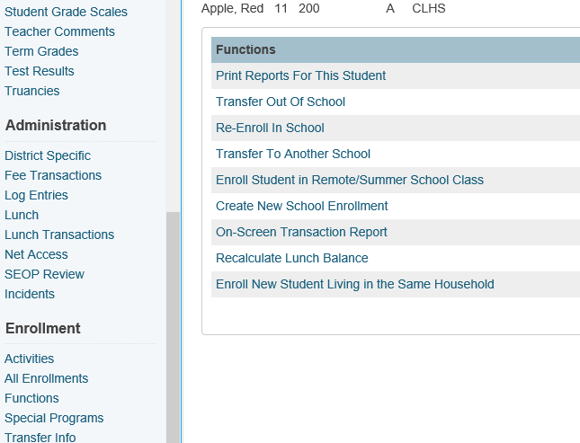

Enter the appropriate information:
Exit Date – the day after the student’s last day at the original number of periods
Exit Code – 19 (Continue in District)
Entry Date – the first day of the student’s new number of periods
Entry Code – E5 (Within District)
Full-Time Equivalency – the student’s new Full-Time Equivalency
Click submit to save the new enrollment record

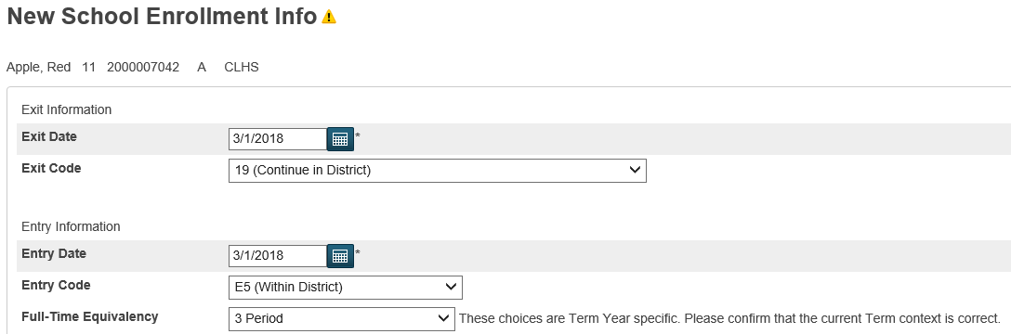

The student’s Transfer Info Screen will reflect the change and the Bell Schedule View will reflect the correct the new number of periods.
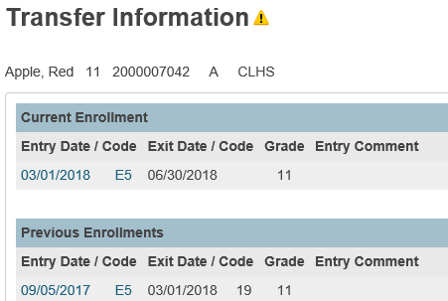

Note: This process will create Section Enrollment Audit errors, however, these errors can be ignored.

