Section 1310d Disciplinary Factors, MCL 380.1310d otherwise referred to as “Disciplinary Factors” is used to meet the requirement of school officials, before suspending or expelling a student, to consider a number of situation-specific factors, including whether a lesser intervention or restorative practices would address the pupil’s violation or behavior.
The Disciplinary Factors section is located in the Michigan State Information area of the Log Entry page within PowerSchool. This data is not submitted or reported to MSDS and is provided as a tool to make meeting the requirement of tracking and considering these factors easier.

To Enter Disciplinary Factor Information in PowerSchool
- Select the student and go to Log Entries under the Administration header.
- Click the New button.
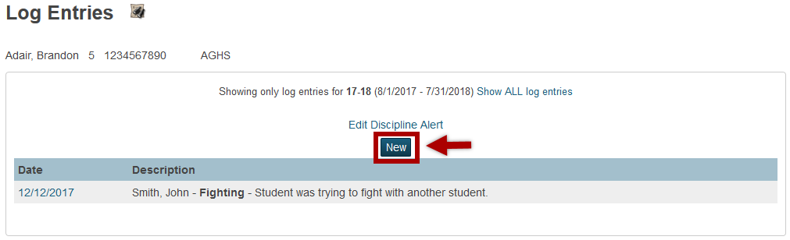
- In the New Log Entry screen set the Log Type to “Discipline”.
*The Michigan State Information section is only accessible when the Log Type is set to Discipline*
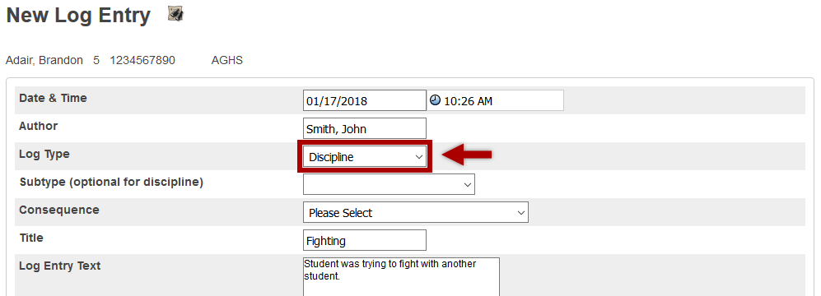
- Fill out all applicable log entry information, when complete scroll down to the Michigan State Information section and complete the applicable state fields. Within this section is an area titled “Section 1310d Disciplinary Factors, MCL 380.1310d”. Before suspending or expelling a student, building administration must complete and consider the factors in this area.

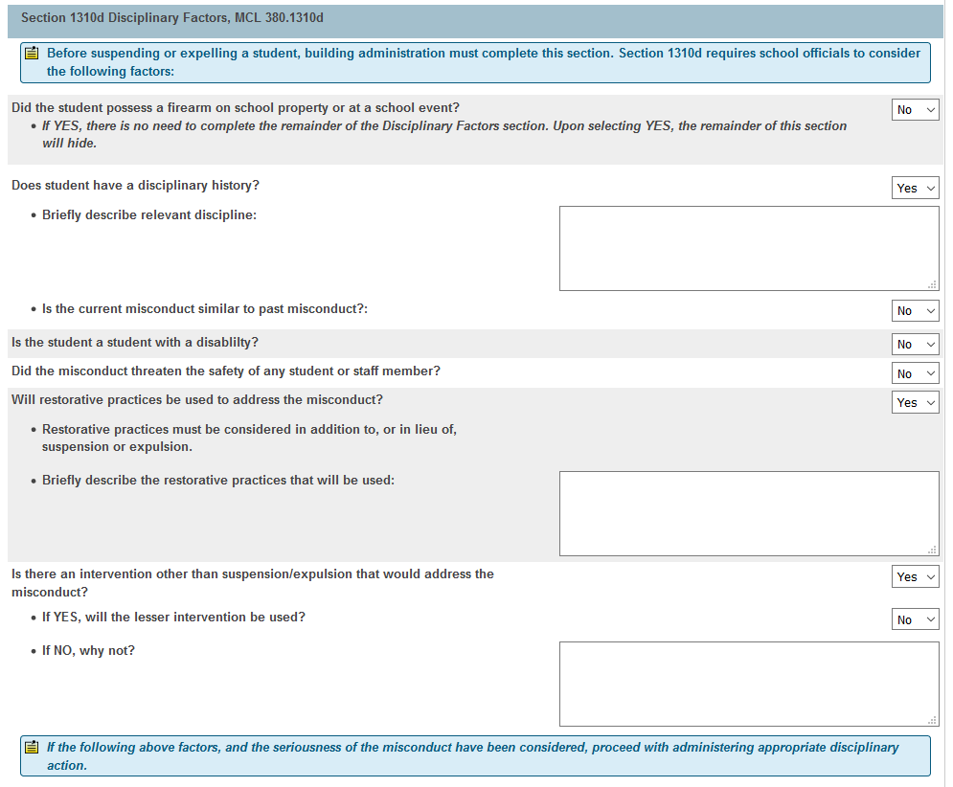

- Depending on the answers provided for each question, additional data entry fields may appear or disappear.
- If the Disciplinary Factors and the seriousness of the misconduct have been considered, the administrator can proceed with administering appropriate disciplinary action.
- Once all appropriate data is entered, click the Submit button at the bottom of the Log Entry.

Data Element Field Mapping
Data Element | Field Name
Did the student possess a firearm on school property or at a school event? | [S_MI_LOG_GC_X]dfPossessFirearm
Does student have a disciplinary history? | [S_MI_LOG_GC_X]dfDiscHist
Briefly describe relevant discipline | [S_MI_LOG_GC_X]dfDiscHistDesc
Is the current misconduct similar to past misconduct? | [S_MI_LOG_GC_X]dfDiscHistMisconduct
Is the student a student with a disability? | [S_MI_LOG_GC_X]dfStuDisability
Did the misconduct threaten the safety of any student or staff member? | [S_MI_LOG_GC_X]dfThreatStuOrStaff
Will restorative practices be used to address the misconduct? | [S_MI_LOG_GC_X]dfRestPractices
Briefly describe the restorative practices that will be used | [S_MI_LOG_GC_X]dfRestPracticesDesc
Is there an intervention other than suspension/expulsion that would address the misconduct? | [S_MI_LOG_GC_X]dfIntervention
If YES, will the lesser intervention be used? | [S_MI_LOG_GC_X]dfLesserIntervention
If NO, why not? | [S_MI_LOG_GC_X]dfLesserInterventionDesc

