There are several data issues that are dependent on the MSDS Prior Count Date and the MSDS Current Count Date fields that are located in the District Information page.
These include:
- Student information that displays at the top of the State/Province-MI pages (Prior Count Date, Current Count Date, Age at Count)
- State reporting field and page validation errors and warnings
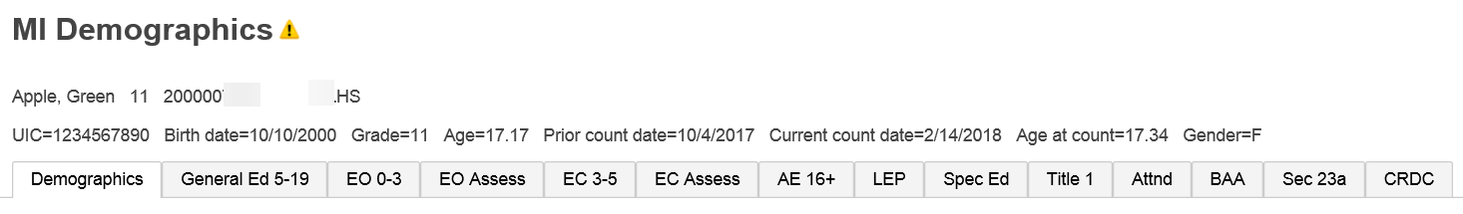

It is important to update this information in a timely manner. We recommend that after your count has been submitted to the state and certified, you go into the District Information page and update these fields.
- District Office > District > District Info > Michigan State Report Information Section
- Operating ISD/ESA Number – select your ISD if it is not already selected
- MSDS prior count date – change to 10/4/2017
- MSDS current count date – change to 2/14/2018
- Submit

