As of the January 2018 State Reporting Release, the capability of flagging a calendar day as “MI Forgiven Day” and “MI Unforgiven Day” became available. MI Forgiven Day would be used for any day that can be counted as forgiven by the state. MI Unforgiven Day would be used for those days that are over the forgiven amount or cannot be considered forgiven by the state.

Forgiven Calendar Days
- Clear all attendance entered for all students for the date school was cancelled.
*TIP: Use the Attendance Change group function to clear attendance in mass.*
- After attendance is cleared, navigate to: Start Page > School > Calendar Setup
- Select the Month/Year link at the top that the forgiven date falls under.
- For the forgiven date, select MI Forgiven Day from the drop-down menu in the Type column.
- Enter in the reason school was cancelled in the Note column for the forgiven date.

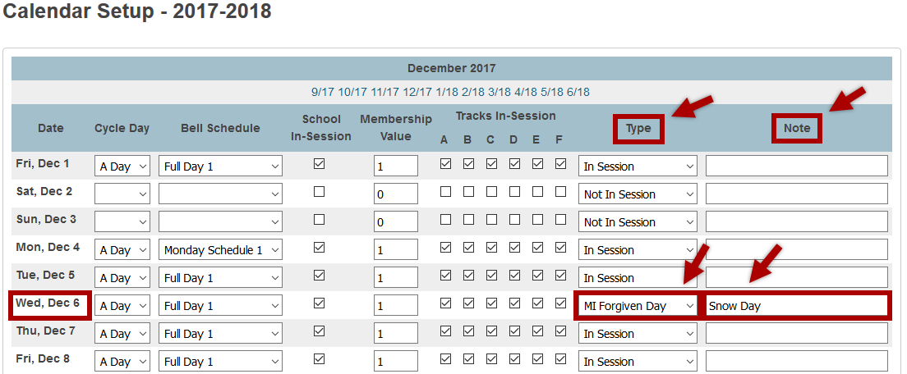
- For the remaining fields displayed, it is a district decision as to how to code those values.
*IMPORTANT: For the 75% Membership report purposes, the Membership Value MUST be greater than 0 in order for the forgiven date to appear on the report.*
- After submitting the changes to the calendar setup, the Refresh Premier Attendance Views Data function will need to be run. This can be done by navigating to: Start Page > Special Functions > Attendance Functions > Refresh Premier Attendance Views Data

MI 75% Membership Report Output
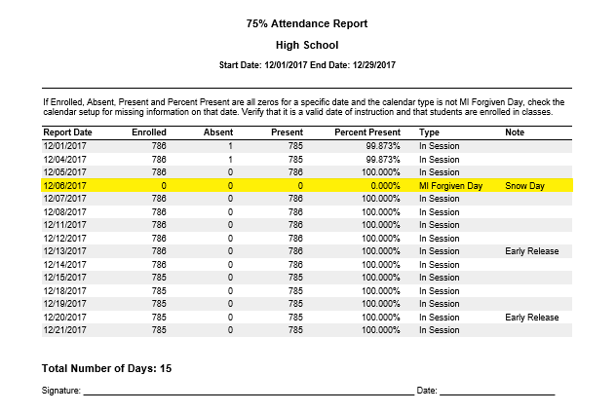

Unforgiven Calendar Days
- Clear all attendance entered for all students for the date school was cancelled.
*TIP: Use the Attendance Change group function to clear attendance in mass.*
- After attendance is cleared, navigate to: Start Page > School > Calendar Setup
- Select the Month/Year link at the top that the unforgiven date falls under.
- For the unforgiven date, clear out all data elements, but select MI Unforgiven Day from the drop-down menu in the Type column.
- Enter in the reason school was cancelled in the Note column for the unforgiven date.

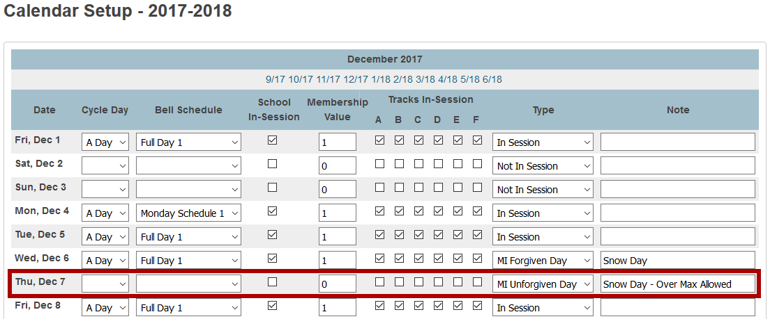
- After submitting the changes to the calendar setup, the Refresh Premier Attendance Views Data function will need to be run. This can be done by navigating to: Start Page > Special Functions > Attendance Functions > Refresh Premier Attendance Views Data

