The Michigan Student Record Maintenance collection may be used to submit updated student data to the state throughout the school year.
The As of Date is a characteristic of the Student Record Maintenance Collection. This is the date that the change in the student record took effect and it can be entered on the General Ed 5-19 tab of the State/Province-MI screen.

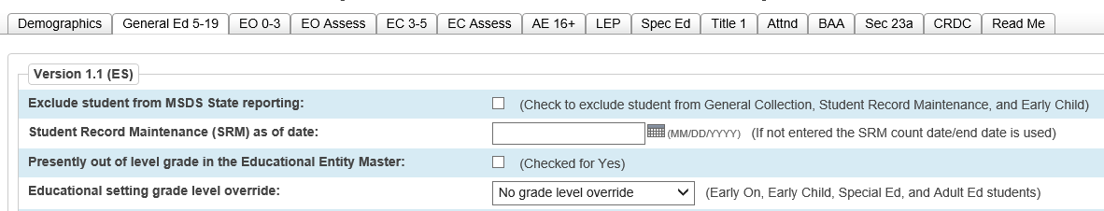

If you enter a date in the As of Date field, you can search this field the following ways:

Search: S_MI_STU_GC_X.SRMDate > 10/15/2015 ; S_MI_STU_GC_X.SRMDate < 12/15/2015

Search: S_MI_STU_GC_X.SRMDate # (not equal to blank)
Search: S_MI_STU_GC_X.SRMDate = ##/##/#### (where ##/##/#### represents a specific date)
Search: S_MI_STU_GC_X.SRMDate contains 2015 (contains the year 2015)
If you leave the As of Date field blank, you can search for students a variety of ways:

Select students individually using the “Select By Hand” function.

Search for exited students:
Example - /Exitdate>10/07/2015 ; Exitdate<12/01/2015 – This search will produce a selection of students who exited your district between 10/07/2015 and 12/01/2015.

Search for newly enrolled students:
Example - /Entrydate>10/07/2015 ; Entrydate<12/01/2015 – This search will produce a selection of students who have a new enrollment between 10/07/2015 and 12/01/2015.

Verify that your selection of students are coded properly to be included in state reporting:
Run the List Students function and include fields:
- Lastfirst
- State_ExcludeFromReporting
- If a value of False is listed, then the student is included in state reporting.
- If a value of True is listed, then the student is excluded from state reporting.

Running the MI General / SRM / Early Childhood Report
- This report may be run from the district level or from the school level.
- If the As of Date is blank, then the Current Count Date entered on the report interface is extracted as the student’s As of Date.
- The report includes students who were enrolled at any time between the Previous Count Date and the Current Count Date.
- The students must not be excluded from state reporting.
- Attendance is automatically calculated for all students.
- Current Selection Students: the selected students only or all students
- Collection Type: from the drop-down menu select Student Record Maint
- Entity Type Code: select District Number
- Entity Code: enter the district code
- Reporting District's State Assigned 5-digit District Number: enter the district number
- First Day of School: enter the first day of school
- Previous Count Date: enter the previous count date
- Current Count Date: enter the current count date
- Select schools to export. If none are selected the export will run for the entire district.

Helpful Hints
- The As of Date cannot be less than the previous count date.
- The As of Date cannot be greater than the current date.
- The As of Date cannot be prior to the student’s enter date.
- The As of Date cannot be after the student’s exit date.
- First Day in Attendance MUST be included for Section 25 SRM requests.

