The Seclusion and Restraint Component is used to collect data related to the use of emergency restraint and seclusion in the school district, public school academy, or intermediate school district program and is required to be reported when a student is secluded and/or restrained.
This component is submitted in the General and Early Childhood Collections. Under the statute, preschool pupils shall not be secluded, even in an emergency and therefore only restraints should be submitted. You must report the number of times in a day that a student was either restrained or secluded.
Starting with the Spring 2018 General and Early Childhood Collections, you are required to report any Seclusion and Restraint data from the beginning of the 17-18 school year.

To Enter Seclusion and Restraint Information in PowerSchool
- Select the student and go to the Seclusion/Restraint tab of the State/Province-MI page
- To add a new Seclusion and Restraint record for a student, click the New button

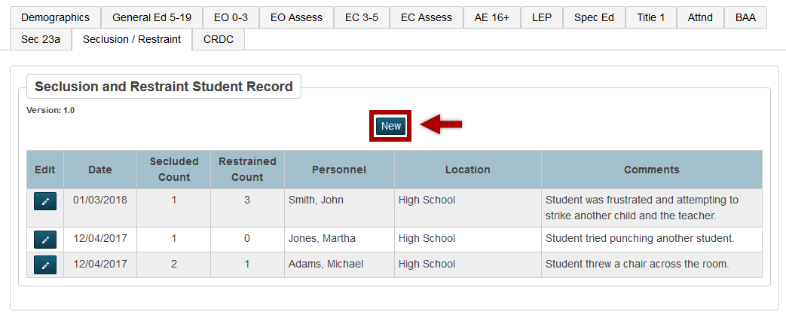

- Enter the date the student was secluded and/or restrained *submitted to MSDS*
- Enter the number of times the student was secluded (valid values 0 through 99) *submitted to MSDS*
- Enter the number of times the student was restrained (valid values 0 through 99) *submitted to MSDS*
- Enter the name of the personnel that initiated the seclusion and/or restraint
- Select the school where the seclusion/restraint happened
- Enter any comments related to this incident in the comments box
- Click Submit

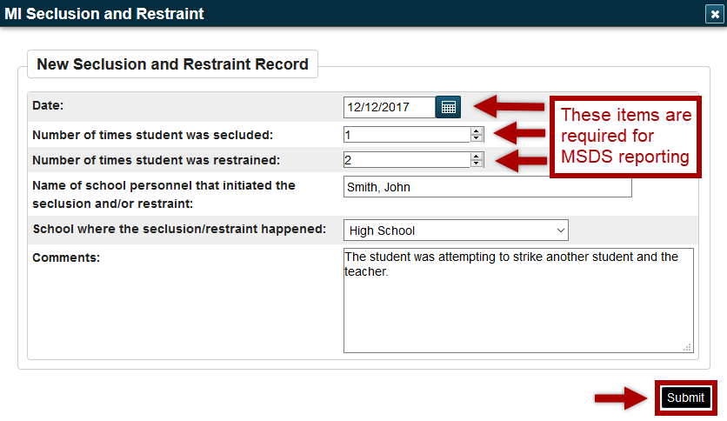

To Edit a Seclusion and Restraint Record
- Select the student and go to the Seclusion/Restraint tab of the State/Province-MI page
- Click on the pencil button in the edit column next to the record you wish to edit
- Click Submit after modifying the information
*The edit feature can also be used to delete an erroneous seclusion and restraint record.*

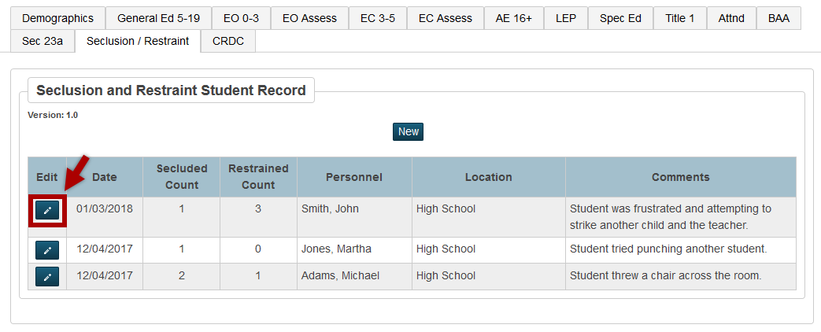
To Delete a Seclusion and Restraint Record
- Select the student and go to the Seclusion/Restraint tab of the State/Province-MI page
- Click on the pencil button in the edit column next to the record you wish to edit
- Click the Delete button

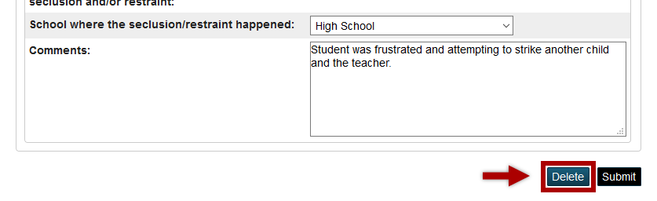
What Happens When There Are Multiple Records for the Same Date?
If there are multiple Seclusion and Restraint Records for a given day for the student, the number of times secluded and restrained in each record will be added together to be reported in one component.
Using the example screenshot from above:
On 12/04/2017, there were two (2) separate records added to the student’s Seclusion and Restraint screen. One record had a total of 1 seclusion and 0 restraints, the other record had a total of 2 seclusions and 1 restraint. In the XML that is extracted from PowerSchool, those totals will be combined together to have a total of 3 seclusions and 1 restraint for that date.
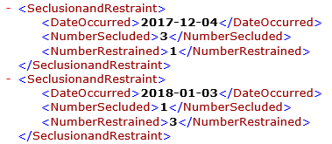
Data Element Field Mapping
Data Element | Field Name
Date | [S_MI_STU_SECREST_C]secRestDate
Number of times student was secluded | [S_MI_STU_SECREST_C]secludedCount
Number of times student was restrained | [S_MI_STU_SECREST_C]restrainedCount
Name of school personnel that initiated the seclusion and/or restraint | [S_MI_STU_SECREST_C]personnel
School where the seclusion/restraint happened | [S_MI_STU_SECREST_C]schoolID
Comments | [S_MI_STU_SECREST_C]comments

