Report Cards on the Parent Portal
Printing the PDF of the Report Cards
- Please note: When printing the report cards in the PS SIS and saving them as a PDF, we suggest you do the following
  - Use Chrome
  - Click on the 3 dots in the upper right corner
  - Choose Print
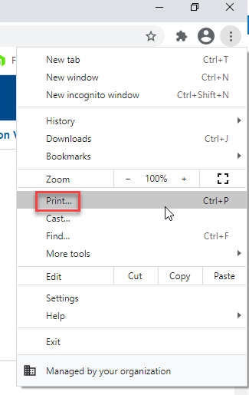
  - Margins should be set as Default, Options: Headers and Footers and Background Graphics should be unchecked and click Save.
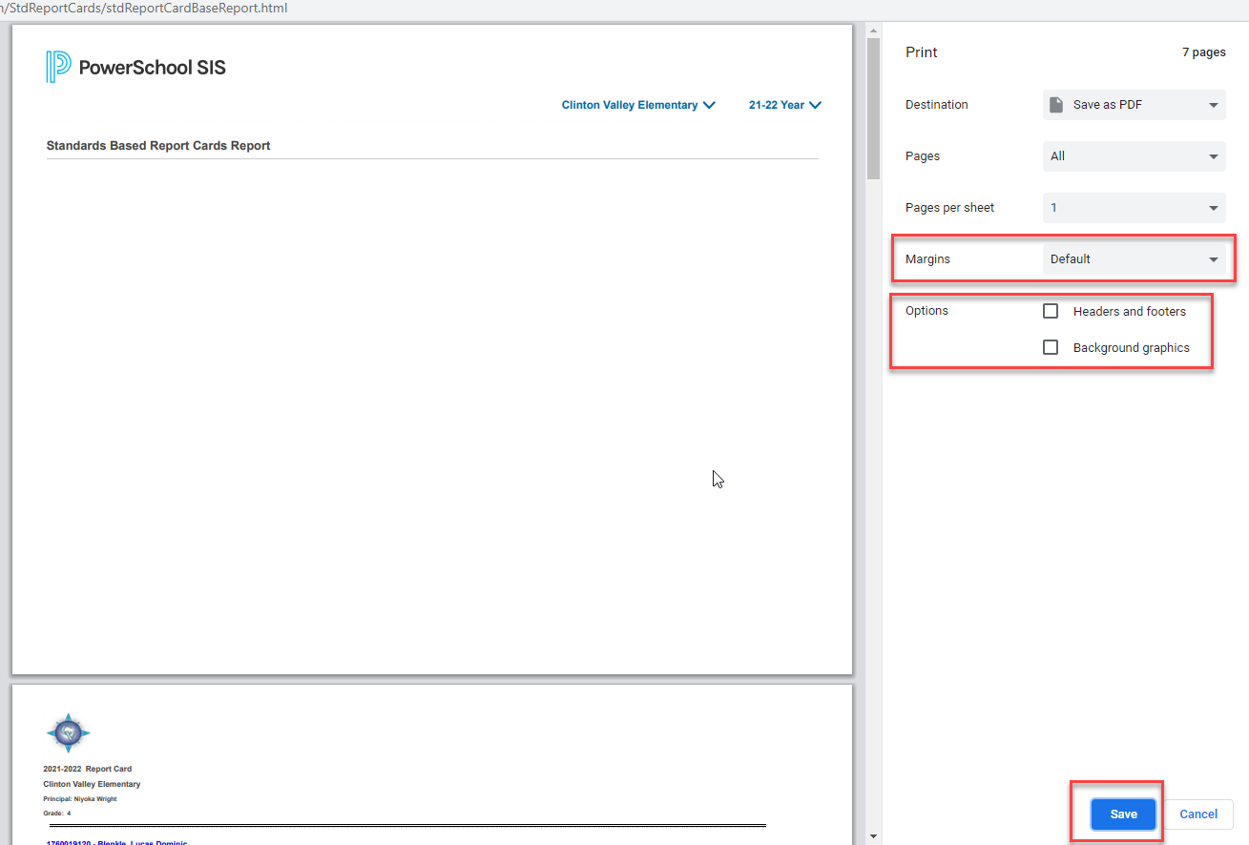
Uploading Report Cards for Parents to view in the Parent Portal

- Run the report cards that are in the SIS for each school and grade (Standard or formerly Traditional) and save them as a .pdf file. Do not delete the first page which is a blank with the logo. We suggest naming this file descriptively (ex: AppleGroveHSGrade10TermDate).
- You now will upload all the files. At the District Level or School Level>Reports>Parent Portal Upload
- NOTE: The latest report card.pdf file must be uploaded in order for parents to see the latest report card.
- 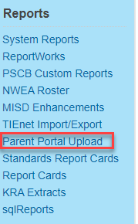
- Choose the file you want to upload and click on the upload button. When it says done!, the file has finished uploading.
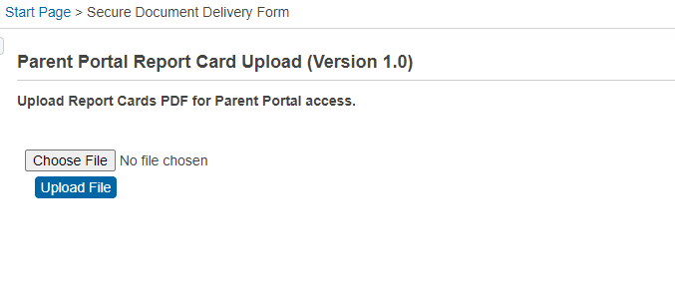

Click upload file button

Choose file to upload
Instructions for Parent to view Report Card.
- Log into Parent Portal
- Click the Student that you want to see the report card for (Step 1)
- Click on the App Switcher button (Step 2)
- Note: Report Cards will show for all students the parent has access to in the one PDF file

Click on App Switcher Button
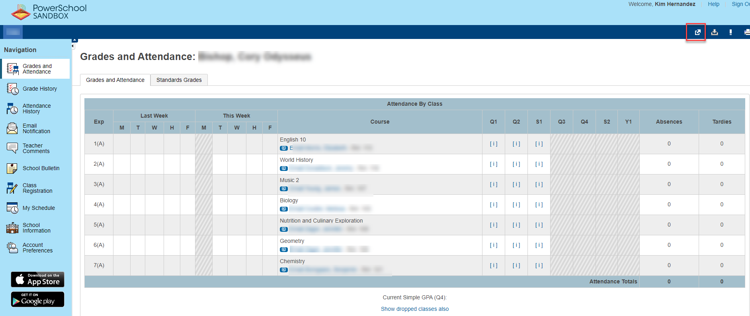

Click on student
- The Applications window will open and you can click on District Report Card
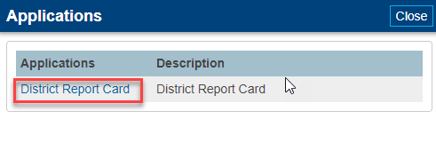

- After clicking on District Report Card, the report downloads in the lower left corner
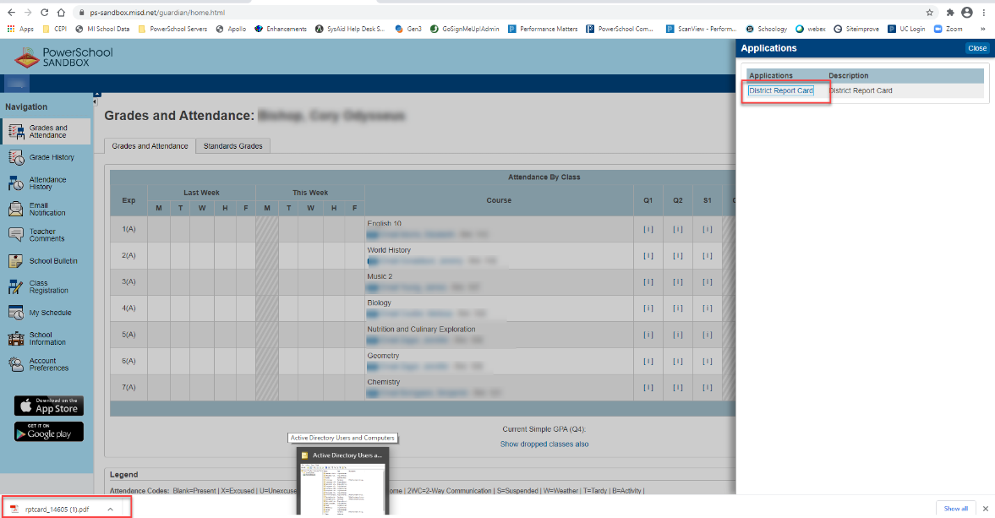

Instructions for Parent to view Report Card in Unified Classroom.
- Log into Unified Classroom
- Click on Quick Links
- Under Custom Links, click District Report Cards
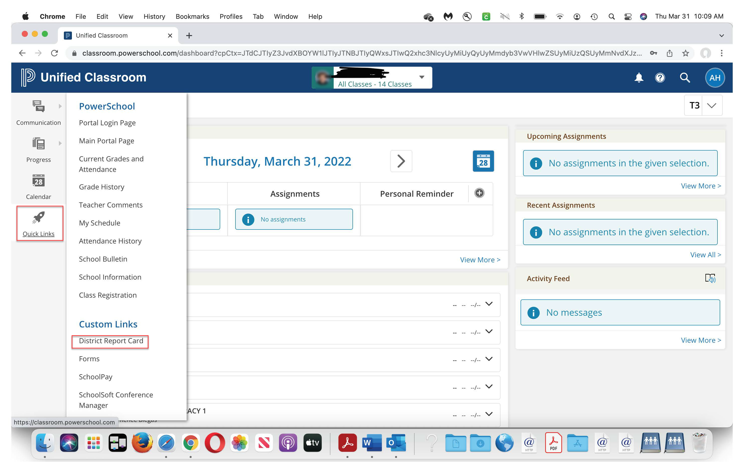

- After clicking on District Report Card, the report downloads in the lower left corner
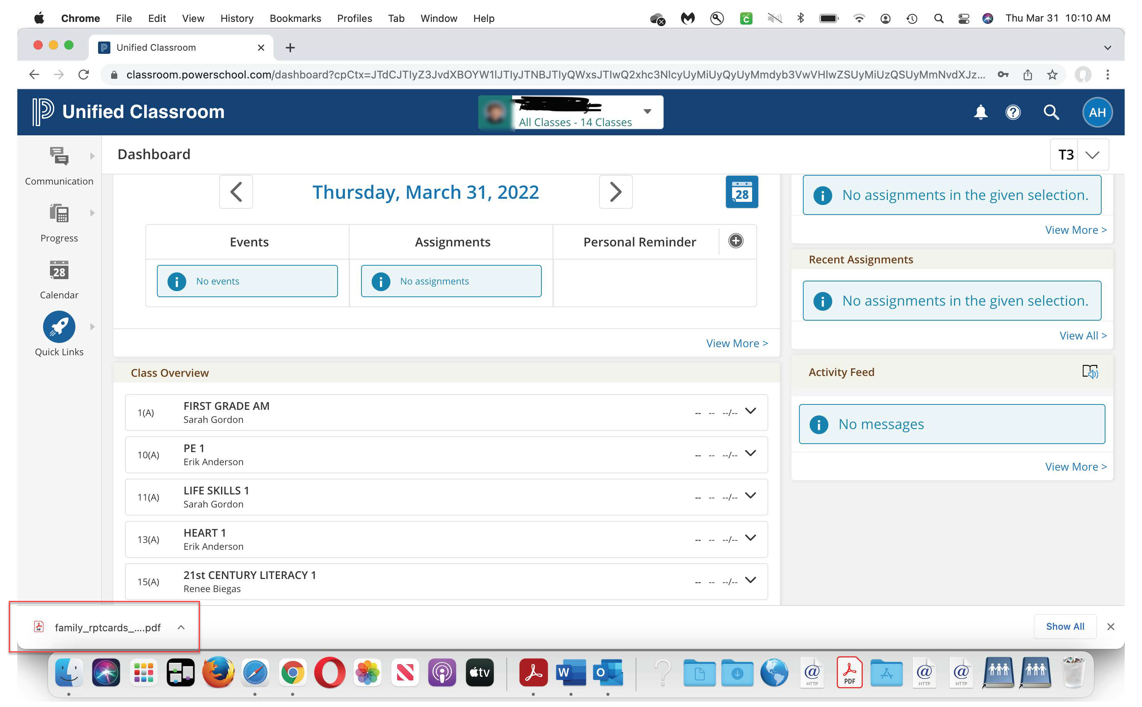

To test this function on your Sandbox
- You will need to create an account attached to a student
- At District>Click on Student
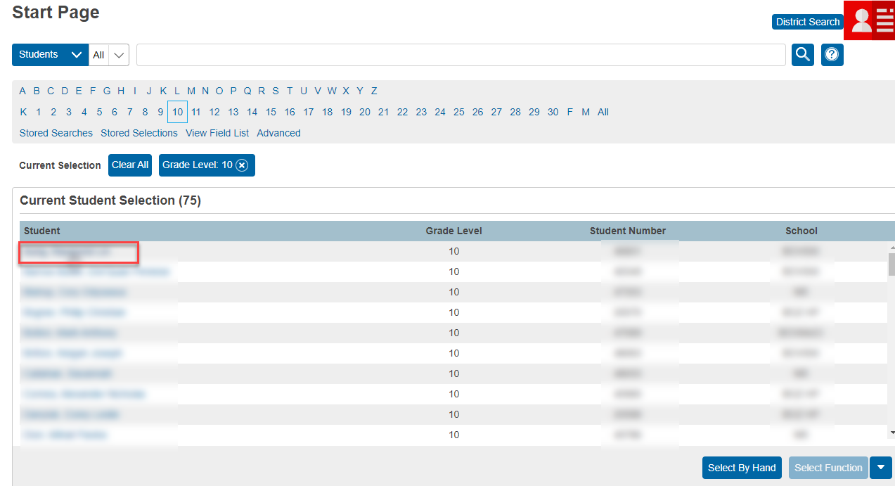
- Click on Contacts>Add
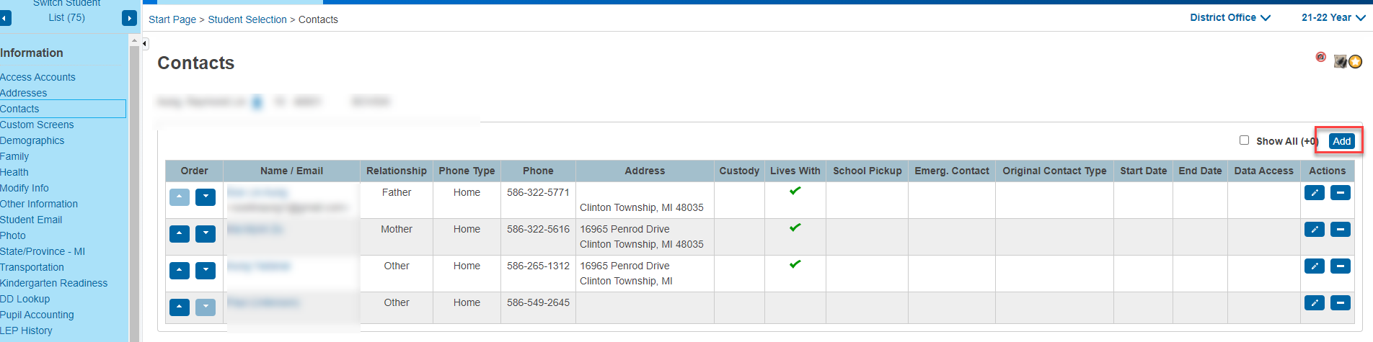

- Click New Contact
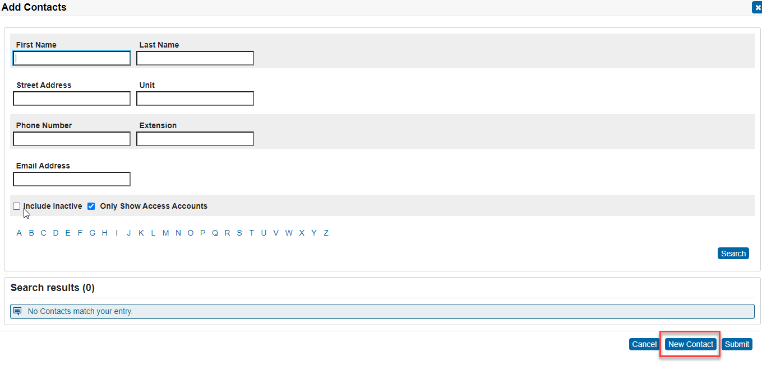
- Fill in appropriate information and under Web Account Access, click Add Account
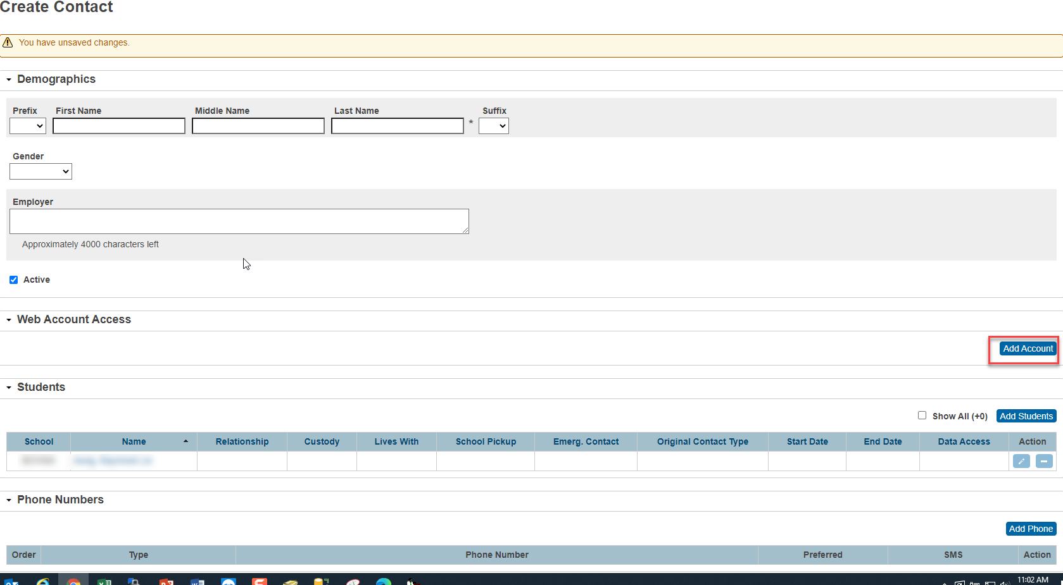

- Fill in appropriate information. You must fill in Username, Password, Account Email, Relationship, Start Date and End Date
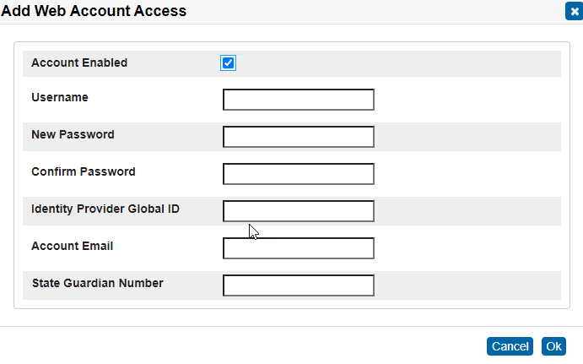

- Go back to the Student Contacts and click on the Pencil to edit the account you just created
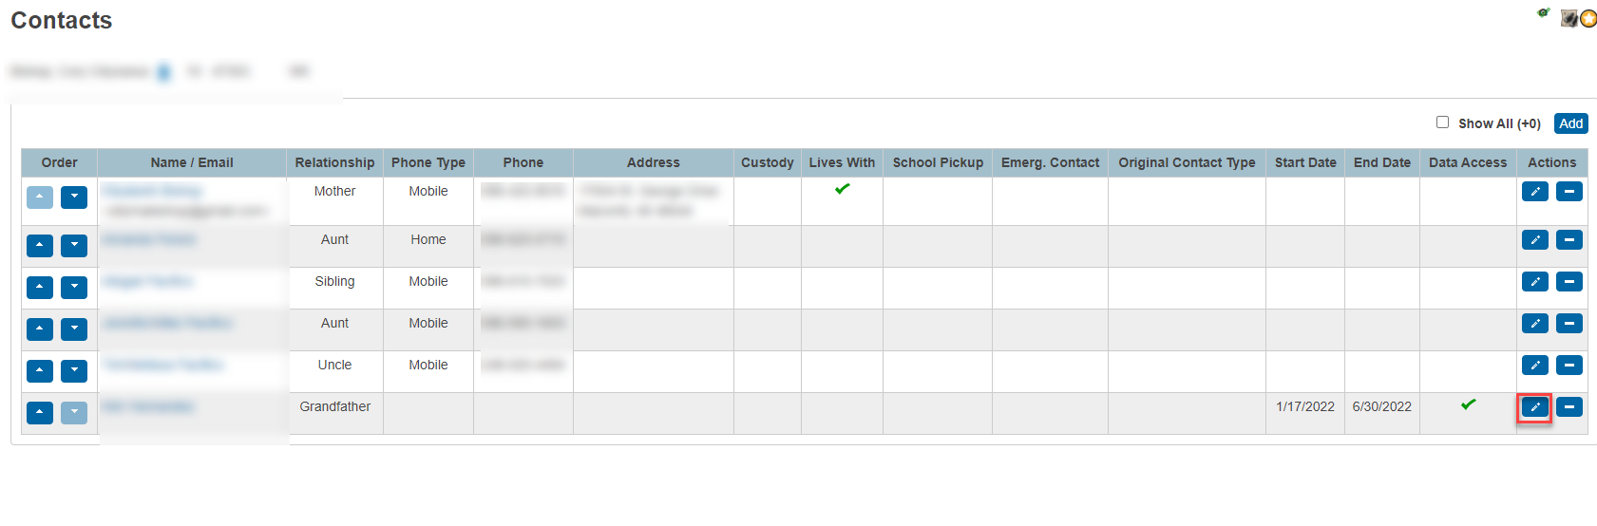

- Click on the Data Access Tab and check the Can Access Student Data and Email checkbox
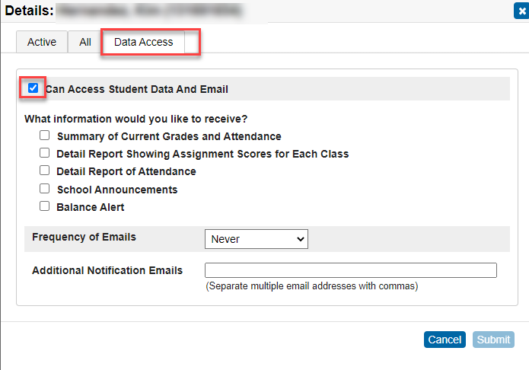

- Click on the Active Tab and fill in relationship, start date and end date
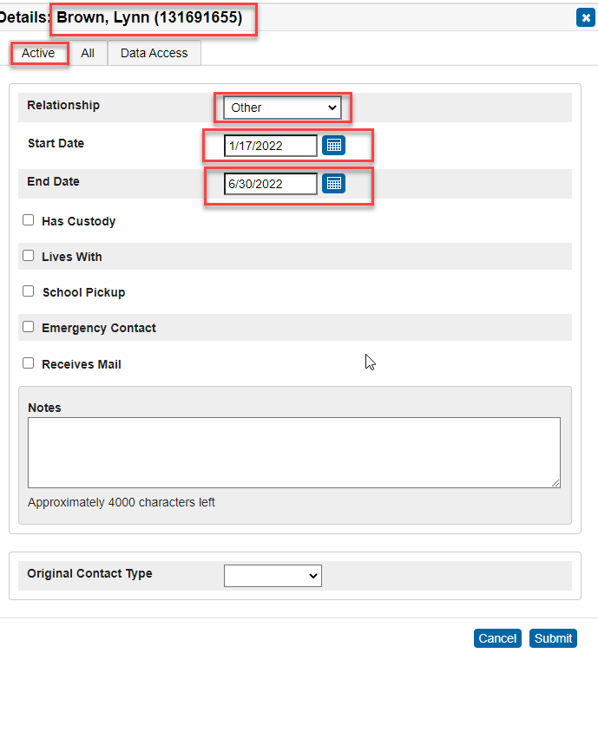

Parents can add link to their Homescreen on their smartphone (mimics app):
- Go to website (unify.performancematters.com) or (districtURL/public)
- Iphone: click icon
Android: click in upper right corner
- Click Add to Home Screen
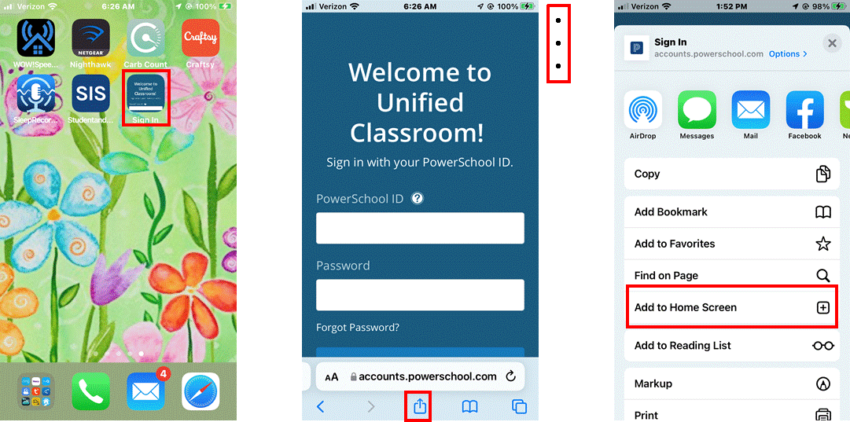

NOTE:
- When new report card files are uploaded, the old files are replaced. Therefore, parents will only see the current report cards that were uploaded. If a parent wants a copy of the previous report card, they will not be able to view it through the portal. It is suggested that parents print their student’s report card if they want to keep a record of their student’s progress.
- When running report cards from the SIS, it is suggested that you run them by school and grade level. Smaller files will not error out.
- Program will only work with report cards that are run in the SIS, it will not work with object reports, sql reports or any other reports.
- Max size of the upload file is 75mg, therefore, again it is suggested that report cards be run by grade level per school when uploading files.
- This program can/should be tested on sandbox. UC (Unified Classroom) can be removed from sandbox if it redirects to UC. Please submit a request via email to help@misd.net for a ticket to be created to remove UC from your district’s sandbox.
- You must be on the following versions of the SIS report card: Traditional Report Cards - Version 4.3 or higher Standards Based - Version 6.6 or higher
- Important: Do NOT use the Sandbox anymore to upload report cards once you go live (production side). Uploading report cards to sandbox will overwrite report cards on the Live side.
- A parent's User ID should not have spaces. For example: Contact’s Name is Minny Mouse / User ID should not be Minny (space) Mouse (Minny Mouse). It should be one continuous ID (Ex: email@phony.com)
- Report Cards cannot be seen using the PowerSchool App, however, if parents log in to PowerSchool through a web browser on their phone, they can see report cards. They then can bookmark the website or add the website to their homescreen.
- Please do not copy and paste information from Microsoft Word. This adds extra code which can affect uploading report cards and other functions of the report cards.

