Teacher Student Data Link (TSDL) Guide
PowerSchool
IMPORTANT: The Michigan Teacher Student Data Link collection MUST be run prior to completing the PowerSchool End of Year Process to ensure that students are reported in the proper grade and building.


Created by the Help Desk and Team
May 2024

Contents

Introduction 1
Whom Do We Report? (ALL STUDENTS) 1
Documentation and Resources 2
CEPI 2
PowerSchool 3
Macomb PowerSchool State Reporting Web Site 3
Important TSDL Reminders 4
Setup 5
District Setup – District Info 5
District Setup – Exclude a School from TSDL 7
District Setup – Michigan TSDL Completion Status 8
Completion Status Codes 13
District Setup – Courses 15
District Setup – Courses 21
School Setup – Sections 23
School Setup – Sections 26
School Setup - Staff 28
School Setup - Staff 29
School Setup – Final Grade Setup 31
School Setup – Storing Grades 35
School Setup – Average Final Grades 36
School Setup – Average Final Grades 40
Student – All Enrollments 42
Manually Updating Student’s Completion Status 42
Manually Updating Student’s Virtual Delivery Method 45
Manually Updating Student’s Exclude From Teacher-Student Data Link Status 47
Student – Historical Grades 50
Student – Historical Grades – College Credits 52
Reports 54
Understanding the Report Output Table 54
Report Descriptions 56
MI MSDS Setup Validation 57
Selection Criteria 57
Report Input 57
Report Output 60
MI Teacher Student Data Link (TSDL) Validation - NEW 61
Selection Criteria 61
Student Selection 61
Course Selection 61
Report Input 62
Report Output 63
MI Teacher Student Data Link (TSDL) Collection - NEW 65
Selection Criteria 65
Generate Reports 69
Report Input 71
Report Output 73
Appendix: Michigan State Code Values 87
Completion Status Codes 87
Subject Area Codes 88
Course Identifier Codes 89
Course Types 90
Gotchas, Reminders, and Best Practices 92

Introduction
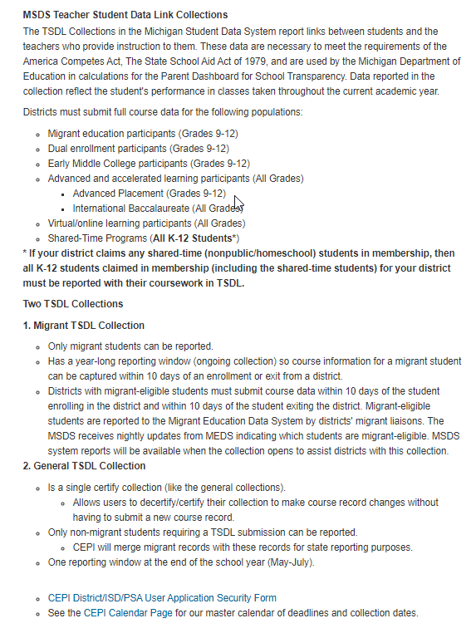

Whom Do We Report? (ALL STUDENTS)
Migrant Students
All migrant-eligible students in grades 9 through 12 are required to be reported. Migrant students' eligibility data will be imported from the Migrant Education Data System (MEDS) into MSDS on a nightly basis. Districts are required to submit all course information for these students whether or not they are receiving migrant services from the district, no matter how long the students have been in the district after the start of the new school year. It is expected that at least one teacher will be reported for each student.

The Migrant Student List Report, which identifies migrant-eligible students in your district, is available through the General Reports drop-down on the Home page of MSDS. This list includes students reported by your district in general and SRM collections who have been flagged as migrant.

Other migrant students not taking high school courses also need to have course data reported in TSDL as any other non-migrant student would be reported.

Migrant-eligible students must have course information submitted in the Ongoing TSDL within 10 days of the migrant-eligible student enrolling in the district and within 10 days of the migrant-eligible student exiting the district regardless of how long the student is in the district.

Dual Enrollment/Early Middle College Students
All courses for students participating in a dual enrollment and/or Early/Middle College program are required to be reported. Report post-secondary courses with code "07" (Dual Enrollment/Early Middle College) in the Course Type characteristic. Only the specific college course should be reported with the dual enrollment code.

Advanced and accelerated learning (AP/IB) participants
All courses for students participating in an advanced/accelerated learning program, such as Advanced Placement (AP) or International Baccalaureate (IB), are required to be reported. For the advanced courses, be sure to report the appropriate code in the Course Type characteristic.

Virtual/online learning participants
All courses for students participating in one or more virtual/online course are required to be reported. For the virtual/online courses, be sure to report the appropriate code in the Virtual Method characteristic.

All other students
Students that do not meet at least one of the above four criterion are not required to be reported in TSDL. However, if your local student information system does not have the capability to exclude these students, you may report them. The exception is Adult Education participants. The system will generate a field-level error when students are reported with Grade or Setting code "20" (adult education).

2018-19 MID YEAR CHANGE: If your district provides shared-time services to non-public or homeschool students and have claimed FTE for them, then you are required to submit the courses for ALL STUDENTS/ALL GRADES, including these shared time students, in to TSDL. FTE claimed from non-public/homeschool students residing in your district that are attending ISD CTE programs is considered a shared-time program and makes you liable for submitting your whole student population.

Documentation and Resources

CEPI
CEPI > MSDS > TEACHER STUDENT DATA LINK
https://www.michigan.gov/cepi/0,1607,7-113-986_50502_57560---,00.html
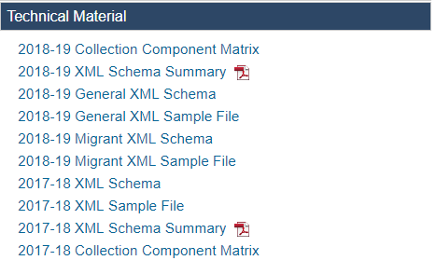
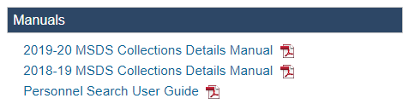
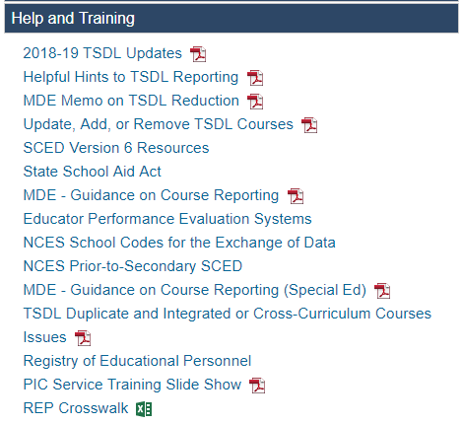

PowerSchool
While logged into PowerSchool, click on the Help link in the upper right corner of the page, then click on State Reporting Help.
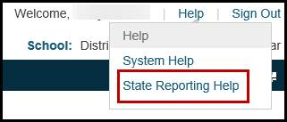
PowerSchool State Reporting Online Documentation will be available.

Macomb PowerSchool State Reporting Web Site
http://powerschool.misd.net/State_Reporting/TSDL.html
Teacher Student Data Link (TSDL) Guide – PowerSchool Procedures
Teacher Student Date Link (TSDL) Checklist – PowerSchool Procedures

Important TSDL Reminders
The Michigan Teacher Student Data Link collection MUST be run prior to completing the End of Year Process to ensure that students are reported in the proper grade and building.

- Student must have had an active enrollment during the current school year.
- Student grade must be associated with a section number.
- Student grade must be associated with a grade scale.
- K-8 students are not required to have a stored grade and will automatically export with a completion status of CP.
- The TSDL report interface has an option for “Elementary ungraded withdrawal” where you can choose WP or WE or WF but this is only for students that left school or a class before the actual ending date.

Setup
The following pages must be set up prior to running the Michigan Teacher Student Data Link Reports.

District Setup – District Info
The following data elements are required for district setup.
- Start Page > District Office > District > District Info.
- Verify that your District Information is correct (Name of District, District Number, etc.)
- In the State Report Information field, verify that your Operating ISD/ESA Number is selected and the proper Count Dates are entered.
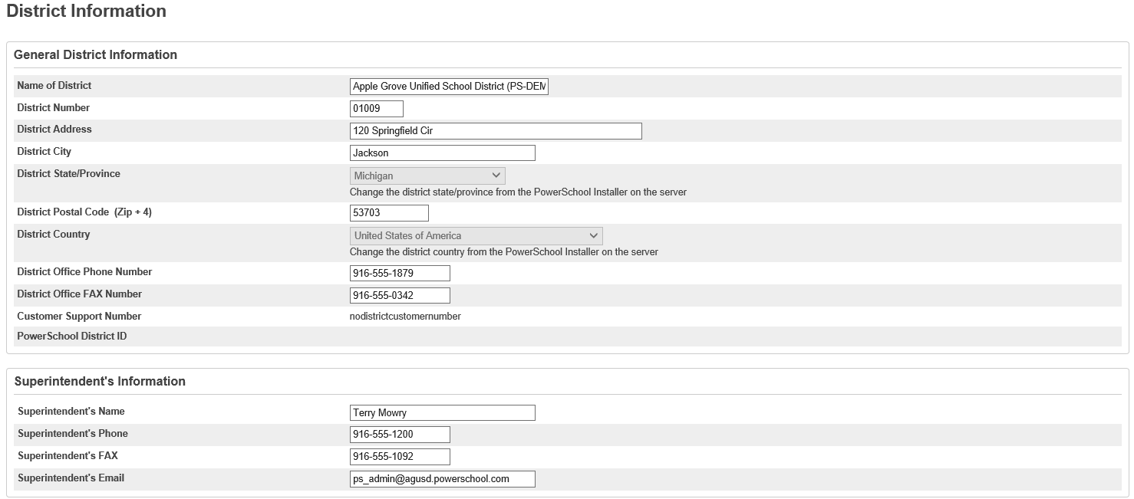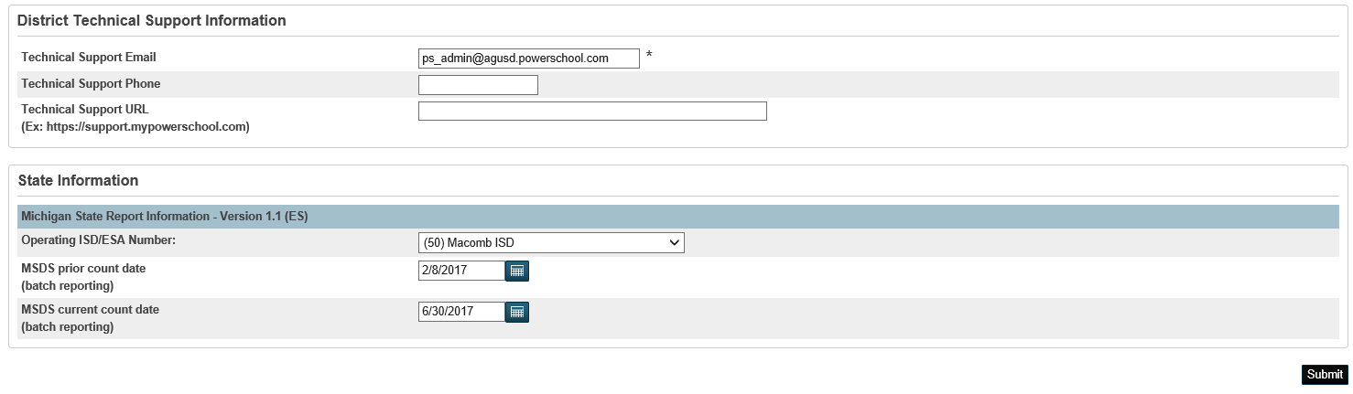

District Setup – Exclude a School from TSDL
The following data elements are required to exclude a school from being exported in the MI Teacher Student Data Link (TSDL) Collection
- Start Page > District Office > District > Schools/School Info > Edit School > Michigan State Information
- Exclude From Teacher Student Data Link field.
- Select Yes from the dropdown menu,
- Submit.
- This will exclude the school from being exported in the MI Teacher Student Data Link (TSDL) Collection.

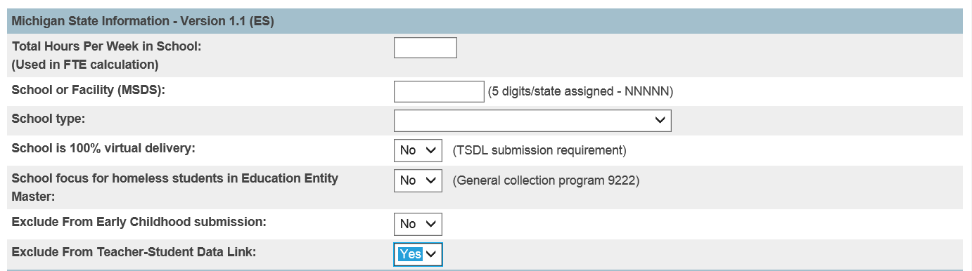

District Setup – Michigan TSDL Completion Status

The following setup is required at the district level for mapping the Michigan TSDL Completion Status.
Use this option to designate specific completion status codes for each grade in each grade scale. The mapped values are used to determine the completion status codes assigned to selected student records.

You must complete this page for each grade scale used in your district before running the Michigan Teacher Student Data Link report.

To create a new grade scale mapping record, follow these steps.
- Start Page > District Office > District > Grade Scales.
- On the Grade Scales page, click the Edit button for the Grade Scale to be mapped.
- The Michigan TSDL Completion Status appears at the bottom of the edit Grade Scale page.
- Select a Grade and select the Michigan TSDL Completion Status and Michigan TSDL Withdrawal Status from the drop down menus. For example, you would select (CP) Pass for the Michigan TSDL Completion Status and (WP) Pass for the Michigan TSDL Withdrawal Status. Click Submit.
- Repeat for all required Grade Scales.

Note: If a completion status dropdown menu does not appear, you may not have permissions to modify the grades scales.
Resolution: District > GPA Calculations > Miscellaneous > Permit modification of grades scales (check the box)

District Setup – Michigan TSDL Completion Status

Grade Mapping needs to be set up at the district level for all grades scales to ensure that PowerSchool assigns the proper completion status based on the student’s final grade.

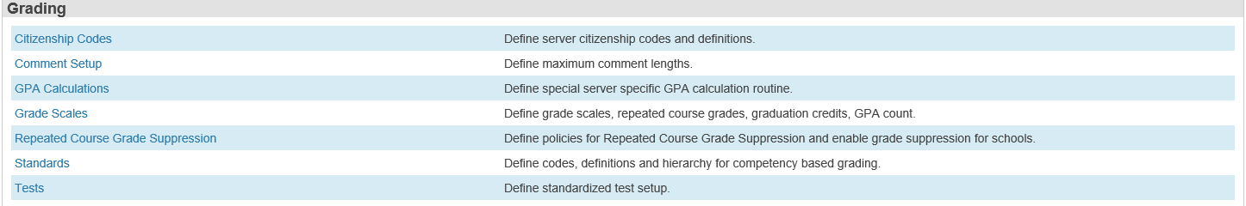
Select Grade Scales
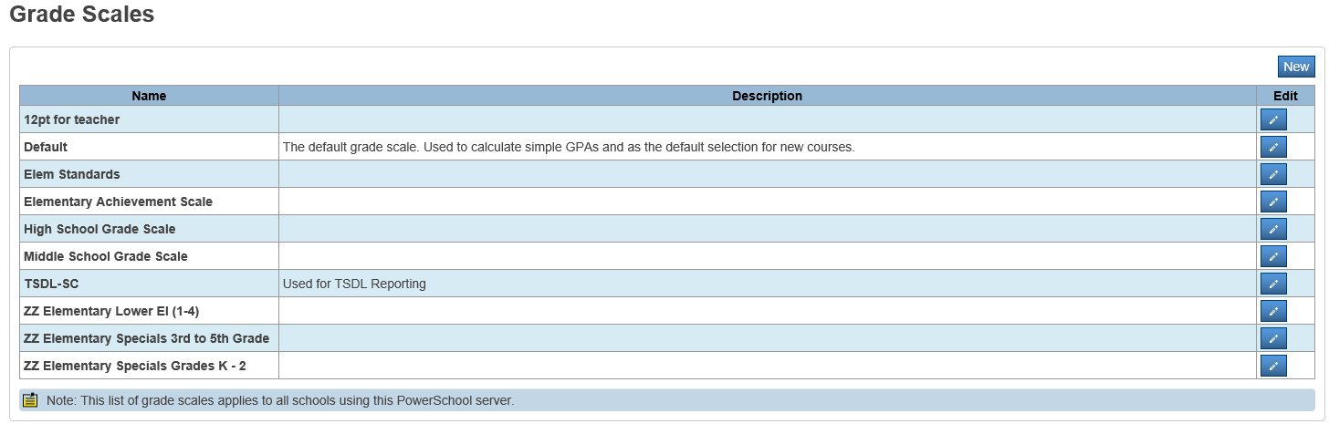
Click on the Edit button for the Grade Scale to be mapped.

District Setup – Michigan TSDL Completion Status

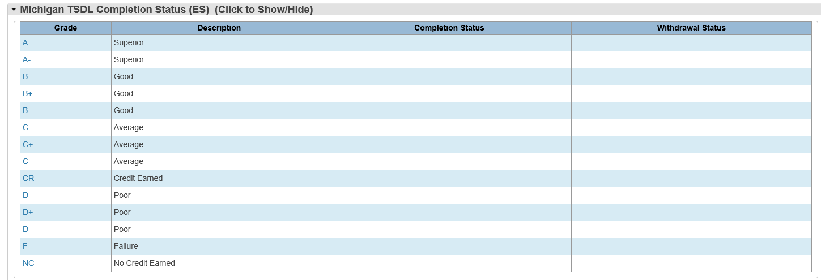
Click on the Grade to be mapped.
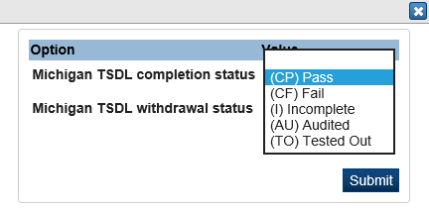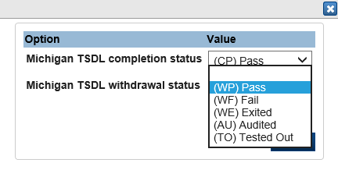
Select the appropriate Michigan TSDL Completion Status.
Select the appropriate Michigan TSDL Withdrawal Status.
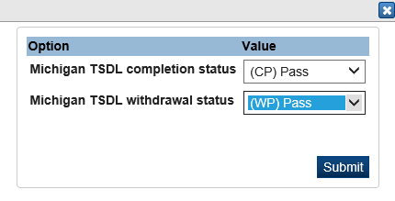
Click the Submit button to save the changes.
District Setup – Michigan TSDL Completion Status

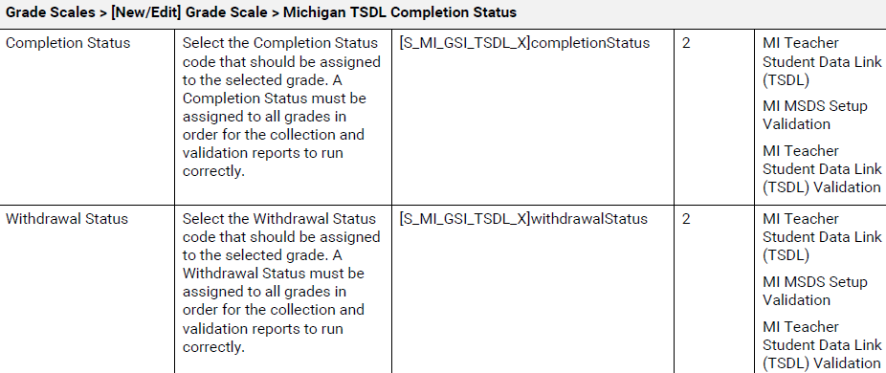

Completion Status Codes
Code | Description
AU | Audit – all must apply: the course is taken in a secondary or postsecondary environment; the course is normally taken for-credit; the student purposefully enrolled in the course as not-for-credit; AND, prior to enrollment, the teacher, student and school administration (counselor/principal) are all in agreement that the student will have the same expectations for the course as all other students, except that there will be no grade or credit issued at its completion.  Sdfdsfk;sdakf;dskffdsfjsdla
TO | Tested Out – The student took a test and received credit without having to take the course.
OE | Ongoing Enrolled – The special education student is reported in grade or setting 14 and is expected to continue in this same course next year. This requires the use of Subject Area Code "73" and Course Section ID "039". This status may also be used for any non-special education student who is expected to continue in this same course and will be reported in a later submission when the course is completed.
CP | Completed/Passed – The student completed the course, meeting at least the minimum expectations.
CF | Completed/Failed – The student completed the course but did not meet the minimum expectations for passing.
CS | Completed/Grade 14 Only – The special education student is reported in grade or setting 14 and has completed or aged out of the course. A course grade and credit are not applicable.  If the student is in grade 14 and enrolled in a course with a subject area of 73, and course identifier of 039, then the TSDL collection report will automatically export a CS for the student.
WE | Withdrawn/Exited – The student withdrew or exited the course before completion.
WP | Withdrawn/Passing – At the time the student withdrew or exited the course, he/she was passing the course.
WF | Withdrawn/Failing – At the time the student withdrew or exited the course, he/she was failing the course.
I | Incomplete – At the time of this reporting, the student must meet additional requirements to receive a grade or credit for the course.
ER | Submitted in Error – This status allows districts to mark a record that was submitted in error in a previous certified collection of the TSDL. Courses marked with this Completion Status will not be included in any reporting of TSDL data and will be considered as not submitted

District Setup – Courses
The following setup is required at the district level for all courses.
All courses need to be properly coded with the following: Subject Area Code, Course Identifier Code, Course Type, Virtual Delivery, and Exclude from TSDL. Changes made in the District Course file will affect courses at all schools.
To code courses:
- Start Page > District Office > District > Courses.
- Select the course to enter the state reporting information for TSDL.
- Under the Michigan State Reporting Information section:
- Select the appropriate Subject Area Code from the dropdown menu.
- Select the appropriate Course Identifier Code from the dropdown menu based on the selected Subject Area Code.
- Select the Course Type from the dropdown menu.
- If applicable, select the Virtual Delivery method from the dropdown menu.
- If applicable, set the Exclude From Teacher-Student Data Link to “Yes”.
Note: This will prevent this course from being included in the TSDL submission.
- Repeat the process until all courses are properly coded.

Teacher PIC Number
- Required unless the Course Type characteristic is reported as Dual Enrollment/Early Middle College (07) or when the Subject Area Code is State Approved CTE Course (00).

Dual Enrollment or Early College courses:
Please make sure to add courses for any Dual Enrollment or Early College courses that students in your district are enrolled in. This will ensure that these courses have associated sections and associated grade scales in the school where the student is enrolled. This will help ensure that these course records are included in the TSDL submission.
- Course file – Subject Area Code should be coded as a secondary course.
- Course file – Course Type should be coded as (07)Dual Enrollment/Early Middle College
- PIC number is not required
- Student should be coded as Early/Middle College in the State/Province screen.
District Setup – Courses

Data Element | Additional Information | [Table]Field Name  Field Length
Course Name | Enter the course name. | [Courses]Course_Name
Course Number | Enter the course number. | [Courses]Course_Number  Field Length: Max 11
Subject Area Code | Select the two-digit Subject Area Code.  Refer to the following links for additional information:  http://nces.ed.gov/pubsearch/pubsinfo.asp?pubid=2007341  http://nces.ed.gov/pubsearch/pubsinfo.asp?pubid=2011801 | [S_MI_CRS_TSDL_X]NCESsubjectArea  Field Length: 2
Course Identifier Code | Select the three-digit Course Identifier Code.  Refer to the following links for additional information:  http://nces.ed.gov/pubsearch/pubsinfo.asp?pubid=2007341  http://nces.ed.gov/pubsearch/pubsinfo.asp?pubid=2011801 | [S_MI_CRS_TSDL_X]NCEScourseID  Field Length: 3
Course Type | Select the code that best represents the level and rigor of the course.  Refer to the Appendix for a list of valid codes. | [S_MI_CRS_TSDL_X]courseType  Field Length: 2
Virtual Delivery | Select the code that represents the Virtual Delivery method of the course if applicable. | [S_MI_CRS_TSDL_X]virtualDelivery  Field Length: 2
Exclude From Teacher Student Data Link | Select whether to include or exclude the course from the Teacher Student Data Link. | [S_MI_CRS_TSDL_X]excludeTSDL  Field Length: 1
District Setup – Courses
Michigan State Reporting Information
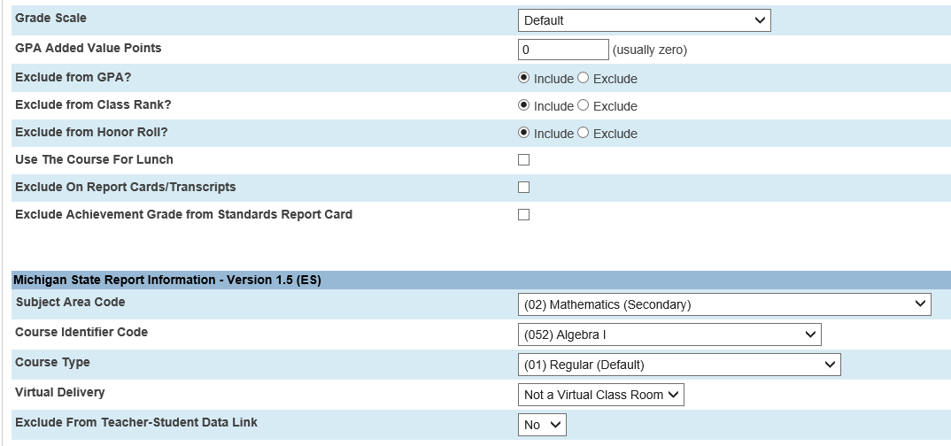

District Setup – Courses
Subject Area Code
Subject Area Codes – Select the appropriate NCES Secondary and Prior to Secondary Subject Area Code from the dropdown listing.
Secondary Math is selected in this example.
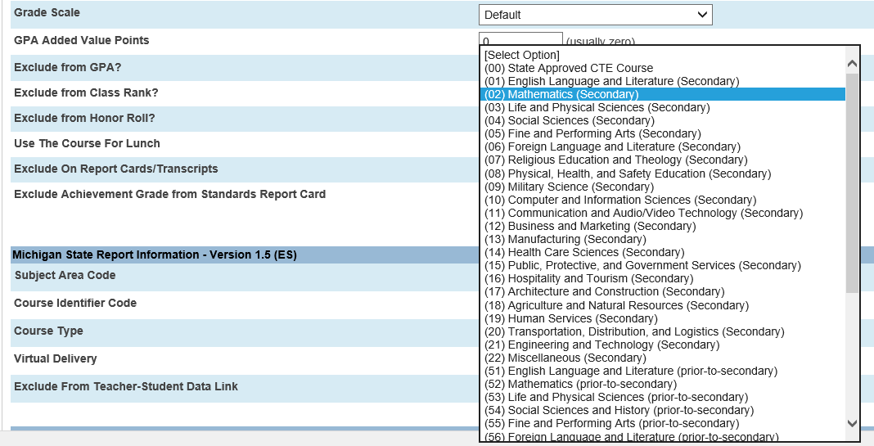
District Setup – Courses
Course Identifier Code
Course Identifier Codes – Select the appropriate NCES SCED Course Identifier Code from the dropdown list that is based on the Subject Area Code selected.
Note that Secondary Math was selected as the Subject Area Code and the SCED codes for Secondary Math are displayed in the Course Identifier Code dropdown list.
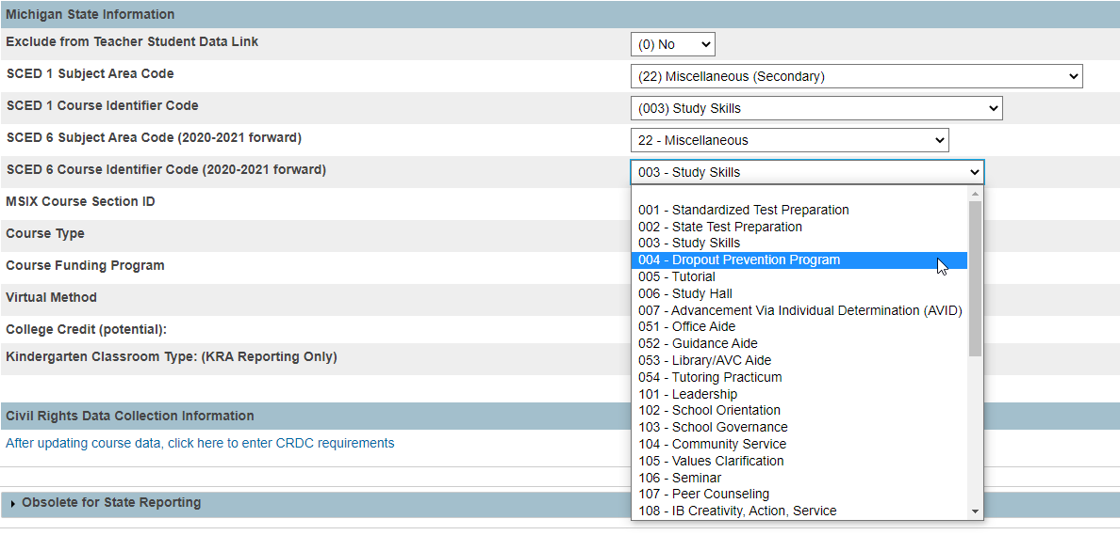

District Setup – Courses
Course Type
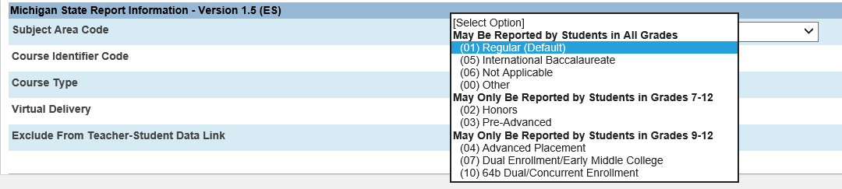
Course Types – select the appropriate Course Type from the dropdown list.
Virtual Delivery
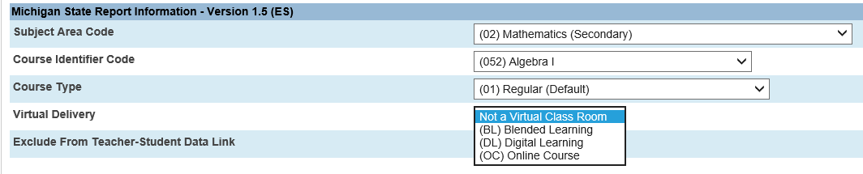
Virtual Delivery – select the Virtual Delivery method, if applicable. Not a Virtual Class Room is the default setting.
Exclude from Teacher-Student Data Link
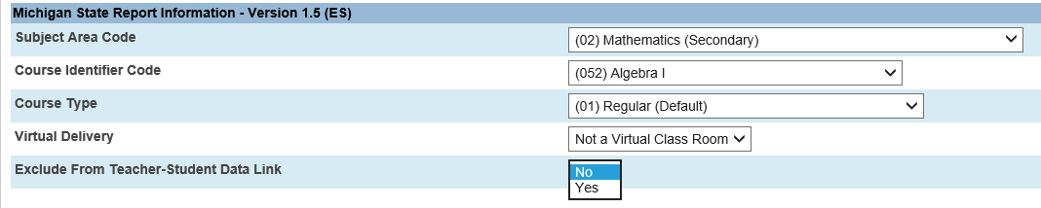
Exclude from Teacher Student Data Link – Yes or No. Use to exclude the course from the TSDL collection.

School Setup – Sections
The following setup is required at each school for all sections.
All sections need to be properly coded with the following: Exclude from TSDL, Co-Teacher PIC Numbers, Virtual Delivery, and, Virtual Mentor PICS. Sections must be updated at each school.
To code sections:
- Start Page > School > Sections.
- Select the section to enter the state reporting information for TSDL.
- Under the Michigan State Reporting Information section:
- If applicable, set the Exclude From Teacher-Student Data Link option to “Yes”.
Note: This will prevent this section from being included in the TSDL submission.
- If applicable, select Co-Teachers from the Co-Teacher drop down boxes.
Note: Teachers will not show up in this dropdown list if they are not listed in the Teacher – Section Lead or in the Teachers/Staff – Additional portions of the Sections page.
- Select the appropriate option for Virtual Delivery.
- If applicable, select Mentor PIC from the Virtual Mentor PIC dropdown boxes - (a Virtual Mentor PIC should only be selected if a Virtual Method is selected for the section).
Note: Teachers are only available in the dropdown if the Virtual Delivery Teacher or Mentor box is set to Yes in the teacher’s information screen.
- Repeat the process until all sections are properly coded for each school.

Data Element | Additional Information | [Table]Field Name
Sections
Course Number | Enter the course number. | [Sections]Course_Number  Field Length: 11
Term | Select the term. | [Sections]TermID  Field Length: N/A
Teacher – Section Lead | Select the lead teacher. | [Sections]Teacher  Field Length: N/A
Teachers/Staff– Additional | Select any additional teachers/staff members. | [SectionTeacher]TeacherID  Field Length: N/A
Section Number | Enter the section number. | [Sections]Section_Number  Field Length: 10
Exclude From Teacher Student Data Link | Select whether to include or exclude the section from the Teacher Student Data Link. | [S_MI_SEC_TSDL_X]excludeTSDL  Field Length: 1
Co-Teacher PIC | Select the Co-Teacher. | [S_MI_SEC_TSDL_X]coTeacher1  Field Length: 10
Co-Teacher PIC | Select the Co-Teacher. | [S_MI_SEC_TSDL_X]coTeacher2  Field Length: 10
Virtual Delivery | Select the Virtual Delivery method. | [S_MI_SEC_TSDL_X]virtualDelivery  Field Length: 1
Select the virtual course mentor PIC(s) for virtual delivery classroom | Select the Mentor Teacher. | [S_MI_SEC_TSDL_X]mentorTeacher1  Field Length: 1
Virtual Course Mentor PIC 2 | Select the Mentor Teacher. | [S_MI_SEC_TSDL_X]mentorTeacher2  Field Length: 1
Virtual Course Mentor PIC 3 | Select the Mentor Teacher. | [S_MI_SEC_TSDL_X]mentorTeacher3  Field Length: 1
School Setup – Sections
Exclude From Teacher Student Data Link – Select Yes or No from the dropdown box. Default value is No. Used to exclude the section from the TSDL collection.
Virtual Delivery – Select the Virtual Delivery method from the dropdown box, if applicable.
Mentor Teacher – Select up to 3 Mentor Teachers from the Virtual Course Mentor PIC dropdown boxes. Teachers are only available in the dropdown if the Virtual Teacher or Mentor box is set to Yes in the teacher’s information screen.

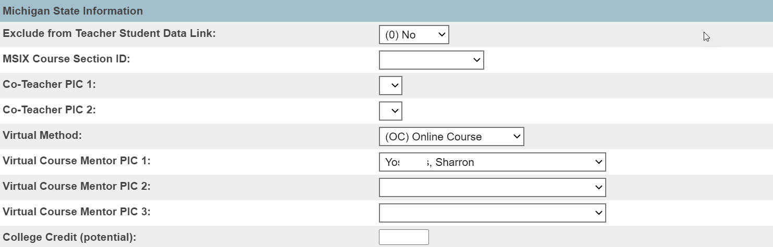
Teachers must be listed in the Teacher – Section Lead or in the Teachers/Staff – Additional portion of the Sections page to be listed in the Co-Teacher PIC dropdown lists.

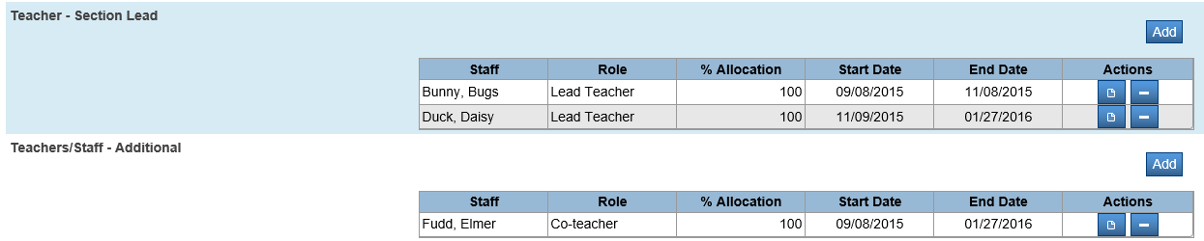
Teachers must be listed in the Teacher – Section Lead or in the Teachers/Staff – Additional portion of the Sections page to be listed in the Co-Teacher PIC dropdown lists.
Teachers must be listed in the Teacher – Section Lead or in the Teachers/Staff – Additional portion of the Sections page to be listed in the Co-Teacher PIC dropdown lists.

The Virtual Teacher or Mentor box must be set to Yes in the teacher’s information screen for the teacher to be listed in the Mentor Teacher dropdown lists.

School Setup – Sections

Multiple Lead Teachers
If your school has multiple lead teachers, the TSDL report will only include the PIC number for the teacher assigned at the end of the term.
If you want both teacher’s PIC numbers to be included, you need to enter the first teacher’s PIC number in one of the Co-Teachers PIC number boxes.

Additional Teachers/Staff
If your school assigns additional teachers/staff to the sections, the PIC numbers for these staff are not automatically included in the TSDL report.
If you want additional teachers/staff PIC numbers to be included, you need to enter their PIC numbers in the Co-Teachers PIC number boxes.
Only Daisy Duck’s PIC number will be included in the TSDL report because she is the teacher assigned at the end of the term.
To include PIC numbers for any other Lead Teachers, select the additional Lead Teachers one of the Co-Teacher dropdown boxes.

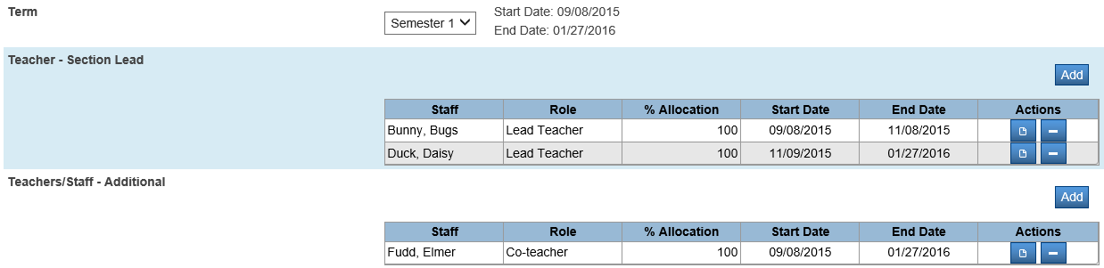
Additional Teachers/Staff PIC numbers are not automatically included in the TSDL report.
To include the PIC number for Additional Staff, select the staff in one of the Co-Teachers dropdown boxes.

School Setup - Staff
The Personal Identification Code is required staff setup for the Michigan Student Teacher Data Link.
- Start Page > Staff.
- Select Edit Information for existing staff members.
- Fill in the Personnel Identification Code (PIC).
- Select the Exclude Teacher-Student Data Link status.
- Select the Virtual Delivery Teacher or Mentor status.
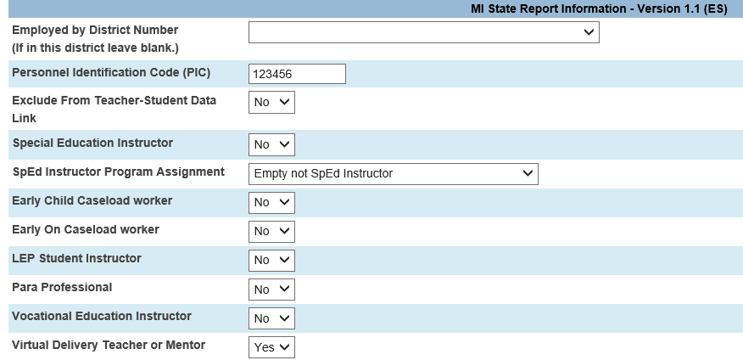
Select the teacher’s Virtual Teacher or Mentor status – Yes or No.
The Virtual Teacher or Mentor box must be set to Yes in the teacher’s information screen for the teacher to be listed in the Mentor Teacher dropdown lists.
Select the teacher’s Exclude from Teacher-Student Data Link status – Yes or No.
If Yes is selected, the teacher’s PIC Number will not be included in ANY TSDL records.
Enter the teacher’s PIC number.

School Setup - Staff

Data Element | Additional Information | [Table]Field Name
Name (Last, First MI) | Enter the name.  Note: Use the format: LastName, FirstName MiddleName | [Teachers]LastFirst  Field Length: Max 40  [Teachers]Last_Name  Field Length: Max 20  [Teachers]First_Name  Field Length: Max 20  [Teachers]Middle_Name  Field Length: Max 15
Personnel Identification Code (PIC) | Enter the Personnel Identification Code (PIC), as assigned in the Registry of Educational Personnel (REP), for a teacher responsible for the instruction of this course. | [S_MI_SSF_TSDL_X]repPIC  Field Length: 10
Exclude from Teacher Student Data Link | Select whether to include or exclude the staff member from the Teacher Student Data Link. | [S_MI_SSF_TSDL_X]excludeTSDL  Field Length: 1
Virtual Delivery or Mentor Teacher | Select if the staff member should be identified as a Virtual Delivery Teacher or Mentor Teacher.  Identified staff members will be used to populate the Virtual Delivery or Mentor Teacher pop-up menus on the Edit Section page. | [S_MI_SSF_TSDL_X]teacherVirtual  Field Length: 1

School Setup – Final Grade Setup
The following data elements are required for school setup.
- Start Page > School > Final Grade Setup.
Note: It is recommended to have the final grade store codes in the Final Grade Setup page match the Term durations of the Sections in your school. For example, the sections in your school have Terms of Semester One and Semester Two, then it is recommended that you have S1 and S2 Final Grade Store Codes.

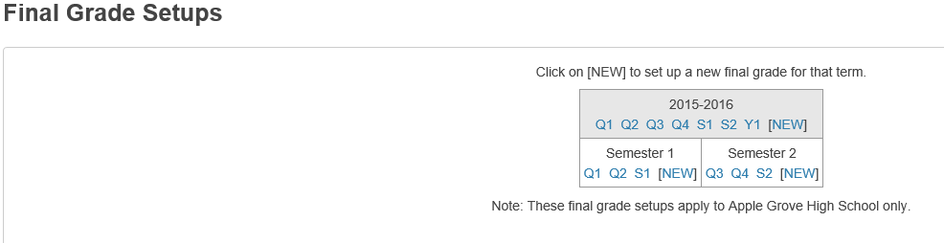
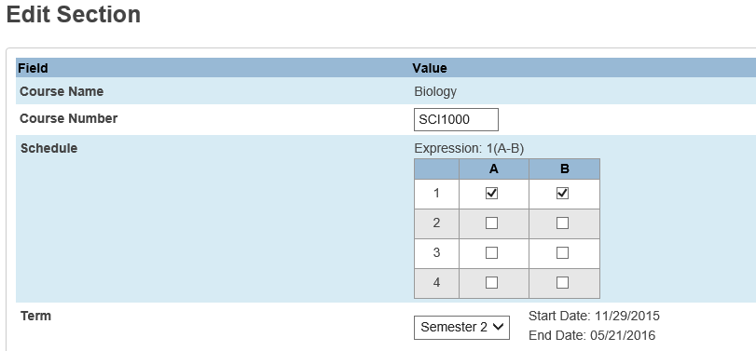

For your data to populate into the NEW TSDL reports, the term code must have the “Include Final Grade in TSDL reporting” checkbox checked on each term code that should be submitted.
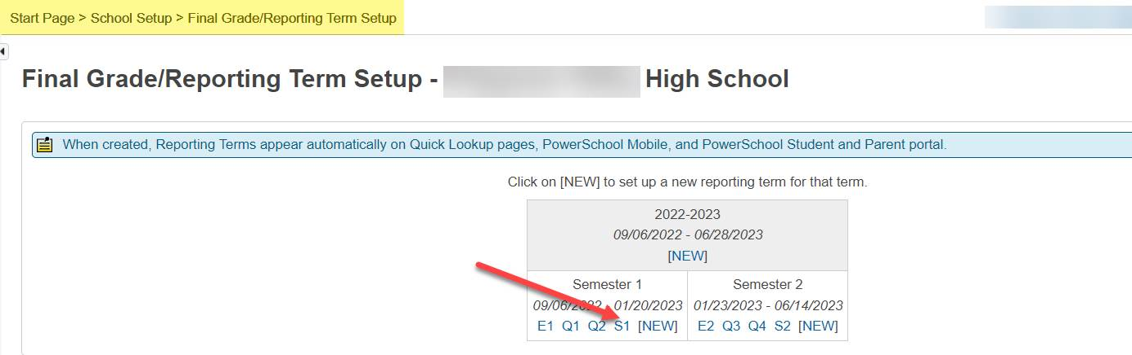
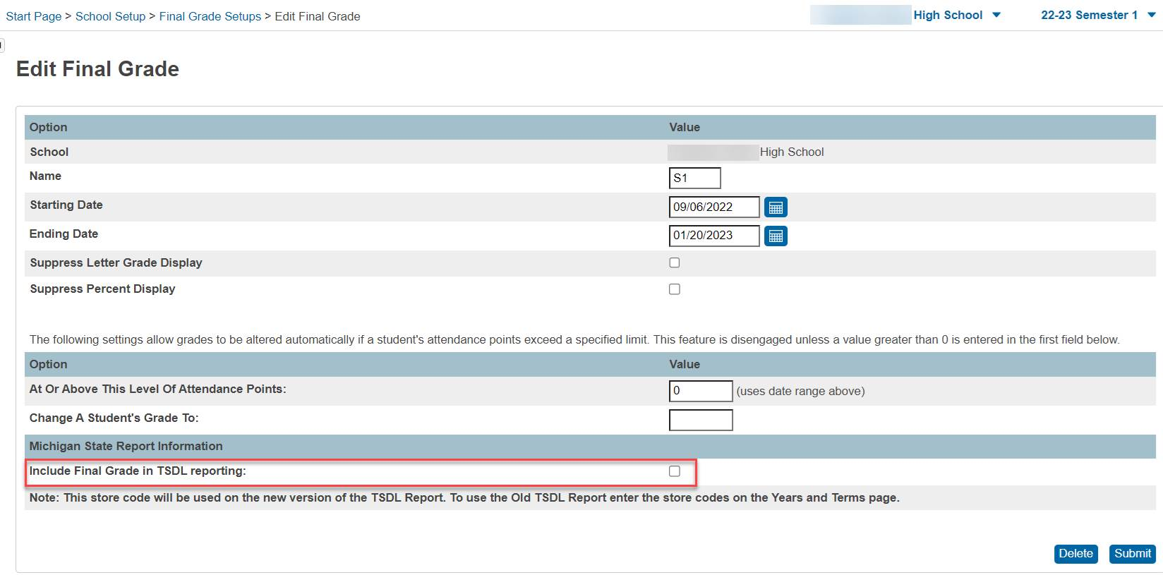

NOTE: You must select the term code for the scheduling term bucket that is scheduled with.
Example: if you schedule on semester length classes and you want the quarter grade to pull in the TSDL report, you would select the Q1 code underneath the Semester 1 bucket and then check the “Include Final Grade in TSDL reporting” box. See example screenshot below.
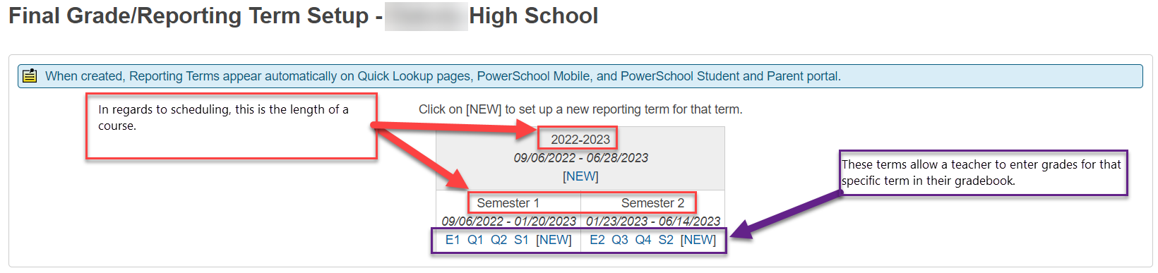

Note: For the Elementary levels, you must have a Y1 underneath the year long bucket. This is so that a Completion Status of CP will export. The dates must be the same dates as the entire year.

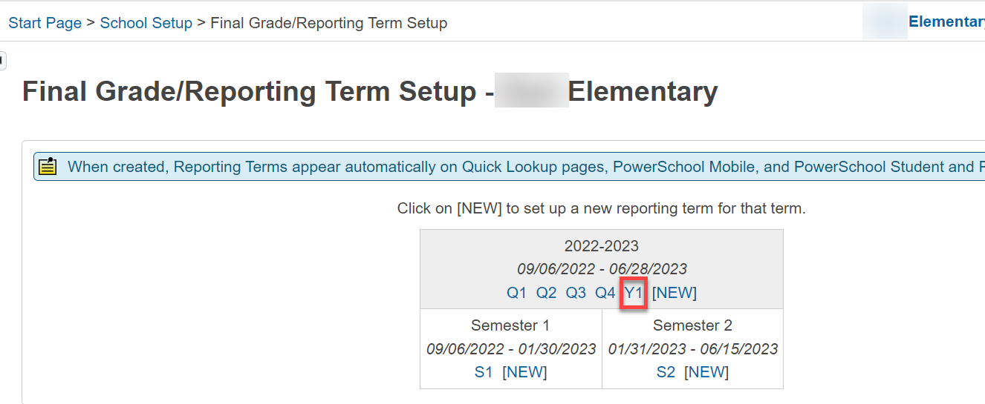

School Setup – Storing Grades

Courses Taken at a Different School
When storing grades for students enrolled in courses at a different school within your district, make sure to select the option to Store grades for classes enrolled at All schools and select the option to Record the school name of The other school.
These options will ensure that the classes are stored with a correct section ID that is connected to the school where the class was actually taken and the class is connected to the correct school name where the class was actually taken.

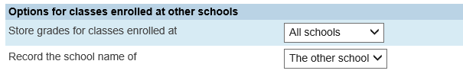

Manually Entering Grades into Historical Grades
When manually entering Historical Grades for a student that your district will be responsible for reporting in TSDL, it is important to enter an associated course and section number.

School Setup – Average Final Grades
TIP: If you are averaging a final grade into a newly created store code, that store code also has to be added to Final Grade Setup, the Final Grade Store Code(s) in the Schools/School Info page, and the Term Store Code Mapping.

If the Final Grade Store Codes do not match the Section Term Durations, then you can use the Average Final Grades Function in PowerSchool to create the Final Grade Store Code that matches the Section Term Duration.

The following steps are required to use the Average Final Grade Function.
- Start Page > System > Average Final Grades.
- Select which students to include.
- Enter the new Store Code, S1 for example. Note: The first character must be a letter, and the second character must be a number.
- Enter the term to limit this action to: Semester 1, for example
- Enter the Store Codes to be averaged and the weight each store code should be given when calculating the average.
- Select how attendance is calculated.
- Select how Potential Credit is calculated.
- Select how Teacher Comments included.
- Enter any grades to be excluded from all grade scales.
- Select the method to be used when averaging grades.
- Select the Section ID to be stored.
- If you want to include alternate grade points in the calculation, verify that the box to include alternate grade points in the calculation is checked.
- If you want to store alternate grade points in the stored grade, verify that the box to store alternate grade points in the stored grades record is checked.
- If you want to overwrite existing stored grades, verify that the box to overwrite existing stored grades for this store code is checked.

School Setup – Average Final Grades
Average Final Grades functionality provides the ability to average a student's final grade from two separate sections or the same section of a course so that an overall grade may be assigned for the course. The calculation uses GPA points or the Percent value from the historical grade record. The result of the calculation is stored as a new record in the Stored Grades table.
This process is intended for schools who have not given a final grade in the historical grade store codes that match the duration specified in the section. For example, you have a year long section and give the student a grade at each quarter but never give a year long grade. In order for TSDL to pull the grade, there needs to be a grade in the year long store code. In this case some schools use the Averaging Grades function in PowerSchool and create a year long store code (usually Y1) to calculate and store a grade. Now this Y1 stored grade will match the year long duration specified in the section and will pull with the TSDL Report.
Before running the average final grades process, you should verify that your existing stored grades are accurate.
Note: CEPI states that when reporting courses in TSDL, course grades should not be averaged unless you are also reporting the averaged grade on the student’s academic record.

Grade Scale Settings for Average Final Grades
To edit the grade scale, navigate to Start Page > District > Grade Scales > Edit Scale > Grade.
Exclude from Average Final Grade Calculation:
This option allows users to exclude a grade from the AFG calculation. Any record with this grade is excluded from the AFG calculation.
Alternative Grade Points:
This value can be used in two ways.
- If "Use Alternate Grade Points in Calculation" is selected when Averaging the Final Grades, then the value in this box is
used in the calculation instead of the gpa point value in the stored grade record.

- If "Store Alternate Grade Points in Stored Grades Record" is selected, then after the average calculation is complete,
alternative grade points are used instead of the grade points.

Cutoff Points:
Cutoff points are always used in the AFG calculation when an average has been calculated and a grade must be determined. The cutoff points work exactly the same as Cutoff Percentages currently work. (Typically cutoff points are out of 4 where cutoff percents are out of 100.)
School Setup – Average Final Grades

Average Final Grades Parameters
To use the Average Final Grade function, navigate to Start Page > System > Average Final Grades.
Which Students:
This option allows the user to select currently enrolled students, a selection, or the recently viewed student.
New store code:
Indicates the store code to associate with the final grade. Enter a valid store code (a letter followed by a single number).
Note: The store code does not need to be defined in the Final Grade Setup section of School Setup.
Term selector:
PowerSchool will average stored grades from sections associated to at term selected, within the current school year.
Use these final grades:
- Store Code: Specify which store codes from existing stored grades this year to average. PowerSchool will determine
which grades to be averaged based on the specified store code and matching students and course numbers.

- Weight: This can be a percentage or a weight. For example, specify two store codes with an equal weight of 50, or
specify each store code as having a weight of 1. In this case they would calculate the same.

If there aren't any stored grade records a store code, PowerSchool ignores the preference and calculates based on the remaining stored grades.
Absences and tardies are:
This option allows the user to handle attendance.
Potential credit is:
This option allows the user to decide how to handle potential credit. The Average Final Grade Process follows the same logic for Earned Credit.
Teacher comments are:
This option allows the user to decide how to handle Teacher Comments.

School Setup – Average Final Grades

Average Final Grades Parameters
For these grade scales, do not assign these grades (comma-separated):
After the grades are all calculated this option determines which grades will not be chosen from the grade scale to be written in the new stored grade record. Enter a comma-separated list of letter grades that you want to excluded, such as WF (withdraw fail), I (incomplete), etc.
Calculate average using:
This option allows the user to choose which averaged values to use to determine the resulting letter grade.
When using Grade Points, the Percent will still be a result of the average of the percent fields from the stored grades records. The Grade Points setting uses the point cutoff from the grade scale.
When using Percent, then the gpa points are not calculated. Instead they are pulled from either the Grade Points or the Alternative Grade Points in the related Grade Scale Item, depending on the Store Alternate Grade Points in the Stored Grades Record.
If "Use Alternate Grade Points in Calculation" and "Store Alternate Grade Points in Stored Grades Record" are unchecked Grade Points are used, PowerSchool averages the original points from the subordinate grades. Po Then uses the cutoff points in gradescale to determine which grade to select. The new grade is awarded the points based on the Grade Point value in the grade scale.
Store which Section ID (where possible):
When stored grade records associated with Section IDs are used in the Average Final Grade Process, it is possible for the sectionID populated in the new historical grade when possible.
Use Alternate Grade Points in Calculation:
This option causes PowerSchool to use the Alternate Grade Point value from the grade scale, rather than the GPA points from the stored grades record. Those values are then averaged together and the result is compared with the Cutoff Points. If "Store Alternate Grade Points in Stored Grade Record is used," PowerSchool will award the Alternate Grade Points.
Store Alternate Grade Points in Stored Grades Record:
Once the grades are averaged together and a resulting grade is chosen, then the points awarded to the resulting record are designated from the Alternate Points value from the related grade scale item.
Overwrite Existing Stored Grades Records:
This option allows the user to overwrite an existing stored grade if one exists for the new grade generated by this process.

School Setup – Average Final Grades

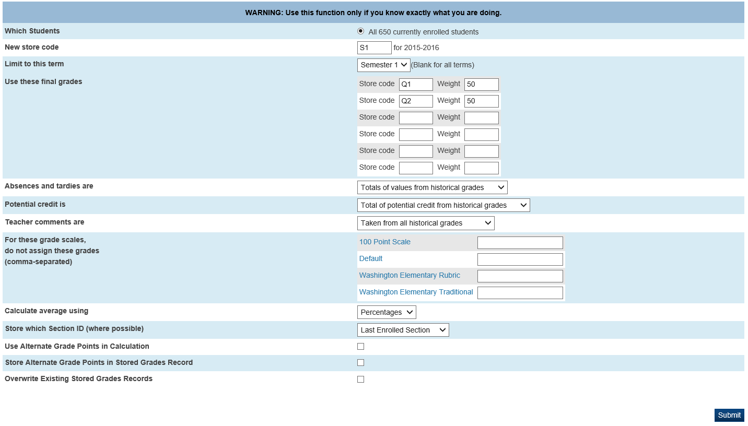
New Store Code
Limit to the Term for the Store Code
Term Store codes being averaged
Weight Terms evenly
Percentages averages the percent in the Store Grades to accurately calculate the new stored grade
Assigns the section ID from the first or last section that the student was enrolled in for the specified term

Student – All Enrollments
The Completion Status, Virtual Delivery Method, and Exclude from Teacher-Student Data Link status can be manually updated for individual student courses through the All Enrollments page.

Manually Updating Student’s Completion Status
To update the Completion Status manually for individual courses, do the following:
- Select the student.
- Click the All Enrollments link in the student menu on the left side of the screen.
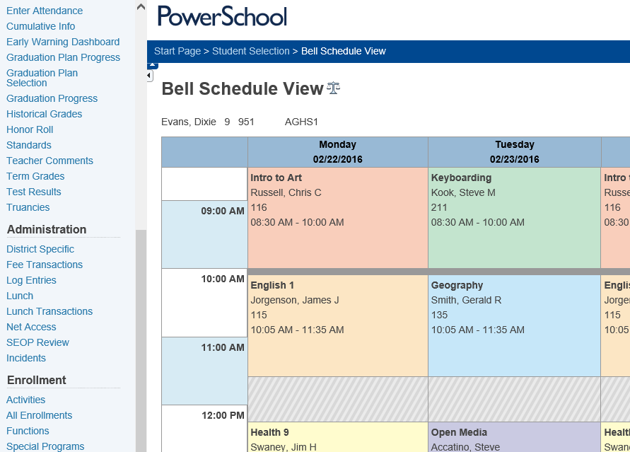
Student – All Enrollments
- Click the Edit link next to the course that you would like to update the Completion Status for.
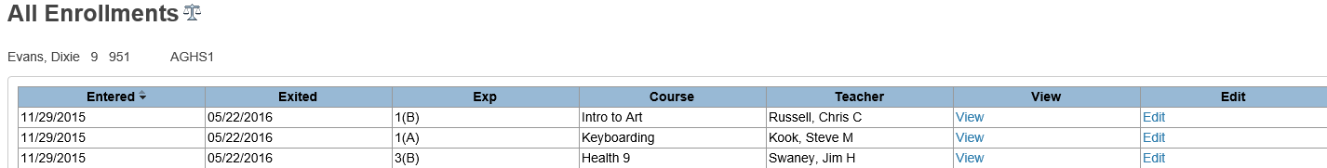
- Select the proper Completion Status from the Completion Status dropdown menu in the Michigan State Information section.
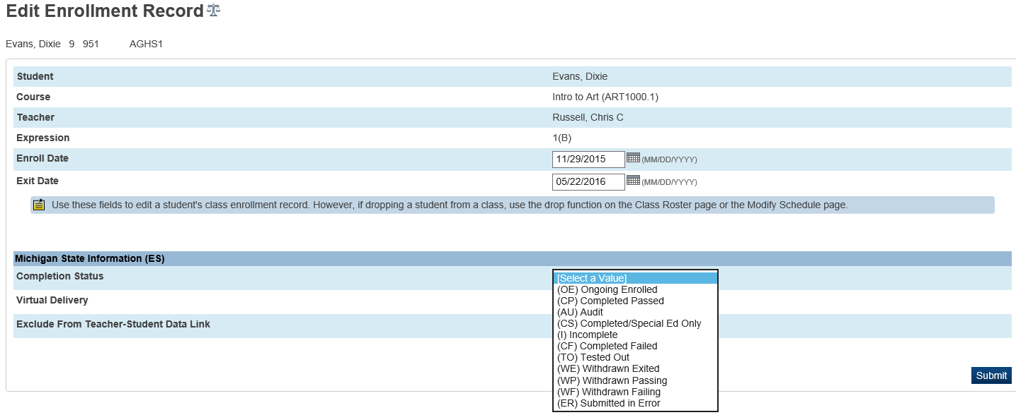
- Click Submit to save the record.

Student – All Enrollments

Manually Updating Student’s Virtual Delivery Method
To update the Virtual Delivery Method manually for individual courses, do the following:
- Select the student.
- Click the All Enrollments link in the student menu on the left side of the screen.
Student – All Enrollments
- Click the Edit link next to the course that you would like to update the Completion Status for.
- Select the proper Virtual Delivery Method from the Virtual Delivery dropdown menu in the Michigan State Information section.
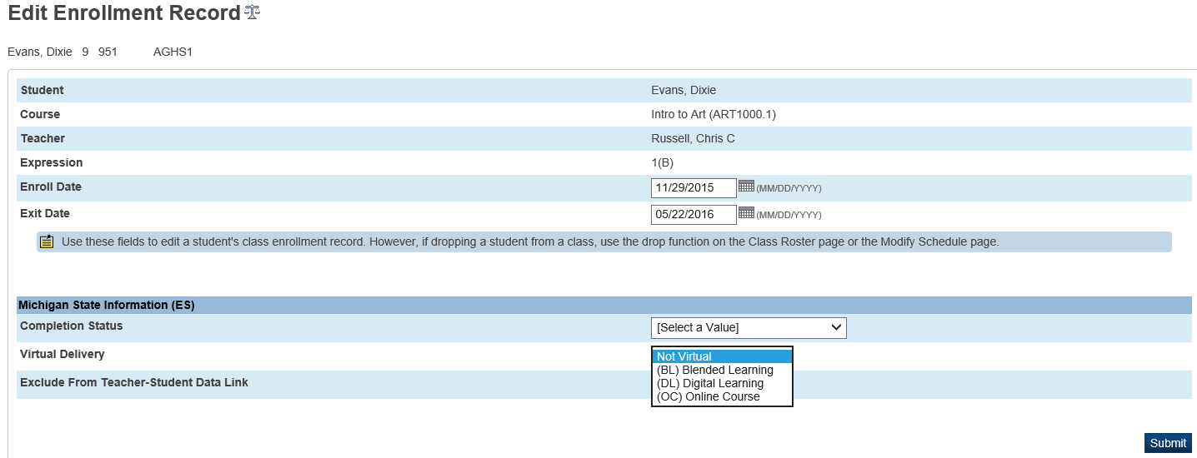
- Click Submit to save the record.

Student – All Enrollments

Manually Updating Student’s Exclude From Teacher-Student Data Link Status
To update the Exclude From Teacher-Student Data Link status manually for individual courses, do the following:
- Select the student.
- Click the All Enrollments link in the student menu on the left side of the screen.
Student – All Enrollments
- Click the Edit link next to the course that you would like to update the Completion Status for.
- Select the proper Exclude From Teacher-Student Data Link status from the Exclude From Teacher-Student Data Link dropdown menu in the Michigan State Information section.
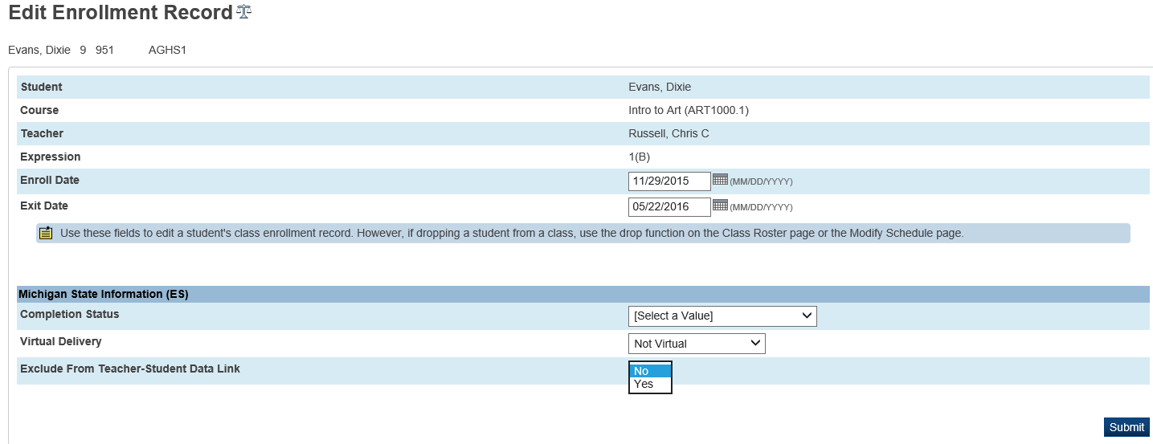
- Click Submit to save the record.

Student – Historical Grades
The student’s historical grades are an important part of the Teacher Student Data Link submission. The historical grades are used to calculate the completion status when using the Term Store Code Mapping and Grade Mapping capabilities in PowerSchool. It is crucial that the student’s historical grades have an associated section and an associated grade scale.
To verify this click on the student’s historical grade:
- Click on the student’s historical grade.
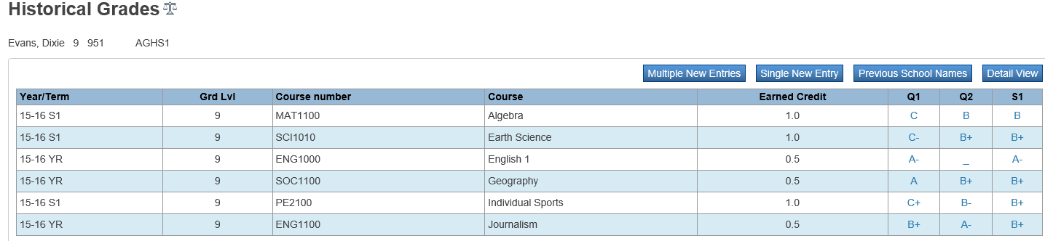
- Verify the following information in the historical grade: the grade has an associated section, an associated grade scale, and that the TermID, Store Code and section Term Duration all match.
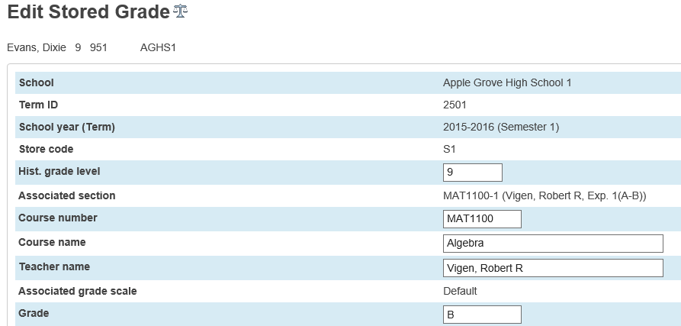
Associated Grade Scale
Associated Section
TermID, Term Duration of the Section and Store code should all match.
Per the PowerSchool SIS Michigan documentation:
“If overrides are needed, the override options for this report are at the Course, Section, All Enrollment and Historical Grade (StoredGrades) levels. The rules are as follows
- Historical Grades (StoredGrades) overrides will supersede all other overrides with the following exceptions:
  - If the All Enrollment is set to 'Exclude from TSDL' the section will not report in TSDL, unless there is a Historical Grade given for a dropped section.
  - If there is a historical grade for a store code in a dropped section, the historical grade will report in the TSDL - New report.
- All Enrollment overrides will supersede Course and Section overrides.
- Section overrides supersede Course overrides.
- The Course override does not override any other override that exists.”

Student – Historical Grades – College Credits
Students who are taking college courses and receiving high school and college credits can be submitted in TSDL with BOTH high school and college credits attached to the course. The high school credits come from the course file. The college credits need to be entered at the bottom of the student’s historical grade.
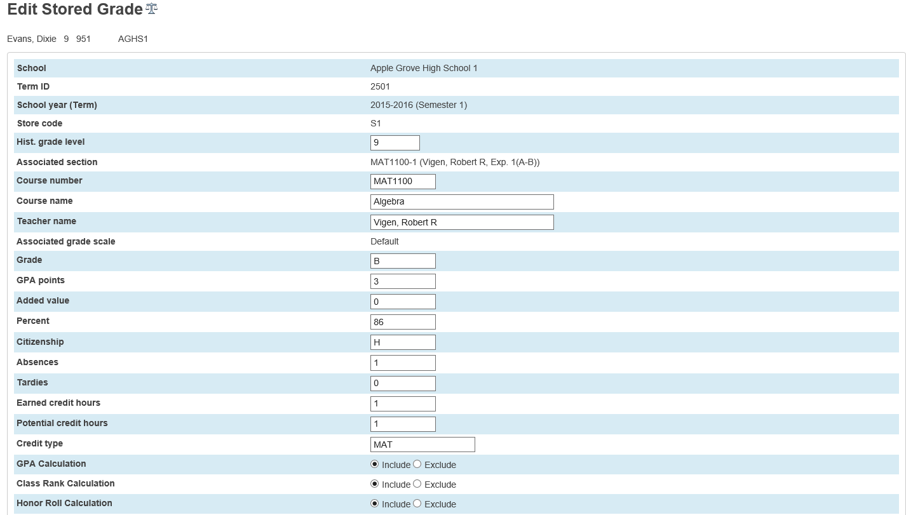
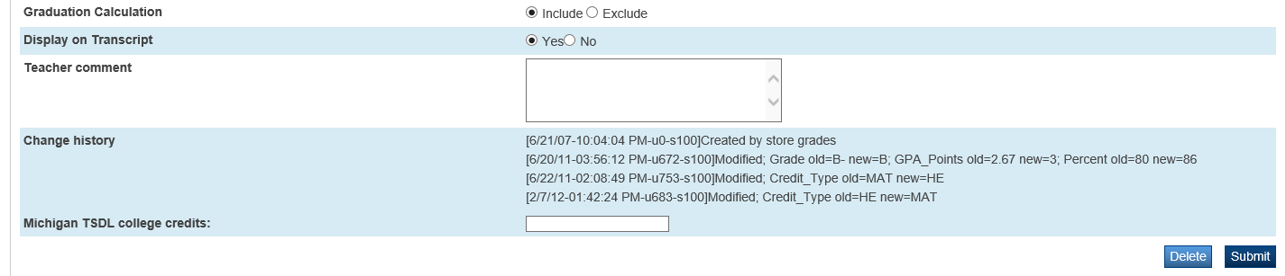

Reports
Generate these reports to collect information for the parameters you specify. You need to set up correct reporting criteria in order to run a successful report. Output display and data varies per report.

Understanding the Report Output Table
The report output tables in this guide include the following elements:
- Item # or Position – Either the numerical order of the data element (first element is 1, second element is 2), or the position in the report. For example, if there is a string of data elements, such as 2009YNYN08091989, the particular element may start at position 5. In this example, position 5 is Y.
- Data Element – The name of the data element.
- Description – Additional information about the data element, including state reporting rules.
- [Table] – The name of the table where the data is stored.
- Field Name – The name of the field where the data is stored.
Note: The Table name appears in brackets with the Field Name directly following. Example: [Table]FieldName.
- Data Type – The field type used for the data element, such as character string, numeric, etc.
- Field Length – The length of the data element when extracted.
- Begin/End Position – The position of the data element in the report. For example, if there is a string of data elements, such as 2009YNYN08091989, the particular element may start at position 5. In this example, position 5 is Y.

Report Descriptions
The following reports are included in this guide.
Report Name | Description | Due Date / Cycle
Michigan Student Data System (MSDS) Data Collections
MI MSDS Setup Validation | This will create the MI MSDS Setup Validation report. Use this to validate MSDS setup data for non-student tables. | As required
MI Teacher Student Data Link (TSDL) Validation - NEW | This will create the MI Teacher Student Data Link (TSDL) Validation report. Use this report to validate TSDL state setup requirements.  This report will extract the same data that is generated with the MI Teacher Student Data Link (TSDL) collection in a readable CSV format. | As required
MI Teacher Student Data Link (TSDL) - NEW | This will create the Teacher Student Data Link (TSDL) Collection XML export file used for submission to the Michigan Student Data System (MSDS). | Refer to the following link for due dates and submission cycles: http://mi.gov/cepi/0,4546,7-113- 72089---,00.html  Refer to the following link for additional information on the Teacher Student Data Link (TSDL) Collection: http://mi.gov/cepi/0,4546,7-113- 986_50502_57560---,00.html

MI MSDS Setup Validation
This will create the MI MSDS Setup Validation report. Use this to validate MSDS setup data for non-student tables. The report will list the records failing validation along with their associated error messages.
The following list of tables are validated:

- Courses
- CC
- GradeScaleItem
- PGFinalGrades
- Sections
- Schools
- SchoolStaff
- StoredGrades
- Students
- Terms

Selection Criteria
Selection criteria determine which database records are used in the report. Refer to selection criteria for analysis when the report does not return the correct records.
Record Selection
The report selects records based on the following criteria:
- Setup elements are invalid or need verification.

Report Input
To generate the MI MSDS Setup Validation report do the following:
- On the Start Page, click System Reports. The Reports page appears.
- Click the State tab. The State Reports page appears.
- Click MI MSDS Setup Validation. The MI MSDS Setup Validation page appears.
- Enter information in all of the required fields.
Note: Select the checkbox next to the filter fields to save the settings as defaults. To select all checkboxes, choose Select All from the pop-up menu. To clear all checkboxes, choose Clear All.
- Click Submit to generate the report.
Field | Description
Reporting District’s State Assigned 5-digit District Number | Enter the reporting district’s state assigned 5-digit district number.
First Day of School | Enter the date of the first day of school.

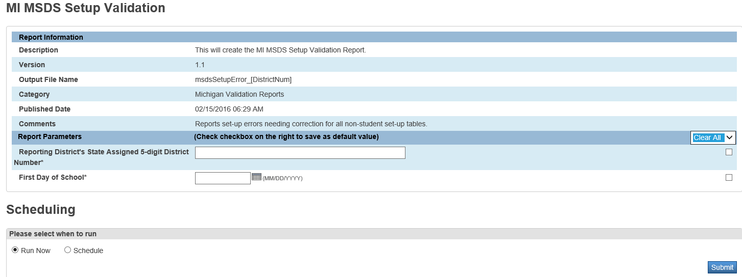
Reporting District’s State Assigned 5-digit District Number
Enter the reporting district’s state assigned 5-digit district number.
First Day of School
Enter the date of the first day of school

Report Output
Each of the fields displayed in the output of the report are described below. See Understanding the Report Output Table for a definition of each column in the table.
Item # | Data Element | Description | [Table]FieldName
1 | Table | This contains the table name where the record exists. | N/A
2 | C1 | This contains identifying information for the record. | [Courses] [CC]  [GradeScaleItem] [PGFinalGrades] [Sections] [Schools] [SchoolStaff] [StoredGrades] [Students] [Terms]
3 | C2 | This contains identifying information for the record. | [Courses] [CC]  [GradeScaleItem] [PGFinalGrades] [Sections] [Schools] [SchoolStaff] [StoredGrades] [Students] [Terms]
4 | Date | This contains the date of the record, if applicable. | [Courses] [CC]  [GradeScaleItem] [PGFinalGrades] [Sections] [Schools] [SchoolStaff] [StoredGrades] [Students] [Terms]
5 | C3 | This contains identifying information for the record. | [Courses] [CC]  [GradeScaleItem] [PGFinalGrades] [Sections] [Schools] [SchoolStaff] [StoredGrades] [Students] [Terms]
6 | Message | This contains the error or verification message for the record. | N/A

MI Teacher Student Data Link (TSDL) Validation - NEW
This will create the MI Teacher Student Data Link (TSDL) Validation report. Use this to display the same TSDL submission data that is submitted to the state in the MI Teacher Student Data Link (TSDL) export file. The report will list errors messages for those records that may need correction or verification.

Selection Criteria

Student Selection
Student records are selected based on the following criteria:
- The student had a school enrollment record between the Date From date and Date To date entered in the report parameters. ([Students]EntryDate, [Students]ExitDate, [ReEnrollments]EntryDate, [ReEnrollments]ExitDate)
- The student is included in state reporting. ([Students]State_ExcludeFromReporting=0)

Course Selection
Course records are selected based on the following criteria:
- The Date Enrolled in the student’s CC record is less than the last day of the term for the section and the Date Left in the student’s CC record is after the first day of the term for the section. ([CC]DateEnrolled<[Terms]LastDay) ([CC]DateLeft>[Terms]FirstDay)

Report Input
To generate the MI Teacher Student Data Link (TSDL) Validation report, do the following:
- On the Start Page, click System Reports. The Reports page appears.
- Click the State tab. The State Reports page appears.
- Click MI Teacher Student Data Link (TSDL) Validation. The MI Teacher Student Data Link (TSDL) Validation page appears.
- Enter information in all of the required fields.
Note: Select the checkbox next to the filter fields to save the settings as defaults. To select all checkboxes, choose Select All from the pop-up menu. To clear all checkboxes, choose Clear All.
- Click Submit to generate the report.
Field | Description
Current Selection Students | Select whether to run the export file for the selected number of students or for all students.
Report Output File | Select Error Report or Submission File
Migrant Students Only | Select whether to run the export file for migrant students only or for all students.
Limit to Migrant, Virtual, DE, EMC, AP, IB students | Select whether to run the export for the required students only – Migrant students and students enrolled in a virtual, dual enrollment, advanced placement, or international baccalaureate course, and early middle college students.
Elementary Ungraded Withdrawal | Select the value for the export file to use for elementary students that were withdrawn from a section and were also ungraded.
Entity Type Code | Select the entity type code.
Entity Code | Enter the entity code.
Reporting District’s State Assigned 5-digit District Number | Enter the reporting district’s state assigned 5-digit district number.
First Day of School | Enter the date of the first day of school.
Date From | Enter the date from (start date) for the date range.
Date To | Enter the date to (end date) for the date range.
Select schools to export. If none are selected the export will run for the entire district. | Select which schools to export if applicable.
Exclude Classes Days | Exclude student section enrollments where their enrollment in the section was less than the value entered.

Report Output
Each of the fields displayed in the output of the report are described below. See Understanding the Report Output Table for a definition of each column in the table.
Item # | Data Element | Description | [Table]FieldName
1 | School | This contains the school name for the associated record. | [Schools]Name
2 | Teacher | This contains the teacher name. | [Users]LastFirst
3 | Course | This contains the course name. | [Courses]Course_Name
4 | Section ID | This contains the section ID number. | [CC]SectionID
5 | Student | This contains the student name. | [Students]LastFirst
6 | Course# | This contains the course number. | [Courses]Course_Number
7 | Section# | This contains the section number. | [Sections]Section_Number
8 | Student# | This contains the student number. | [Students]Student_Number
9 | Grade Level | This contains the grade level. | [Students]Grade_Level
10 | Migrant | This identifies if the student is migrant. | [S_MI_STU_GC_X]flagMigrant
11 | Out Level | This identifies if the student is out of grade level. | [S_MI_STU_GC_X]flagOutOfLevel
12 | Date In | This contains the date the student entered the section. | [CC]DateEnrolled
13 | Date Out | This contains the date the student exited the section. | [CC]DateLeft
14 | SCED Subject | This contains the two-digit Subject Area Code.  Refer to the following links for additional information:  http://nces.ed.gov/pubsearch/pubsinfo.asp?pubid=2007341  http://nces.ed.gov/pubsearch/pubsinfo.asp?pubid=2011801 | [S_MI_CRS_TSDL_X]SCEDsubjectCode
15 | SCED Course | This contains the three-digit Course Identifier Code.  Refer to the following links for additional information:  http://nces.ed.gov/pubsearch/pubsinfo.asp?pubid=2007341  http://nces.ed.gov/pubsearch/pubsinfo.asp?pubid=2011801 | [S_MI_CRS_TSDL_X]SCEDcourseCode
Item # | Data Element | Description | [Table]FieldName
16 | Course Type | This contains the code that best represents the level and rigor of the course.  Refer to the Appendix for a list of valid codes. | [S_MI_CRS_TSDL_X]courseType
17 | Credits | This contains the amount of credits earned. | [StoredGrades]EarnedCrHrs
18 | Grade | This contains the course grade earned. | [StoredGrades]Grade
19 | Status | This contains the completion status. | Calculated
20 | PIC 1 | This contains the PIC number associated with the record. | [S_MI_SSF_TSDL_X]repPIC
21 | PIC 2 | This contains the PIC number associated with the record. | [S_MI_SSF_TSDL_X]coTeacher1
22 | PIC 3 | This contains the PIC number associated with the record. | [S_MI_SSF_TSDL_X]coTeacher2
23 | Method | This contains the code that represents the Virtual Delivery method of the course. | [S_MI_CC_TSDL_X]virtualDelivery
24 | Virtual Course Mentor PIC 1 | This contains the mentor teacher PIC number associated with the record. | [S_MI_SEC_TSDL_X]mentorTeacher1
25 | Virtual Course Mentor PIC 2 | This contains the mentor teacher PIC number associated with the record. | [S_MI_SEC_TSDL_X]mentorTeacher2
26 | Virtual Course Mentor PIC 3 | This contains the mentor teacher PIC number associated with the record. | [S_MI_SEC_TSDL_X]mentorTeacher3
27 | College Credit | This contains the amount of college credits earned. | [S_MI_SGR_TSDL_X]collegeCredits
28 | Message | This contains the error or verification message for the record. | N/A
29 | Rule# | This contains the CEPI business rule number. | N/A

MI Teacher Student Data Link (TSDL) Collection - NEW
This will create the MI Teacher Student Data Link (TSDL) XML export file. Use this to export out all information that is required for the Teacher Student Data Link submission to the state.
The TSDL collection is used to report links between students and the teacher(s) who provide instruction to them. Data reported in the collection reflect the student's performance in classes taken throughout the current academic year and the status of his/her academic report at the end of the school year.
Note: The Michigan Teacher Student Data Link collection MUST be run prior to completing the End of Year Process to ensure that students are reported in the proper grade and building.

This report does not populate the completion status on the Student All Enrollment page. The completion status is included in the export and determined using the grade mapping and store code mapping settings.

Selection Criteria
Selection criteria determine which database records are used in the report. For the Michigan Teacher Student Data Link, student and course records are selected.
Course Selection
Course records are selected based on the following criteria:
- The Date Entered is less than End Date and the Date Left is after the Start date.
Student Selection
Student records are selected based on the following criteria:
- The student has an enrollment date that falls between the Start and End Dates.
- The student is included in state reporting. ([Students]State_ExcludeFromReporting=0)

When using the MI Teacher Student Data Link report option to limit to the required students, the additional selection criteria are as follows:
Migrant Students:
- Migrant students are included if the Migrant Student checkbox in the Program Eligibility section of the General 5-19 tab of the State/Province-MI page is selected.
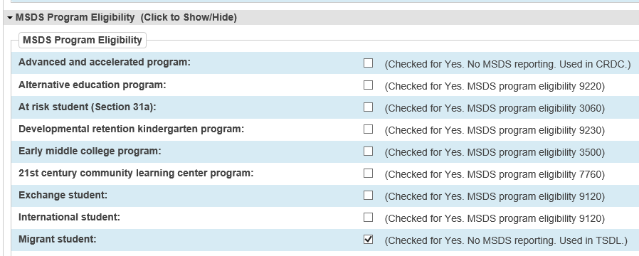
Dual Enrollment (DE) / Early Middle College (EMC) Students:
- Dual Enrollment/Early Middle College Students are included if they are enrolled in a course with a Dual Enrollment/Early Middle College course (Course Type 07).
(07) Dual Enrollment / Early Middle College (Courses > Course Type)
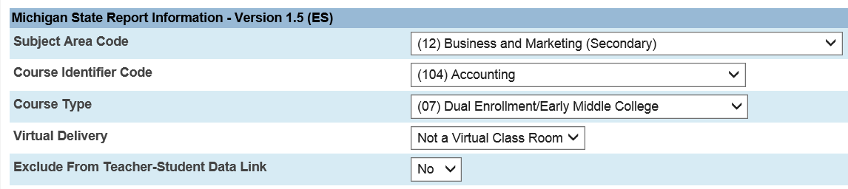
Advanced Placement (AP) or International Baccalaureate (IB) Students:
- Any student enrolled in a course with an Advanced Placement course (Course Type 04) or an International Baccalaureate course (Course Type 05).
(04) Advanced Placement (Courses > Course Type)
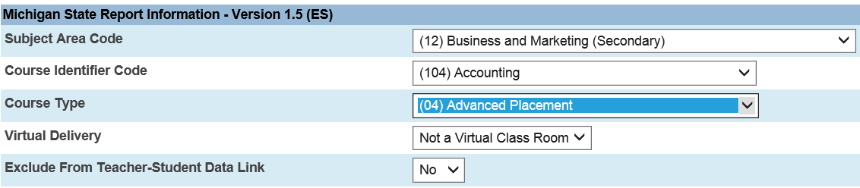

(05) International Baccalaureate (Courses > Course Type)
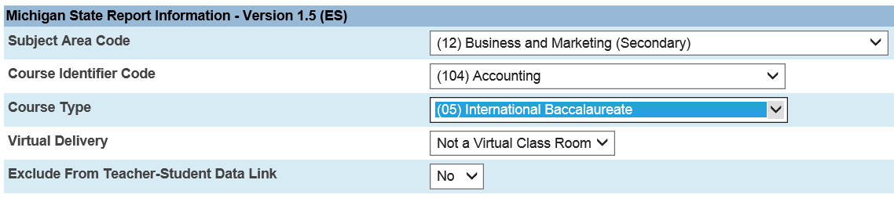
Students Enrolled in Virtual/Online Learning:
Students enrolled in a Virtual/Online Learning course with a virtual method selected.
Virtual Delivery (Courses > Virtual Delivery)
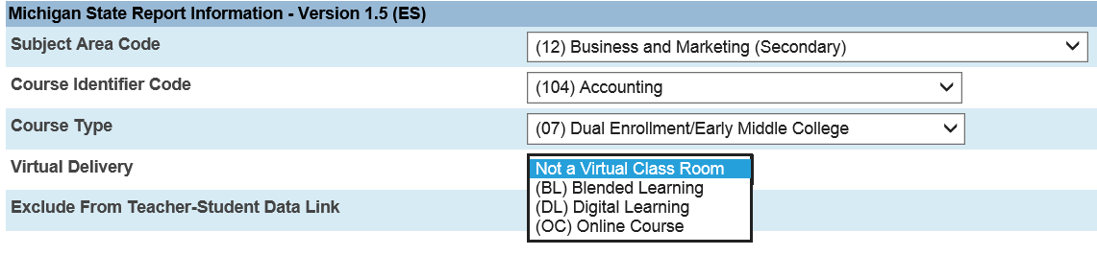

Students enrolled in a Virtual/Online Learning section with a virtual method selected.
Virtual Delivery (Section > Virtual Delivery)
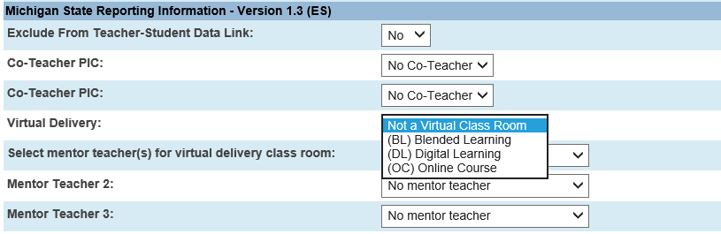

Generate Reports
To generate the Michigan Teacher Student Data Link report, do the following:
- On the Start Page, click System Reports. The Reports page appears.
- Click the State tab. The State Reports page appears.
- Click MI Teacher Student Data Link (TSDL). The MI Teacher Student Data Link (TSDL) Report page appears.
- Enter information in all of the required fields.
Note: Select the checkbox next to the filter fields to save the settings as defaults. To select all checkboxes, choose Select All from the pop-up menu. To clear all checkboxes, choose Clear All.
- Click Submit to generate the report.

Report Input
Each of the available run options and required and optional data fields for the report are described below.
Field | Description
Current Selection Students | Select whether to run the export file for the selected number of students or for all students.
Migrant Students Only | Select whether to run the export file for migrant students only or for all students.
Include Early On/Early Child Students | Select whether to include Early On/Early Childhood students in the export
Limit to Migrant, Virtual, DE, EMC, AP, IB students | Select whether to run the export for the required students only – Migrant students and students enrolled in a virtual, dual enrollment, advanced placement, or international baccalaureate course, and early middle college students.
Elementary Ungraded Withdrawal | Select the value for the export file to use for elementary students that were withdrawn from a section and were also ungraded.
Entity Type Code | Select the entity type code.
Entity Code | Enter the entity code.
Reporting District’s State Assigned 5-digit District Number | Enter the reporting district’s state assigned 5-digit district number.
First Day of School | Enter the date of the first day of school.
Date From | Enter the date from (start date) for the date range.
Date To | Enter the date to (end date) for the date range.
Select schools to export. If none are selected the export will run for the entire district. | Select which schools to export if applicable.
Exclude Classes Days | Exclude student section enrollments where their enrollment in the section was less than the value entered.
Report Input
Current Selection Students
This report can be run for all students or a selected group of students
Migrant Students Only
Select whether to run the export file for migrant students only or for all students
Include Early On/Early Child Students
Select whether to include Early On/Early Childhood students in the export
Limit to Migrant, Virtual, DE, EMC, AP, IB students
Select whether to run the export for the required students only – Migrant students and students enrolled in a virtual, dual enrollment, advanced placement, or international baccalaureate course, and early middle college students.
Elementary Ungraded Withdrawal
Select the value for the export file to use for elementary students that were withdrawn from a section and were also ungraded
Entity Type Code
Select the entity type code
Entity Code
Enter the entity code
District Number
Enter the reporting district’s state assigned 5-digit district number
First Day of School
Enter the date of the first day of school
Date From
Enter the date from (start date) for the date range
Date To
Enter the end date (must be equal to or greater than the Exit Date for the course (Term End Date)
Select schools to export
Select which schools to export if applicable
Exclude ALL classes enrolled for less than X days
Enter the minimum number of days that a student must be enrolled in a course to be included in TSDL.

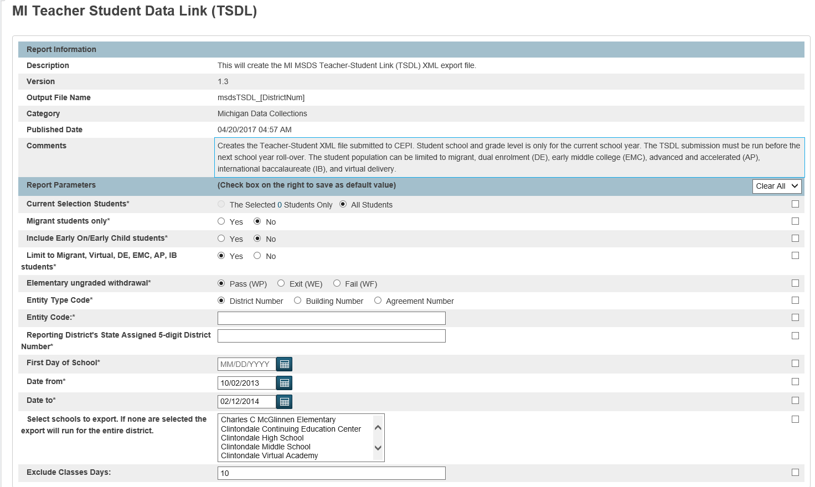

Report Output
Each of the fields displayed in the output of the report are described below. For documentation of XML report output from the state department of education, refer to the CEPI – Teacher Student Data Link Web page.
See Understanding the Report Output Table for a definition of each column in the table.
Item # | Data Element | Description | [Table]FieldName
Submitting Entity
1 | Submitting Entity Type Code | This field contains the value entered in the Submitting Entity Type Code on the Michigan Teacher Student Data Link Interface page, Reports > Run Reports > Michigan Teacher Student Data Link. The values are:  - D for district  - B for school building | N/A
2 | Submitting Entity Code | This field contains the submitting entity type value entered on the Michigan Teacher Student Data Link Interface page, Reports > Run Reports > Michigan Teacher Student Data Link. | N/A
Personal Core
3 | UIC | This field contains the student’s unique state-assigned identification number. This field value is extracted from the General tab, Student > State/Province – MI > General. | [Students]State_StudentNumber
4 | Last Name | This field contains the student’s last name. This field value is extracted from the General tab, Student > State/Province – MI > General. | [Students]Last_Name
5 | First Name | This field contains the student’s first name. This field value is extracted from the General tab, Student > State/Province – MI > General. | [Students]First_Name
6 | Middle Name | This field contains the student’s middle name. This field value is extracted from the General tab, Student > State/Province – MI> General. | [Students]Middle_Name
7 | Student Suffix | This field contains the abbreviated name suffix that follows the student’s full name (Jr, Sr, III, etc.). This field value is extracted from the General tab, Student > State/Province – MI > General. | [S_MI_STU_GC_X]stuNameSuffix
8 | Date of Birth | This field contains the student’s data of birth. This field value is extracted from the General tab, Student > State/Province – MI > General. | [Students]DOB
9 | Multiple Birth Order | This field identifies the birth order of the student if the student is part of a multiple birth where the siblings share all unique identifying characteristics, including a first and last name. This field value is extracted from the General tab, Student > State/Province – MI > General. | [S_MI_STU_GC_X]multipleBirth
10 | Gender | This field contains the code identifying the student’s gender. This field value is extracted from the General tab, Student > State/Province – MI > General. | [Students]Gender
School Demographics
11 | Operating ISD ESA Number | This field contains the Operating ISD/ESA number assigned to the district in which this student is enrolled. This field value is extracted from the General tab, Student > State/Province – MI > General. | [Prefs]Value  [Prefs]Name=MI_SCMOperISDEASNum  [S_MI_STU_GC_X]operISDESA
12 | Operating District Number | This field contains the number identifying the operating district. This field value is extracted from the District Information page, District Setup > District Information. | N/A
13 | School Facility Number | This field contains the state-assigned code for the student’s school. This field value is extracted from the General tab, Student > State/Province – MI > General. | [S_MI_SCH_TSDL_X]adminUnit  [S_MI_STU_GC_X]adminUnit
14 | Student ID Number | This field contains the number assigned to the student record in PowerSchool. This field value is extracted from the Demographics page, Student > Demographics. | [Students]Student_Number
15 | Grade Or Setting | This field contains the grade in which the student is enrolled  If the student is enrolled in a standard grade level then the student’s grade level is extracted from the Enrollment page, Transfer Information.  If the student is not enrolled in a standard grade level, this field contains the educational setting in which the student is enrolled. This field value is extracted from the General tab, Student > State/Province – MI > General. | [Students]Grade_Level  [Reenrollments]Grade_Level  Or  [S_MI_STU_GC_X]educSetting
16 | S2E2Code | This contains the school or relationship code (Educational Entity Master S2E2 code) for the student. | [S_MI_STU_GC_X]S2E2code
17 | OutofLevelGrade | This identifies whether the student is considered as being presently out of level grade in the Educational Entity Master. | [S_MI_STU_GC_X]flagOutOfLevel
Student Course
18 | Subject Area Code | This contains the two-digit Subject Area Code.  Refer to the following links for additional information:  http://nces.ed.gov/pubsearch/pubsinfo.asp?pubid=2007341  http://nces.ed.gov/pubsearch/pubsinfo.asp?pubid=2011801  This field value is extracted from the Course Information page, District Setup > Courses. | [S_MI_CRS_TSDL_X]NCESsubjectArea
19 | Course Identifier Code | This contains the three-digit Course Identifier Code.  Refer to the following links for additional information:  http://nces.ed.gov/pubsearch/pubsinfo.asp?pubid=2007341  http://nces.ed.gov/pubsearch/pubsinfo.asp?pubid=2011801  This field value is extracted from the Course Information page, District Setup > Courses. | [S_MI_CRS_TSDL_X]NCEScourseId
20 | Local Course Id | This field contains the course identification code assigned by the educating entity. The purpose is to allow the district to send student record updates for specific courses (e.g., interim grade, followed by final grade).  This field value is extracted from the Course Information page, District Setup > Courses. | [Courses]Course_Number
21 | Local Course Title | This field contains the course name assigned by the educating entity.  This field value is extracted from the Course Information page, District Setup > Courses. | [Courses]Course_Name
22 | Course Section ID | This field contains the course section number as it would appear on a student transcript. This code may be used in combination with the Local Course ID to differentiate between individual classes (e.g. First period Business Math versus second period Business Math, or a language arts course taught both virtually and in a traditional classroom).  This field value is extracted from the Sections page, School Setup > Sections. | [Sections]Section_Number
23 | Course Type | This field contains the code best representing the level and rigor of the instruction provided throughout the reported course.  If Code 07 is displayed, this course is identified as a college-instructed course for which the student will receive high school credit. The student may be participating in an Early/Middle College program or a dual enrollment program.  This field value is extracted from the Course Information page, District Setup > Courses. | [S_MI_CRS_TSDL_X]courseType
24 | Academic Year | This field contains the academic year in which the student last attended the course (e.g. 2010-2011). | Calculated from [Terms]YearID
25 | Credits Granted | This field contains the amount of credits granted to the student in Carnegie units for the course or a section of a course (e.g., 1.0, .50, .33, .25, .20).  This field value is extracted from the Historical Grades table, Student Selection > Historical Grades. | [StoredGrades]EarnedCrHrs
26 | Course Grade | This field contains the grade the student received for completing the course. These should be board approved grades. The grade reported as it would be reported on the academic record.  If a course for a student is recorded on his/her academic record, the course and student information is required to be submitted; regardless of whether or not a grade is reported on the academic record.  This field value is extracted from the Historical Grades table, Student Selection > Historical Grades. | [StoredGrades]Grade
27 | Completion Status | This field contains the code identifying the student's standing for this course when the student is no longer a participant.  This field is determined using the Grade Mapping table record for the grade scale, District Setup > Grade Scales. If the Completion Status field is not blank, then the Completion Status value is extracted.  - AU – The student attended the course without expecting or receiving credit.  - TO – The student took a test and received credit without having to take the course.  - OE – The special education student is reported in grade or setting 14 and is expected to continue in this same course next year. This requires the use of Subject Area Code "73" and Course Section ID "039". This status may also be used for any non-special education migrant student who is expected to continue in this same course and will be reported in a later submission when the course is completed.  - CP – The student completed the course, meeting at least the minimum expectations. | Calculated  [S_MI_CC_TSDL_X]CompletionStatus
 | Completion Status - continued | - CF – The student completed the course but did not meet the minimum expectations for passing.  - CS – the special education student has completed or aged out of the course. A course grade and credit are not applicable.  - WE – the student withdrew or exited the course before completion.  - WP – At the time the student withdrew or exited the course, he/she was passing the course.  - WF - At the time the student withdrew or exited the course, he/she was failing the course.  - I – At the time of this reporting, the student must meet additional requirements to receive a grade or credit for the course.  - ER – This status allows districts to mark a record that was submitted in error in a previous certified collection of the TSDL. Courses marked with this Completion Status will not be included in any reporting of TSDL data and will be considered as not submitted. | Calculated  [S_MI_CC_TSDL_X]CompletionStatus
29 | PIC | The Personnel Identification Code (PIC), as assigned in the Registry of Educational Personnel (REP), for each teacher responsible for some or all of the instruction of this course.  A maximum of 3 PICs per student and course may be reported.  This field value is extracted from the Sections page, School Setup > Sections. | [S_MI_SSF_TSDL_X]repPIC  [S_MI_SEC_TSDL_X]coTeacher1  [S_MI_SEC_TSDL_X]coTeacher2
30 | Virtual Method | This field indicates the type of virtual instruction the student is receiving. This could be virtual learning, online learning or computer courses; distance learning; or self-scheduled virtual learning. Valid values include:  - Not a Virtual Class Room.  This is a default setting and if chosen will not export the Virtual Method characteristic.  - BL – Blended Learning  A hybrid instructional delivery model where pupils are provided content, instruction, and assessment at a supervised educational facility where the pupil and teacher are in the same physical location and in part through internet-connected learning environments with some degree of pupil control over time, location, and pace of instruction. | [S_MI_CRS_TSDL_X]virtualDelivery  [S_MI_SEC_TSDL_X]virtualDelivery  [S_MI_CC_TSDL_X]virtualDelivery
 | Virtual Delivery - continued | - DL – Digital Learning  Instruction delivered via a web-based delivery system that uses various information technologies to provide a structured learning environment, including online and blended learning instructional methods.  - OC – Online Course  A course of study that is capable of generating a credit or a grade that is provided in an interactive internet-connected learning environment, where pupils are separated from their teachers by time or location, or both  This field value is extracted the Course, Section, or Student All Enrollments page. | [S_MI_CRS_TSDL_X]virtualDelivery  [S_MI_SEC_TSDL_X]virtualDelivery  [S_MI_CC_TSDL_X]virtualDelivery
31 | Virtual Course Mentor PIC | Selecting a teacher from the drop down list will include that teacher’s PIC number in the Mentor Teacher characteristic.  Up to 3 Mentor Teachers can be selected for each section.  Nothing should be selected in this field if this is not a virtual course.  This field value is extracted from the Sections page, School Setup > Sections. | [S_MI_SSF_TSDL_X]repPIC  [S_MI_SEC_TSDL_X]mentorTeacher1  [S_MI_SEC_TSDL_X]mentorTeacher2  [S_MI_SEC_TSDL_X]mentorTeacher3

Appendix: Michigan State Code Values
This section contains the state code values included in the Single Record Student Data Report. The state code names are sequenced in alphabetical order.

Completion Status Codes
You must define the following state-required Completion Status codes for the district.
Code | Description
AU | Audit – The student attended the course without expecting or receiving credit.
TO | Tested Out – The student took a test and received credit without having to take the course.
OE | Ongoing Enrolled – The special education student is reported in grade or setting 14 and is expected to continue in this same course next year. This requires the use of Subject Area Code "73" and Course Section ID "039". This status may also be used for any non-special education migrant student who is expected to continue in this same course and will be reported in a later submission when the course is completed.
CP | Completed/Passed – The student completed the course, meeting at least the minimum expectations.
CF | Completed/Failed – The student completed the course but did not meet the minimum expectations for passing.
CS | Completed/Special Education Only – The special education student has completed or aged out of the course. A course grade and credit are not applicable.
WE | Withdrawn/Exited – The student withdrew or exited the course before completion.
WP | Withdrawn/Passing – At the time the student withdrew or exited the course, he/she was passing the course.
WF | Withdrawn/Failing – At the time the student withdrew or exited the course, he/she was failing the course.
I | Incomplete – At the time of this reporting, the student must meet additional requirements to receive a grade or credit for the course.
ER | Submitted in Error – This status allows districts to mark a record that was submitted in error in a previous certified collection of the TSDL. Courses marked with this Completion Status will not be included in any reporting of TSDL data and will be considered as not submitted

Subject Area Codes
You must select the appropriate state-required Subject Area Code for the course based on the NCES SCED Codes.
The NCES SCED codes for prior to secondary courses can be found at: http://nces.ed.gov/pubsearch/pubsinfo.asp?pubid=2011801
The NCES SCED codes for secondary courses can be found at: http://nces.ed.gov/pubsearch/pubsinfo.asp?pubid=2007341

Subject Area Code located on the Course Information page
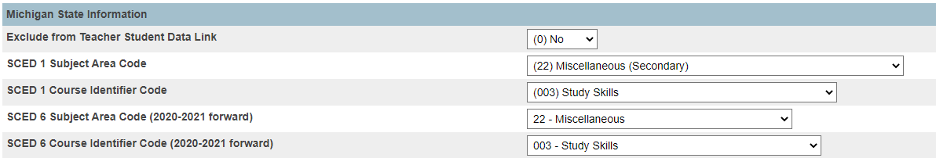

NOTE for 2020-2021 and onward: Michigan has updated to the SCED version 6 codes. Please make sure that your courses have been updated to the new SCED 6 codes using the fields above.

Course Identifier Codes
You must select the appropriate state-required Course Identifier Code for the selected Subject Area Code based on the NCES SCED Codes.
The NCES SCED codes for prior to secondary courses can be found at: http://nces.ed.gov/pubsearch/pubsinfo.asp?pubid=2011801
The NCES SCED codes for secondary courses can be found at: http://nces.ed.gov/pubsearch/pubsinfo.asp?pubid=2007341

Course Identifier Code located on the Course Information page

NOTE for 2020-2021 and onward: Michigan has updated to the SCED version 6 codes. Please make sure that your courses have been updated to the new SCED 6 codes using the fields above.

Course Types
You must define the following Course Type codes for the district.

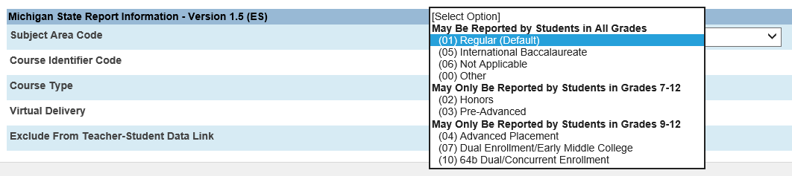

Code | Description | Applicable Grade Levels
00 | Other | May be reported for any grade level
01 | Regular (Default) | May be reported for any grade level
02 | Honors | May only be reported for grade levels 7-12
03 | Pre-Advanced | May only be reported for grade levels 7-12
04 | Advanced Placement | May only be reported for grade levels 9-12
05 | International Baccalaureate | May only be reported for grade levels 9-12
06 | Not Applicable | Not Applicable
07 | Dual Enrollment/Early Middle College | May only be reported for grade levels 9-12

Gotchas, Reminders, and Best Practices

How the MI Teacher Student Data Link (TSDL) Report Export Works
The TSDL Export looks at the student’s all enrollments to select the proper course enrollments between the dates specified on the report interface. Then it looks at the student’s historical grade for an associated section and associated grade scale. Then it looks at the duration of the section and looks for the associated term ID from the Term Store Code to make sure that it is pulling the proper grade. It then uses the Grade Mapping to determine the proper completion status based on the student grade in the course.

All teachers must have a PIC number. If a teacher does not have a PIC number in PowerSchool, then any courses and sections that the teacher teaches will be excluded from the TSDL export.

How the MI Teacher Student Data Link (TSDL) Report Exports Migrant Students
A few districts reported that courses were being exported for migrant students in the TSDL Collection report even though the course and/or section were excluded from TSDL. This issue came up at the elementary level as they wanted to exclude all courses but an AM or PM course or a course that was not going to appear on the student’s academic record.
We asked CEPI if courses for migrants could be excluded and here is their reply:
All courses for a migrant-eligible student in grades 9-12 must be reported even if the course is not reported on the student's academic record. Migrant-eligible students in grades 6-8 that are taking high school courses for credit must also report these courses even if not reported on the student's academic record. All other migrant-eligible students (kindergarten through eighth grade) should have at least one course reported.
CEPI explains that K-8 only need to report one course, but the MI TSDL report will export all courses for the migrant student. If districts wish to exclude any courses for migrant students, this should be done at the student level (all enrollments).
It is also important to remember to use the current date as the Date to*(End Date) in the TSDL report interface to ensure that the student’s grades and completion status are properly reported. If a later date is entered, the completion status may export blanks and the academic grade may export as N/A. If the current date is used, the report has logic to export a completion status of OE (ongoing enrolled)
Excluding Courses, Sections, Students from TSDL
- Course excluded – section or individual student will not be exported.
- Section excluded – only that section marked and students associated with that section will not be exported.
- Student excluded – individual student excluded from export, course and section not affected.

Early College Students
Early College of Macomb students receive their instruction at post secondary institutions. According to the CEPI guidelines the Primary Education Providing Entity (PEPE) district is responsible for the reporting of all student course information in TSDL. CEPI has indicated that the district that submits the student in the MSDS General Collection would be the proper district to submit the student course information in TSDL. These courses should be submitted as a course type of 07 – Dual Enrollment/Early Middle College.

Special Education Students
- Completion Status Code (CS) -- Completed Special Education
This code is used for Special Education students and is automatically calculated for student in Grade 14 with no stored grade and a course type of 73(Non-Subject Specific) and a Course Identifer Code of 039(Prior to Secondary).
- Completion Status Code (OE) -- Ongoing Enrolled
For the End of Year submission, the Ongoing Enrolled completion status can only be used for Migrant students or Special Education students who will be taking the same course the following year.
For Special Education students, the Subject Area Code for the course needs to be 73(Non-Subject Specific) and the Course Identifer Code needs to be 039(Prior to Secondary).
- Submitting Students in Grade 14
Grade 14 can only be used for Special Education students who are 18 or older by December 1st of the current year.
Special Ed Students can also receive a completion status based on their course grade. In this case, the grade scale mapping setup would report the proper completion status based on the students academic grade.

Completion Status of N/A
Overlapping section enrollments could result in a completion status of N/A. Run the PowerSchool Section Enrollment Audit report to find these errors.
Mentor teacher is not showing in the dropdown list in the Sections page?
The mentor teacher selection box only populates the names of the staff members that have a PIC number entered in the Information page for the staff member and have Yes selected for Virtual Delivery Teacher or Mentor.

MISDmsds – Error Checking Tip
In the spring of 2016, the error checker program was modified to validate and error check TSDL data exclusively. Refer to the MISDmsds documentation on our website for more detailed information: misd.net > MISD DEPARTMENTS > Management Technology > MISDmsds Collection Program

MSDS (State) Upload - Last Record In Wins!
Keep in mind that if you upload TSDL records to the state for the same student, the last record in wins. For example, you have uploaded a TSDL record for Charlie Brown that has with Math 101 in it. Then you decide to upload another record for Charlie with Math 101 and English 100. The information in the second Math 101 record will overwrite the first record, English 100 will be added to the student’s TSDL information at the state.

21f Courses - How are we to report teachers for 21f courses in the TSDL?
If a student takes a course through an online provider such as MVU, we assign a mentor teacher that has two way interaction with the student each week. Who is the teacher that should be reported in the TSDL as the teacher of record? Is it the virtual teacher from MVU and would we need to get the PIC of the teacher that is teaching the course online and enter that number as the teacher of record or is it assigned the mentor teacher? We would not have a MVU provider/teacher in our REP data since they are not employed by the district.
If we are required to report our mentor teacher as the teacher of record as well, can the mentor and teacher of record be different. Who would the grade the student is assigned be reported on in the TSDL.
Response from CEPI - If the MVU teacher is a Michigan Certified teacher, your district’s REP user would be able to search for his/her PIC number using the PIC Search function in REP. You would then enter that PIC as the Teacher-Of-Record in the PIC field in TSDL, and the local mentor PIC in the Virtual Mentor PIC field. If the teacher is not a Michigan Certified teacher, you should enter the Mentor’s PIC in both the PIC and Mentor PIC field. Please note the Mentor must also be a certified teacher if there is no certified Teacher-Of-Record to report.

What are the methods for reporting elementary student course information in TSDL?
There are 3 methods for reporting elementary student course information in TSDL depending on the student’s schedules.
- If the student receives ALL instruction in one classroom from one teacher:
The district can choose to report one course for these students. For example, this can be an AM attendance course. This course should have a Subject Area Code of 73 – Nonsubject Specific (prior to secondary), the Course Identifier Code set to the proper grade level, the Course Type set to 01 – Regular (Default), and should not be excluded from TSDL. The district would set up one course for each grade level. All other elementary courses should be excluded from TSDL when using this method.

- If the student receives all core instruction from one teacher, but changes teachers for specials:
The district can choose to report one course for the core instruction for these students and individual courses for the specials. For example, the course for core instruction can be an AM attendance course. This course should have a Subject Area Code of 73 – Nonsubject Specific (prior to secondary), the Course Identifier Code set to the proper grade level, the Course Type set to 01 – Regular (Default), and should not be excluded from TSDL. The district would set up one course for each grade level. All other elementary courses, except the specials, should be excluded from TSDL when using this method.

The specials should be coded with the proper Subject Area Code, Course Identifier Code, Course Type, and should not be excluded from TSDL.

This method will include one course for all core subject instruction with the homeroom teacher as the teacher of record and all specials will be reported with the appropriate teachers as the teacher of record.

- If the student changes teachers for all instruction:
The district must report all courses separately these students. All courses should be coded with the proper Subject Area Code, Course Identifier Code, Course Type, and should not be excluded from TSDL. This method will include a course for each individual area of instruction and will be reported with the appropriate teachers as the teacher of record.
If there are AM and PM courses that are used strictly for attendance, these courses should be excluded from TSDL.

Note: The last method will work for any one of the scenarios described above. If the student receives all instruction
from one teacher, the teacher will be listed as the teacher of record for all student courses submitted.

Notes from CEPI
- If the art, music and PE classes are reported on these student's academic records, then they should be reported in TSDL.
- If a course for a student is recorded on his/her academic record, the course and student information is required to be submitted, regardless of whether or not a grade is reported on the student's academic record.
- The TSDL Missing Student Report lists any student who was submitted by a district in any previous MSDS collection who isn't also reported in the district's TSDL Collection. This includes students who are exempt from TSDL reporting (e.g. early childhood, adult ed etc).
- When your district's TSDL is complete, this report should only list students who are exempt from reporting and students who were enrolled in the district for so brief amount of time that the course is not reported on the student's academic record. -- The only other reasons a student might not be reported in TSDL is if he/she is a Career and Technical Education student whose data is submitted in CTEIS or if the student is a "shared" student and all of the student's courses are reported by another district in their TSDL Collection. We would expect all other students to be reported in TSDL.
- Your district's Student Reporting Rate is not using data from the Missing Student Report. The Student Reporting Rate specifically excludes students who are exempt from reporting (e.g. early childhood, adult ed etc).
- In the case of "shared" students where courses are reported on the student's academic record, districts need to work together to decide who will report the courses in TSDL. Ultimately, the PEPE district is responsible for ensuring the courses are reported.
- When reporting courses in TSDL, course grades should not be averaged unless you are also reporting the averaged grade on the student’s academic record.

REVISIONS – June 2020
- Removed 64b information – 64b was retired 2019-2020 school year
- Updated Mentor Teacher to new name – Virtual Mentor PIC

