PowerSchool State Reporting  
Procedures for General Collections  
Fall, Spring, End of Year (F,S,E)

**MISD PowerSchool State Reporting Documentation**

**Macomb County PowerSchool District Liaison Procedures**

**This document was created by the Macomb County PowerSchool Liaisons and the MISD Help Desk Team.**

**This documentation contains custom reports and procedures that are specific to Macomb and many of the functions described in this document may not be appropriate for the building level user such as mass change commands, access to district screens, etc. We hope this document assists you with your general collection state submissions.**

**Please find this document along with other state reporting documents at** [**http://powerschool.misd.net**](http://powerschool.misd.net/) **> STATE > State Reports**

**Contents**

Important Reminders 5

Resources 5

MISD Knowledge Base 5

CEPI Website 5

10/30 Day Rules 5

Student Enrollment Status (enroll_status) 5

Summer Graduates/Completers 5

Hover Over Field Tool Tip Function 6

PowerSchool Search Tip 6

Teacher PIC Numbers for TSDL 6

Before Count Day 7

District Info Page – MSDS Count Dates (F,S,E) 7

UIC Numbers (verify regularly) 8

School Enrollment Audit Report (run regularly) 9

Section Enrollment Audit Report (run regularly) 9

PowerSchool Special Ed (TIEnet) Import/Export Report (run regularly) 10

Weekly Teacher Attendance Reports (F,S) 11

Enter Dates (verify regularly) 11

Exit Dates (verify regularly) 12

Enrollment Summary Report (run regularly) 12

Full Time Equivalency (verify regularly) 13

Student Schedules (Incomplete or Missing) (verify regularly) 14

Verify Early Childhood Special Education Assessment Data (F,S,E) 14

Pupil Codes-Shared District Codes-10/30 Day Rule (F,S) 15

State/Province-MI Page 17

Assessment Component – RETIRED 18

Attendance Component (Days Attended/Days Enrolled) (F,S,E) 19

Contacts (F,S,E) 20

Early Childhood Programs Component (F,S,E) 23

Early Childhood Special Education Assessment Component (F,S,E) 25

Early On Component (F,S,E) 26

Early Reading Deficiency (E) 27

Manual: Enrollment Component (F,S,E) 28

General Education FTE Component (F,S) 30

Homeless Demographics Component (F,S,E) 32

Initial IEP Component (F,S,E) – Flows from PSSP 33

Initial IFSP Component (F,S,E) 34

Membership Component (F,S,E) 34

Part B Referral Component (F,S,E) 36

Part C Assessment Component (F,S,E) 37

Personal Core (F,S,E) 38

Personal Curriculum Component (F,S,E) 39

Personal Demographics Component (F,S,E) 40

Resident LEA Number (F,S,E) 40

District of Residence (F,S,E) 41

Program Participation Component (F,S,E) 45

Alternative Education Program (F,S,E) 45

Developmental Kindergarten (F,S,E) 45

Early Middle College Participant (F,S,E) 46

Foreign Exchange Student (F,S,E) 46

Immigrant Funding (F,S,E) 47

International Student (F,S,E) 47

Military Connected Student (F,S,E) 47

Out of State Resident Student (F,S,E) 48

Seat-Time Waiver Participants (F,S,E) 48

Section 31a At-Risk Student (F,S,E) 49

Section 504 (F,S,E) 49

Sec. 6(4)(l)(ii) Pupil Count Exception (F,S,E) 50

Title 1 Targeted Assistance Program (F,S,E) 50

Advanced and Accelerated Program (CRDC) 51

Foster Care Student 51

Migrant Student (TSDL) 51

School Demographics Component 53

Operating District Number (F,S,E) 53

School Facility Number (F,S,E) 53

Local Student Identification Number (F,S,E) 54

Student Grade or Setting (F,S,E) 54

Specialized Shared Educational Entity Code (EEM S2E2 code) (F,S,E) 54

Building Pupil Would Otherwise Attend (BPWOA) 55

Operating ISD/ESA Number 57

Seclusion and Restraint Component (F,S,E) 58

Section 23a Component 59

Section 25 Component 60

Supplemental Nutrition Eligibility Component (SNE) (F,S,E) 61

Special Education Component (F,S,E) 62

Student Record Maintenance Component 65

Title 1 Services Component (F,S,E) 66

Title III English Learner and Immigrant (F,S,E) 68

Obsolete tab (Adult Ed) 70

On Count Day 71

Teacher Attendance on Count Day (F,S) 71

Weekly Teacher Attendance Reports (F,S) 71

Class Rosters (F,S) 71

Student Schedules (F,S) - Student Schedule Listing 72

Student Schedules (F,S) - Student Schedule Report 72

Student Schedules (F,S) – Student Schedule – v2.0 73

Master Schedule (F,S) 73

Building Calendar (F,S) 73

Bell Schedules (F,S) 74

Attendance Codes (F,S) 74

Enrollment Summary Report (F,S,E) 74

Monthly Exit/Transfer In Report (gain/loss report) (F,S,E) 74

Code 10 Day Rule on Pupil Accounting Screen (F,S) 74

Code 30 Day Rule on Pupil Accounting Screen (F,S) 75

Code 45 Day Rule on Pupil Accounting Screen (F,S) 75

PowerSchool SE – Nightly Update to PowerSchool (F,S,E) 75

Free/Reduced Lunch (F,S) 77

Discipline (F,S,E) 78

StuFTE – Membership Report (F,S,E) 84

Pupil Share Code Reports (F,S) 85

Official Enrollment Student Roster (F,S,E) 86

4061 FTE (F,S) 86

Worksheet A (F,S) (Macomb runs out of PowerSchool SE) 86

Worksheet B (F,S) (Macomb runs out of PowerSchool SE) 87

Third Grade Retention Collection (EOY / Summer) 88

After Count Day 90

Weekly Teacher Attendance Reports (F,S) 90

MI 10/30 Day – By Class (F,S) 90

MI 10/30 Day – By Period (F,S) 92

Export Data from PowerSchool 93

Refresh Premier Attendance Views Data function 93

MI General/SRM/Early Childhood Collection 93

Use the MISDmsds Error Checker Program 95

Upload General Collection File to CEPI 95

End of Year General Collection 96

FTEs (General Ed, Section 52, Section 53) 96

Attendance 96

Graduates and Completers 96

Audit Reports 99

Monthly Exit/Transfer-In Report (gain/loss report) 99

75% Membership 99

Delayed Start Days 100

Forgiven Days/Unforgiven Days 101

# Important Reminders

## Resources

MISD Knowledge Base [http://powerschool.misd.net](http://powerschool.misd.net/) > STATE

CEPI Website <http://www.michigan.gov/cepi/0,1607,7-113-986_50502---,00.html>

## 10/30 Day Rules

Students who have an unexcused absence on the count date have **10 (school) in-session** **days** to return to class. **NOTE:** Please take school breaks into consideration

Students who have an excused absence on the count date have **30 calendar** **days** to return to class.

Students who have a suspension/expelled absence on the count date have **45** **calendar days** to return to class.

## Student Enrollment Status (enroll_status)

-2 (Inactive), -1 (Pre-Registered -- inactive), 0 (Active), 1 (Inactive), 2 (Transferred Out -- inactive, 3 (Graduated -- inactive), 4 (Imported as Historical)

Only active students will show up in normal student searches on the Start Page. Precede your search string with the forward slash (/) to include students without an enroll_status value of 0.

To include inactive students in your searches, you can enable the Smart Search feature:

Start Page > Personalize > Interface > Include Inactive Student/Staff Results

## Summer Graduates/Completers

If a student graduates or completes late in the summer, then you should report this student to the state through an SRM. Note: the steps described below are a suggested best practice, but you may already have your own best practices to report these students.

Transfer the student out of PowerSchool using an appropriate exit code and exit date. Exit date should be prior to the first day of school.

Student Record Maintenance tab > Student Record Maintenance (SRM) As of Date

Enter in an As of Date. This date can match the student’s exit date. **This must be done before the first day of school.**

Attendance tab > Days Attended and Days Enrolled in Reporting Periods

Enter in a value of zero for both fields since student’s attendance was reported in the EOY submission.

General Education FTE tab > General Education FTE/Section 52 FTE/Section 53 FTE

Enter in a value of zero in the FTE field.

State/Province-MI page > Exclude student from MSDS State Reporting

Exclude the student from state reporting after their record is sent through the SRM. This way the student’s record will not export with the Fall General Collection.

## Hover Over Field Tool Tip Function

Place your mouse pointer over a field label or field entry box and tool tip will appear displaying the database table name and field name. This may help you when searching for a field. Note: the tool tip window only stays active for a few seconds so we have included field names in this document. In addition, we have a document on our PowerSchool Knowledge Base titled Field Code Listing for State Pages which lists the name of each field.

## PowerSchool Search Tip

Want to include Inactive Students in your search?

Start Page > Click your Initials > Manage Profile > Include Inactive Student/Staff Results (check the box, Submit). This feature works when searching for Staff members too.

## Teacher PIC Numbers for TSDL

All Teachers must have a Personnel Identification Code (PIC) number for the Teacher Student Data Link submission.

Field Name: S.MI.SSF.TSDL.X.RepPic

This field is located on the Staff > Edit Info

To search for teachers that are missing a PIC number, run the following reports:

* System Reports > State Reporting tab > MI MSDS Setup Validation
* System Reports > sqlReports5 > State Reporting > Teachers w/Missing PIC

# Before Count Day

## District Info Page – MSDS Count Dates (F,S,E)

There are several data issues that are dependent on the MSDS Prior Count Date and MSDS Current Count Date fields that are located on District Information page. These include state reporting field and page validation errors and warnings, and the student information that displays at the top of the State/Province-MI pages (Prior Count Date, Current Count Date, Age at Count). It is important that these dates be changed prior to each submission period.

Displays at the top of the State/Province-MI Pages

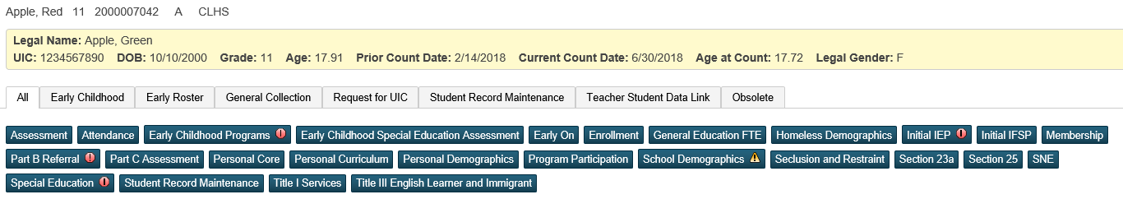

These fields should be updated prior to each count.

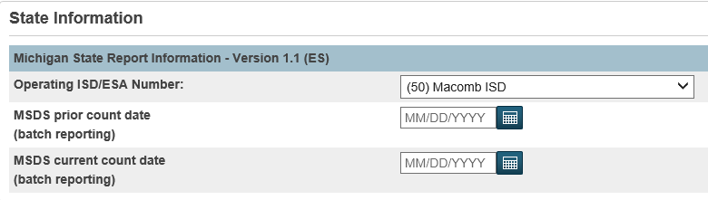

To change these dates:

* District Office > District > District Info
* In the State Information section, change the **MSDS prior count date** field to be the prior count date and change the **MSDS current count date** field to be the current count date.
* Click Submit.

## UIC Numbers (verify regularly)

All students must have a Unique Identification Code (UIC). Below are steps that will help you identify students with duplicate UIC numbers as well as identify students who are missing UIC numbers.

This field is located on three different pages in PowerSchool:

* State/Province-MI > Personal Core tab (view only)
* PowerSchool Demographics – Macomb Custom Page

Field Name: State_StudentNumber

**Search for students with duplicate UIC numbers:**

Run the Duplicate UIC Numbers report

* This report can only be run at the District Office.
* System Reports > sqlReports 4 > State Reporting
* This will display students with duplicate UIC numbers.
* *Tip* Click on the Student Name or UIC column header to sort the data.
* If two different students share a UIC number, then you will need to research which student has the correct UIC number and perhaps need to request a new UIC for the other student.
* You may see the same student listed twice but with different schools. This means that the student exited your district and then returned but was not re-enrolled the proper way. They were enrolled again as if they were a brand new student so they got another record created in the database. This report may help you identify “housekeeping” issues you may have with your clerical staff.

**Search for students with missing UIC numbers:**

Run the Invalid/Missing UIC Numbers report

* This report can be run at the district or building level.
* System Reports > sqlReports 4 > State Reporting
* This report has an option to display only students that have an exit date greater than or equal to the MSDS previous count date.
* Use the selection of students produced by this report and run the MI Request for UIC collection.
* Upload the xml file that is produced by this report to the state to obtain UICs.

Run the MI Request for UIC Collection

* This report can be run at the district or building level.
* System Reports > State Reporting
* In the Run For: parameter, choose Students Without UIC.
* Use the xml file that is produced by this report to upload to the state to obtain UICs.

Search for active and inactive students whose UIC number field is equal to blank

* This search can be run at the district or building level.
* Search: /state_studentnumber=
* Note: this search will pull all active and inactive students that may have been in your database for many years so you may want to add a date parameter to your search such as: /state_studentnumber= ; districtentrydate>##/##/####
* If you only have a few students who need UIC numbers then you can obtain UIC numbers individually from the state site.

or

* Use the selection of students produced by this search and run the MI Request for UIC collection.
* Upload the xml file that is produced by this report to the state to obtain UICs.

If you have uploaded a file to the state, and the state has assigned the students’ UIC numbers, then you can download that file from your Data Staging area and import into PowerSchool.

Refer to the Obtaining New UICs for PowerSchool document posted on our knowledge base [http://powerschool.misd.net](http://powerschool.misd.net/) > STATE

## School Enrollment Audit Report (run regularly)

Use the School Enrollment Audit report to identify possible school enrollment errors such as students with enrollment date overlap.

This report can be run at the district or building level:

* System Reports > School Enrollment Audit

## Section Enrollment Audit Report (run regularly)

Use the Section Enrollment Audit Report to identify possible student enrollment errors such as:

* Students enrolled in school, but not in any classes
* Students with course date misalignments with school enrollments

This report can be run at the district or building level:

* System Reports > Section Enrollment Audit

## PowerSchool Special Ed (TIEnet) Import/Export Report (run regularly)

On a daily basis demographic data is sent from PowerSchool to PowerSchool SE through a scripting process and special education data is sent from PowerSchool SE to PowerSchool through the AutoComm Setup process.

The TIEnet Import/Export Report will identify errors that may occur between this data exchange and we highly recommend that you run this report at least once a week.

This report can be run at the district or building level:

* Start Page > TIEnet Import/Export
* Select either TIEnet Production or TIEnet Snapshot from the dropdown menu

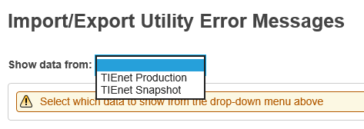

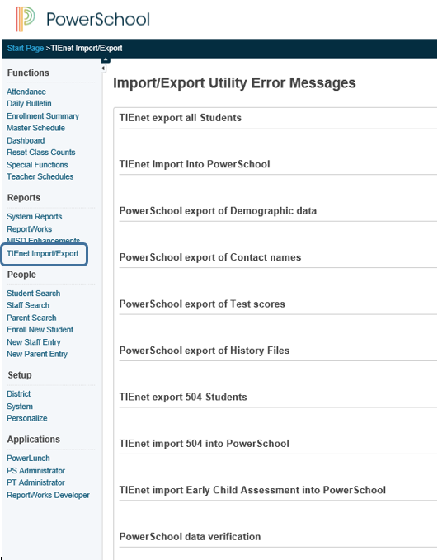

## Weekly Teacher Attendance Reports (F,S)

**Need to have weekly attendance reports signed by the teacher – the week before count day, the week of count day, and weekly for the following 4 weeks.**

OFFICE STAFF – Print Class Attendance Audit Report

* System Reports > Class Attendance Audit
* Enter the weekly range
* All Teachers
* All Periods
* Submit

TEACHERS – Print Weekly Attendance Review from PowerTeacher

* Student Information (Backpack)
* Weekly Attendance Review – Menu on the left
* **Print, sign, and date the report – full signatures in INK**

## Enter Dates (verify regularly)

Since most reports look at the student’s entry and exit dates it’s very important to make sure that these dates fall within the current school year. Use the procedures below to verify student entry dates. This date is located on the Transfer Info Page.

Note: this date is the PowerSchool entry date and although it is a highly important date within the system, it is not the date that is sent to the state. That date is the District Entry Date which is described later in this document.

Field Name: EntryDate

Search for students that have an enter date prior to the first day of school:

/EntryDate<##/##/20##;ExitDate>##/##/20##

If you have students listed, verify the information in the student’s Transfer Info page and make corrections as necessary.

--or--

Use the Student Field Value function to mass change the students’ entry date.

## Exit Dates (verify regularly)

Since most reports look at the student’s entry and exit dates it’s very important to make sure that these dates fall within the current school year. Use the procedures below to verify student exit dates. This date is located on the Transfer Info page.

Note: PowerSchool advised us to set the Last Day of Term for the full year in Years & Terms to be June 29. This would make it easier to extend the calendar in the event that a district or school had to add days to the calendar at the end of the year (too many snow days, for example). These searches work with the assumption that you have June 29 set as the last day for the full year.

Note: The student’s Exit Date in the Transfer Info page will be 6/30/20YY (one day after the 29th)

Field Name: ExitDate

Search for students that have an exit date not equal to June 30 of the current school year:

/ExitDate> 06/01/20##;ExitDate#06/30/20##

If you have any students listed, verify the information in the student’s Transfer Info page and make corrections as necessary. Be careful to not change students who may have exited your district within the school year.

--or--

Use the Student Field Value function to mass change the students’ exit date.

## Enrollment Summary Report (run regularly)

The Enrollment Summary Report is a good report to run on a regular basis to ensure that your student enrollment is accurate. This report displays student Scheduling/Reporting Ethnicity data.

This report can be run at the district or building level.

If running the report at the district level, data is calculated for all active students for today’s date.

If running the report at the school level, you can choose the students and date for which you want data to be calculated.

**Example of the Enrollment Summary Report run at the building level:**

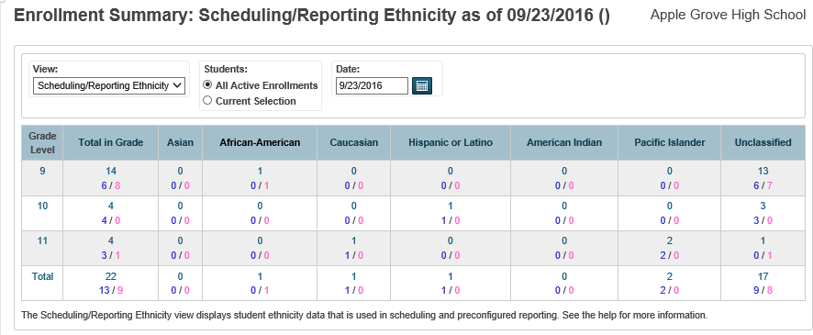

## Full Time Equivalency (verify regularly)

Full Time Equivalencies are used for reporting on ADA and ADM, therefore it is vital that all students have a full time equivalency value assigned to them. Upon enrollment, a student is assigned a Full Time Equivalency (FTEID) value. This value comes from the Full-Time Equivalencies you created for your school. You may have several Full-Time Equivalencies created for your school if you have students attending full time and half time for example. The process below will step you through identifying the FTEs that have been assigned to each of your school buildings for the current year.

1. Use DDE to search for the assigned FTEs for each of your school buildings. You will need to know your school numbers when doing this search.
2. Find a school number: District Office > District > Schools/School Info
3. Find the FTEID(s) for each school. Note: Field name is FTEID and Table name is FTE(159)
4. Search in DDE:

* Search the FTE table(159)
* SchoolID = the school ID
* YearID = XX (XX = the current school year. Example 28 or the 18-19 school year)
* Click on the Table View link
* Click on the SchoolID link for each FTE listed and the ID value will be shown.
* This will list all of the FTEIDs for your school.

1. Verify that students are assigned the proper FTEID for each school:

* Start Page > search ALL students
* Select the List Students function
* Field 1 – enter in LastFirst
* Field 2 – enter in FTEID
* Optional: Sort Field Name – enter in FTEID to sort by FTEID
* Review results to confirm that students have the appropriate FTEID number assigned to them.
* If you need to change an FTEID number, you can change individually on the student’s Transfer Info page, or use Student Field Value to do a mass change.

## Student Schedules (Incomplete or Missing) (verify regularly)

Search for students with incomplete or missing schedules

***For these searches to work properly in secondary schools, you should be in the desired term. For these searches to work properly in most elementary schools, you should be in the full year.***

Search for students who do not have a schedule:

Search: *number_of_classes < 1

Run the Section Enrollment Audit Report (System Reports)

Search for students with incomplete schedules:

Search: *number_of_classes < #

(# represents the number of classes a student should be enrolled in)

Search for students not enrolled in a specific period:

* *not_enrolled_in_period = 1

## Verify Early Childhood Special Education Assessment Data (F,S,E)

Search for students with Early Childhood Special Education Assessment Data that are no longer in Grade 30:

S_MI_STU_GC_X.flagECAssess=1; grade_level#30

IF you are using the Educational setting grade level override field to denote Grade 30 students:

S_MI_STU_GC_X.flagECAssess=1; S_MI_STU_GC_X.educsetting#30

Use student field value to clear this field.

## Pupil Codes-Shared District Codes-10/30 Day Rule (F,S)

The Pupil Accounting screen is used to track pupil codes, shared districts, share time FTE and the 10/30 day rule for students. Reference the Pop III Priority Listing document.

The information entered in this screen prints out on the following reports:

* Pupil Share Code - By Code
* Pupil Share Code - By Grade
* StuFTE – Membership Report

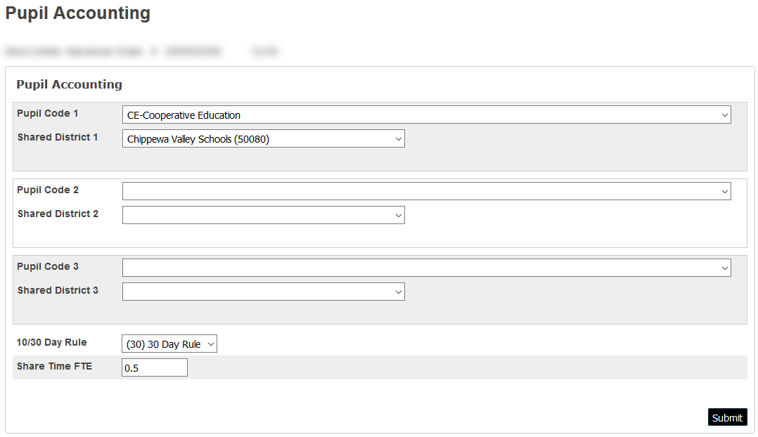

**Fields on the Pupil Accounting screen are:**

| **Field Label** | **Field Name** |
| --- | --- |
| Pupil Code 1 | U_MISD.Pupil_Code1 |
| Pupil Code 2 | U_MISD.Pupil_Code2 |
| Pupil Code 3 | U_MISD.Pupil_Code3 |
| 10/30 Day Rule | U_MISD.Pupil_1030DayRule |
| Shared District 1 | U_MISD.Pupil_SharedDistrict1 |
| Shared District 2 | U_MISD.Pupil_SharedDistrict2 |
| Shared District 3 | U_MISD.Pupil_SharedDistrict3 |
| Share Time FTE | U_MISD.Pupil_ShareTimeFTE |

10/30 Day Rule Field

Prior to the Fall and Spring counts, the 10/30 Day Rule field should be cleared.

Search for students who have a value in this field that is not equal to blank:

/U_MISD.Pupil_1030DayRule#

You can use the Student Field Value function to clear the data for any students listed.

Pupil Codes and Shared District Codes

Prior to the Fall and Spring counts, the pupil codes and the shared district codes should be verified and corrected if necessary.

The easiest way to verify students coded with a pupil code or a shared district is by running one of the Pupil Share Code Reports on the State Reporting tab:

* System Reports > State Reporting
* Select Pupil Share Code-By Code or Pupil Share Code-By Grade
* Run for the selected number of students or run for all students
* Enter in the count date
* Submit
* Verify Pupil Codes and Shared District Codes

**Reminder: You will need to clear EX - Suspended/Expelled (5-N) code for each count.**

**Tip!**

When searching for an individual pupil code, use the “@” symbol so you do not have to type out the entire pupil code name. For example, to search for SC-School of Choice students:

Search: U_MISD.Pupil_Code1=SC@

All of your School of Choice students will be listed without having to enter in the entire pupil code. Also note that the search is not case sensitive.

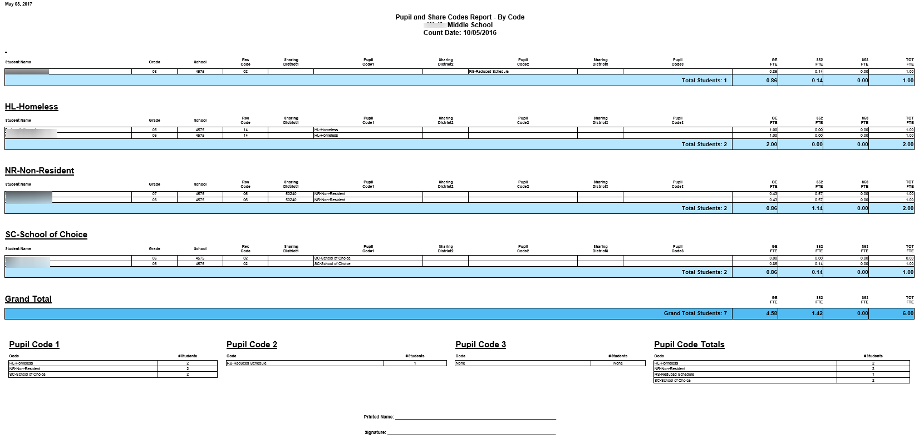

## State/Province-MI Page

The State/Province-MI page has been updated to an MSDS component based format.

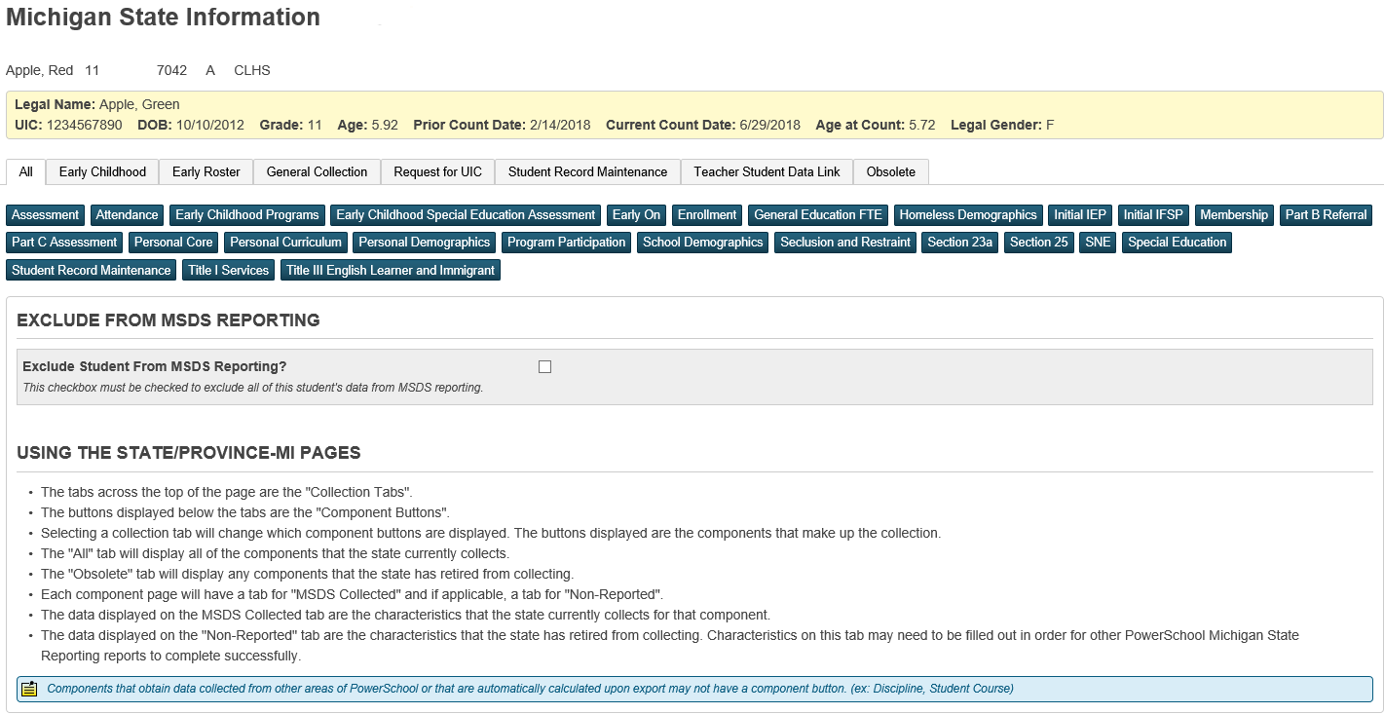

**Exclude Student from MSDS State Reporting (F,S,E)**

Field Name: State_ExcludeFromReporting

A checkbox in this field indicates that the student is excluded from all General Collections, Student Record Maintenance collection, and all Early Childhood collections.

If this field is checked, a value of 1 will be assigned to the field.

Search for students that have a check in this checkbox by running the following search:

/State_ExcludeFromReporting=1

If students are listed, you will want to verify this these students should be excluded from state reporting.

## Assessment Component – RETIRED

The Assessment Component (formerly known as BAA Assessment Component) has been made available in the Early Roster Collection to allow district users to pre-identify students for Michigan assessment examinations. For additional information about assessments and pre-identification requirements, please refer to the MDE Division of Accountability Services (DAS) website.

DAS will be offering a new Early Literacy and Mathematics assessment for grades 1 and 2 in the fall and kindergarten, 1 and 2 in the spring, therefore a new Other Test Type has been added. Only the fall administration of the assessment for grades 1 and 2 can be submitted on the Early Roster for pre-identification purposes. DAS will NOT be using the Early Roster for the spring assessment. DAS will not be offering the KEA or additional Interim assessments in the fall, but could possibly continue in future years. Therefore, we are not removing the KEA or Interim Test Types at this time.

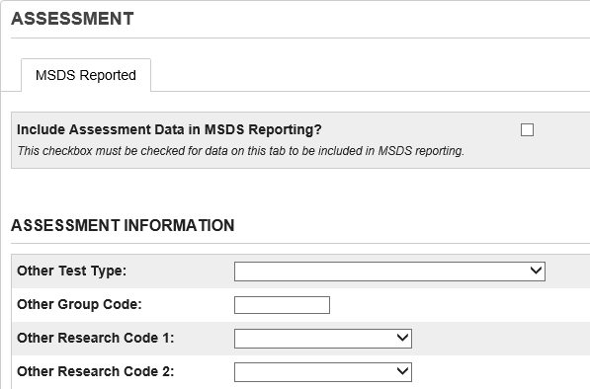

**Fields in this section are:**

| **Field Label** | **Field Name** | **Explanation** |
| --- | --- | --- |
| Include Assessment Data in MSDS Reporting | S_MI_STU_GC_X.flagBAA | A checkbox in this field indicates that the student’s Assessment data will be exported in the Early Roster Collection. |
| Other Test Type | S_MI_STU_ASSESS_X.OtherTestType | The test types in the dropdown menu are:  (10) Early Literacy and Mathematics |
| Other Research Code 1 | S_MI_STU_ASSESS_X.OtherResearchCode1 | The research codes in the dropdown menu are: 01, 02, 03, 04, 05, 06, 07, 08, 09, 10 |
| Other Research Code 2 | S_MI_STU_ASSESS_X.OtherResearchCode2 | The research codes in the dropdown menu are: 01, 02, 03, 04, 05, 06, 07, 08, 09, 10 |

## Attendance Component (Days Attended/Days Enrolled) (F,S,E)

The Attendance Component is used to collect data related to the student's possible and actual attendance for the current school year.

Attendance exports with all three general collections and the SRM collection.

Attendance is required for exited students for the Fall and Spring counts and for ALL students for the EOY count.

The General Collection report will automatically calculate attendance for exited students if the General Collection Fall or Spring option is chosen in the report interface.

The General Collection report will automatically calculate attendance for ALL students if the General Collection EOY option is chosen in the report interface.

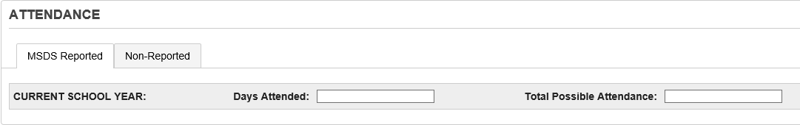

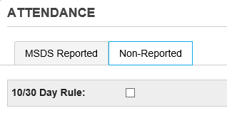

**Fields in this section are:**

| **Field Label** | **Field Name** | **Explanation** |
| --- | --- | --- |
| Days Attended | S_MI_STU_GC_X.attDays | The total number of days that the student actually attended or received educational services. (NOTE: This characteristic does not address instructional days or clock hours.) |
| Total Possible Attendance | S_MI_STU_GC_X.attDaysEnroll | The total number of days that education services were available to the student. This is a cumulative number, from the first day the student could have attended (the first day of the school year, the date of new enrollment, or the beginning of a program through the last day of attendance (last day of school year, enrollment or program). |
| 10/30 Day Rule | S_MI_STU_GC_X.flag1030day | RETIRED – not included in state report exports but can be used for informational purposes. |

Days Attended and Days Enrolled

Because the General Collection and SRM Collection automatically calculates days attended and days enrolled upon export, it is not necessary to manually code these fields.

It’s good practice however to search these fields for invalid data/odd characters since any data entered in this field will override the auto calculate function:

Use the following search:

/S_MI_STU_GC_X.State_excludefromreporting = 0; S_MI_STU_GC_X.attdays#; S_MI_STU_GC_X.attdaysenrolled#

If students are listed, you can verify the data using the List Students function.

If you choose the clear the data, use the Student Field Value function.

Virtual Attendance

Per Roberta, it depends on how the course work is delivered. It is recommend that districts follow the rules in the 5-O sections of the PAM regarding the Virtual Learning Options and review the Pupil Membership Auditing Manual (PMAM).

There are varying types of virtual classes which is why there are varying codes for the virtual learning classes.

Districts need to:

* Identify and define the type of Virtual Course being offered
* Identify the type of Delivery Method
* Identify and provide documentation for the type of Participation

Virtual delivery is another huge piece of the puzzle with regard to reporting. This is why districts are required to provide Roberta with the Virtual Lists that include the assurances for compliancy.

**Since there can be multiple factors that may impact attendance calculations, please refer to the Attendance for MSDS Submissions documentation located on our MISD Knowledge Base:** <http://powerschool.misd.net/statereporting/state-reports/>

## Contacts (F,S,E)

Contains contact information data related to the student and family.

When Is This Component Required? You are required to submit the Contacts Component when you submit a student record in the Early Childhood, General (Fall, Spring or EOY), and Student Record Maintenance collections, unless the student is reported as Homeless (i.e., the Homeless Demographics Component is submitted). It is optional in the Request for UIC and Early Roster Collections, and not allowed in the Teacher Student Data Link Collection.

When you submit this component, one of the occurrences must include an Address Type of “Physical.” You may need to submit multiple occurrences of this component for the following reasons:

• Early On When the Part B Referral Component is reported, and either the Parent Address Unknown or Parent Telephone Unknown characteristics are reported with “No,” at least one occurrence of this component must be reported with an Address Type of Mother, Father, Guardian or Other.

• Read by Grade 3 For third grade students, submit an occurrence of this component with an Address Type of “Mailing” if the student’s mailing address is different than the physical address.

• Pandemic EBT MDE has not yet determined whether Pandemic EBT benefits will continue into the 2021-22 school year. If benefits are available, to ensure that students and their families receive these benefits, submit an occurrence of this component with an Address Type of “Mailing” if the student’s mailing address is different than the physical address. This component can be reported up to six times. However, only one occurrence for each Address Type may be submitted.

**Fields in this component are:**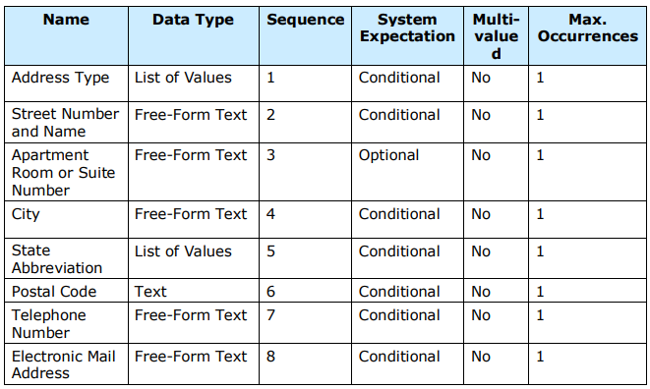

*Address Type: f*

* Physical (This type is REQUIRED.)
* Mailing (Only use this type if it is different than the Physical address.)
* Father
* Mother
* Guardian
* Other

*Street Number and Name:* The number and name of the location of the address for the reported Address Type.

*Apartment Room or Suite Number:* The additional street address information such as apartment, room, suite or lot number that refers to the reported Address Type.

*City:* The name of the city or town where the address is located.

*State Abbreviation:* The abbreviation for the state (within the United States) or outlying area in which the address is located.

*Postal Code:* The five- or nine-digit ZIP code of the location where the address is located.

*Telephone Number:* The primary telephone number given by the student’s parent or guardian.

*Electronic Mail Address:* The numbers, letters, and symbols used to identify the primary electronic mail (email) address provided by the student’s parent or guardian.

**NEW!!! Contacts - Count Day Street Address**

On the Contacts tab in the State/Province-MI student page, the following new fields are available:

* Count Day Street Address ([S_MI_STU_GC_X]pdStreetAddress)
* Count Day Street Address 2 ([S_MI_STU_GC_X]pdStreetAddress2)
* Count Day City ([S_MI_STU_GC_X]pdCity)
* Count Day State ([S_MI_STU_GC_X]pdState)
* Count Day Zip ([S_MI_STU_GC_X]pdZipCode)

If these fields are populated, they will override the core address fields. This allows districts to override the student's current address when creating the MI General / SRM / Early Childhood, MI Early Roster, MI Request for UIC, or MI Teacher Student Data Link export files.

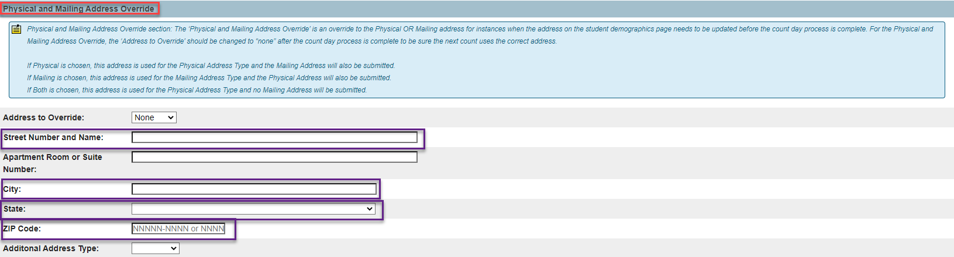

## Early Childhood Programs Component (F,S,E)

The Early Childhood Programs Component is used to collect data related to the student’s participation in early childhood programs or services. You are required to report this component when the student is identified as participating in the Great Start Readiness Program or Sec. 32p Early Childhood Block Grant. Although this is not a requirement, the Michigan Department of Education’s Office of Great Start encourages you to report students participating in any other early childhood programs to assist in longitudinal program evaluations. This data is reported in the Early Childhood Fall, Spring, and End of Program (EOP) Collections.

Please refer to the Early Childhood Reporting – LEA and ISD Submission Process documentation located on our MISD Knowledge Base: <http://powerschool.misd.net/statereporting/state-reports/>

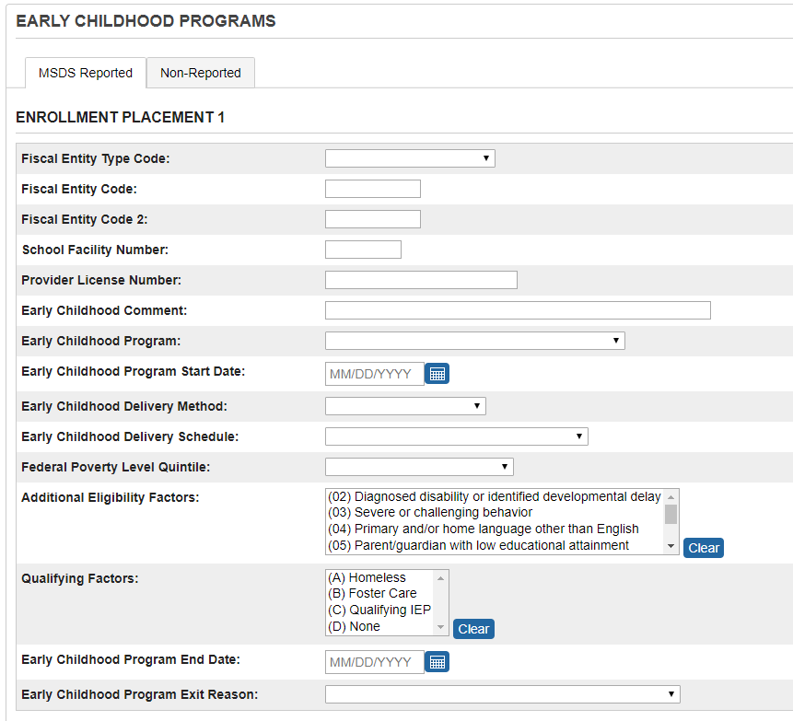

**Note: The Fiscal Entity Code 2 characteristic can only be reported if the child is in a GSRP/Head Start Blend program.**

Note: The Early Childhood Parent and Early Childhood Teacher information is located Non-Reported tab.

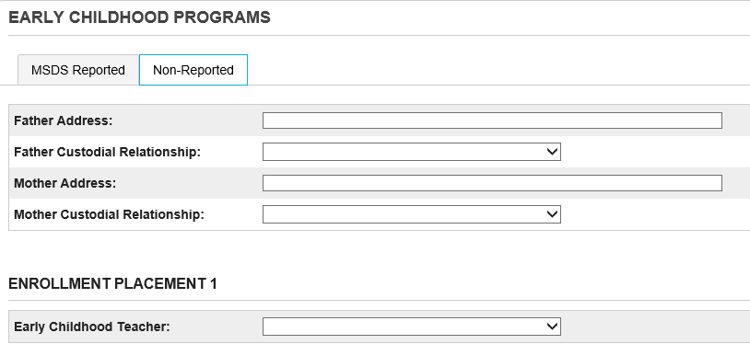

**GSRP – Wait List (S)**

FROM CEPI’S MSDS Collection Details Manual: GSRP – Wait List:

“A child eligible for GSRP must be less than 5 years of age on September 1 of the current school year and greater than or equal to 4 years of age on December 1 of the current school year.

An ISD must be reported as the fiscal entity for this program.

The following characteristics must be reported when this program option is selected: EC Delivery Method “4” (None – Wait List), Federal Poverty Level Quintile, Additional Eligibility Factors, and Qualifying Factors”.

From MPAAA: “MDE and CEPI recently published the new reporting requirements for GSRP students who have been placed on wait lists.  In future years, this information will be collected in the Spring EC collection.

The students who are on your wait lists need to be reported with the following information:

* The early childhood program now has a new code, **“21: GSRP Wait List**” that must be reported for these students.

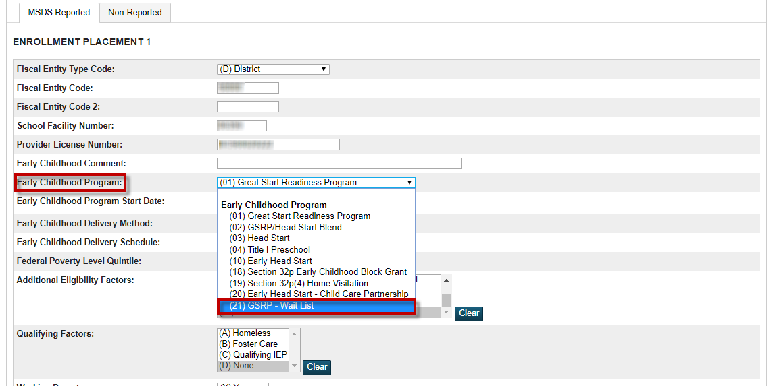

* The delivery method also has a new code, “**4: None - Wait List**”, that also must be reported.

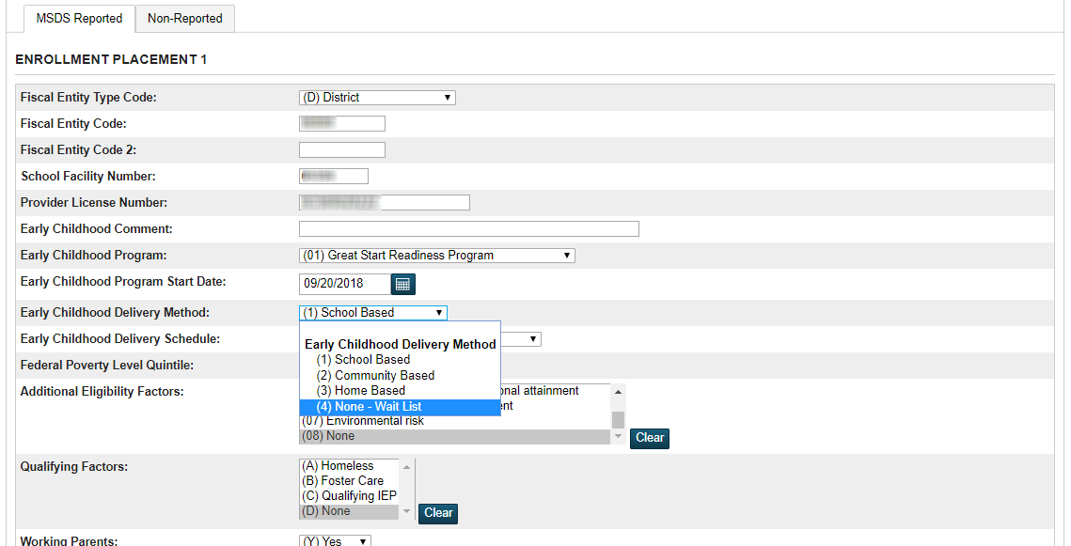

In addition, the following data must also be reported for the students on your waitlist:

* The fiscal entity type and fiscal entity code (required for all EC programs).
* The program start date should be reported as the date they went onto the waitlist.
* The federal poverty level quintile must be reported.
* The qualifying factor, as well as at least one eligibility factor, must be reported.
* Finally, an error will result if the student’s age does not meet the same requirements as all other students served in the GSRP program”.

## Early Childhood Special Education Assessment Component (F,S,E)

The Part C Assessment Component is used to collect the entry, exit and annual assessment data for Early On children. These data are reported in the General Collections and may also be reported in the Student Record Maintenance Collection.

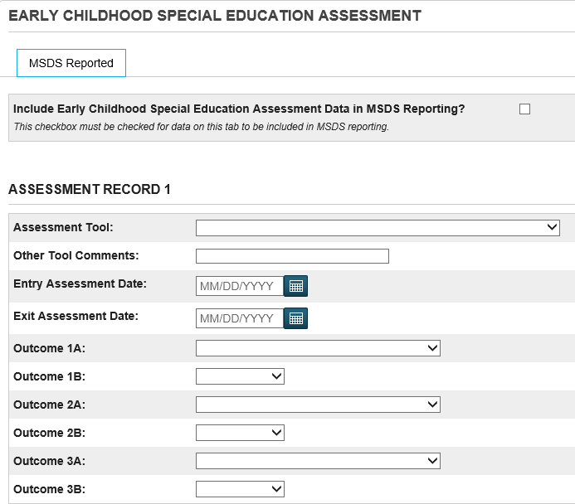

Early Child Special Ed Assessment, Field Name: S_MI_STU_GC_X.flagECAssess

Search for students with Early Childhood Special Education Assessment data that are no longer in Grade 30:

/S_MI_STU_GC_X.flagECAssess=1 ; grade_level#30

If students are listed, you can verify the data using the List Students function.

If you choose the clear the data, use the Student Field Value function.

Search for students who have the Educational Setting Grade Level Override field set to Grade 30:

/S_MI_STU_GC_X.flagECAssess=1 ; S_MI_STU_GC_X.educsetting#30

If students are listed, you can verify the data using the List Students function.

If you choose the clear the data, use the Student Field Value function.

## Early On Component (F,S,E)

The Early On component is used to collect data related to children under the age of 3 who are receiving services from a district which may or may not include Special Education services.

These data are reported in the General Collections and may also be reported in the Student Record Maintenance Collection.

Note: the Early On Parent Data is located on the Part B Referral tab and is included in the exports.

**In Macomb this data is maintained in PowerSchool Special Ed and uploaded to the state by the MISD Special Education department.**

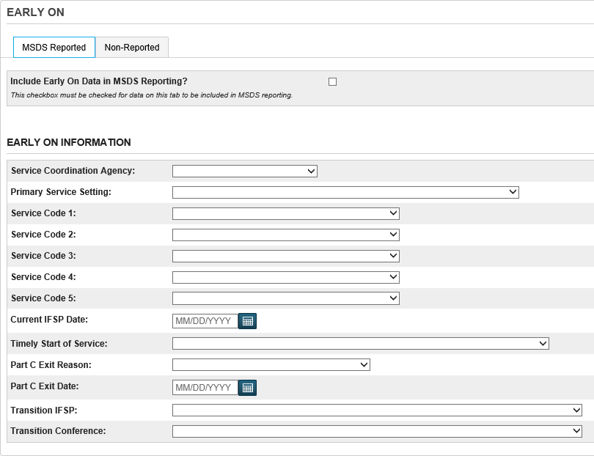

Early On Intervention Student, Field Name: S_MI_STU_GC_X.flagEarlyOn

The following search will display students who have this field checked:

/S_MI_STU_GC_X.flagEarlyOn=1

Note: The Early On Caseworker and Transition IFSP information is on the Non-Reported tab.

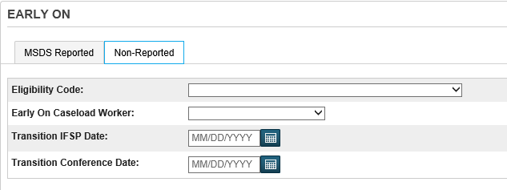F

## **Early Reading Deficiency (E)**

FROM CEPI’S MSDS Collection Details Manual:

“Section 35a(5) of the State School Aid Act provides $19,900,000 to districts for additional instructional time and interventions for pupils in grades K-3 who have been identified as needing additional supports and interventions in order to be reading at grade level by the end of grade 3.

The Early Reading Deficiency Component is used to collect growth data for students identified with a reading deficiency. MDE interprets growth as identifying whether a student still has reading deficiencies by the end of the school year if they were identified with a deficiency at the beginning of the school year. This component will also be used to identify what additional services were provided to pupils with reading deficiencies

You are required to report the Early Reading Deficiency Component for all K-3 students in the End of Year General Collection if your district received the Section 35a(5) Additional Instructional Time and Interventions grant.

If Reading Deficiency Identified = “Yes,” then the Reading Deficiency Continuation and Reading Deficiency Activities characteristics must be submitted”.

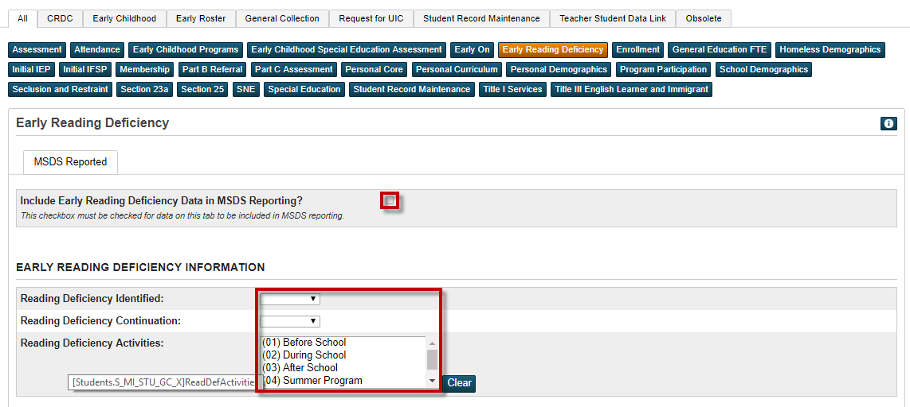

**Tips!**

If you want to search for all of the students that were active sometime during this school year, you could search: **/exitdate > 7/1/20##** (or whenever the start of school is). Then further drill down by searching**/S_MI_STU_GC_X.flagReadDef=1**. If you only need students that exited early then you could also add exitdate < the last day of school.

**Fall, Spring and SRM Collections – REPORT ONLY EXITED STUDENTS**

Figure out who your NO SHOWS & EXITED students are.

* 1. NOTE: You must submit the Early Reading Deficiency Component when a student has exited the district (District Exit Status **not** equal to “19” or “00” in the Enrollment Component)
  2. NOTE: According to CEPI, if you have students that**EXITED** after the first day of this school year, you **WILL** have to report last year’s deficiency information unless the students have been reevaluated.
  3. NOTE: IF you have students that were **NO SHOWS** for this school year, you can use, for example, 09/01/20## (if your start date was after 09/01/20##) as the exit date, so that you will **NOT** have to report the Reading Deficiency Component for these students.

Figure out/Know who your retained 3rd graders are from the previous school year.

Clear the Reading Deficiency Component for your current 4th graders **ONLY** before Fall Count (See an example in screenshot below)

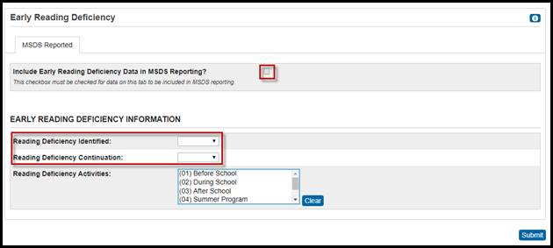

For your K-3 current/active students, make sure to clear out the Early Reading Deficiency Component as well for these students. Why? Because your schools/teachers should be assessing these K-3 students and if an Early Reading Deficiency is identified, they will then code their Early Reading Deficiency screen.

**End-of-Year General Collection**

You are required to submit the Early Reading Deficiency Component for all K-3 studentsreported in the EOY General Collection who do not meet one of the criteria for exemption listed at the end of this section (Nonpublic student & Home-schooled student).

## Manual: **Enrollment Component (F,S,E)**

This field should contain the date the student first entered your district. If this date is entered on the PowerSchool Demographics page, then it will appear on the State Demographics page. This date will change when the student breaks enrollment and then re-enters the district. This date is very important to maintain since page validations reference this field and it is exported with many state collection reports.

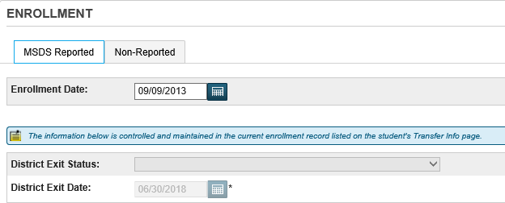

Field Name: DistrictEntryDate

This field is located on two different pages in PowerSchool:

* State/Province-MI > Enrollment Component tab
* PowerSchool Demographics

Search for students who have a value in this field that is equal to blank:

/DistrictEntryDate=

If you have any students listed, go to each student’s record and enter in the appropriate district entry date.

Note: The Entry Date information from the Transfer Info page is on the Non-Reported tab.

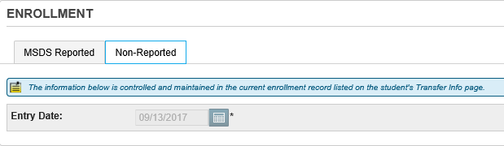

**NEW Enrollment Characteristic in 2022 – Additional Graduation Award**

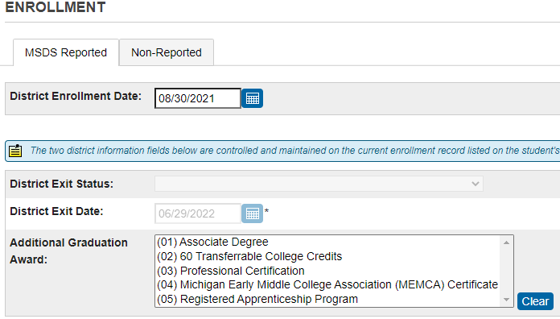

Field Name: S_MI_STU_GC_X.addGradAward

The additional award earned by a student in addition to a high school diploma as the result of successfully graduating from an early middle college program. Choose the code that represents the graduation award that the student obtained as the result of a successfully graduating from an early middle college program.

Note: Only students reported with exit code “40” may be reported with this characteristic.

## General Education FTE Component (F,S)

The Fall and Spring General Collections are the primary means for submitting student membership (FTE) on which state foundation payments are based.

For General Education students, the FTE must be entered in the General Education FTE field on the state General Ed tab. Acceptable values are from 0.0 and 1.0.

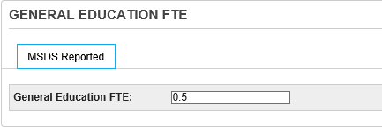

**Fields in this section are:**

| **Field Label** | **Field Name** |
| --- | --- |
| General Education FTE | S_MI_STU_GC_X.FTE |

The General Education FTE Component is the vehicle for claiming membership in general education for a student enrolled in your district.

Note: the numeral 1 is the default value in this field. If you enter in 1.00 and hit the Submit button, the value will default to 1.

Prior to the Fall and Spring counts, you can clear FTE values for inactive students. Use the following searches to identify exited students who have FTE values:

Search for inactive students:

/enroll_status=2

If students are listed, you can clear the data using the Student Field Value function:

Field to Change: S_MI_STU_GC_X.FTE

Check the “Clear Field Value” checkbox

Submit

## Homeless Demographics Component (F,S,E)

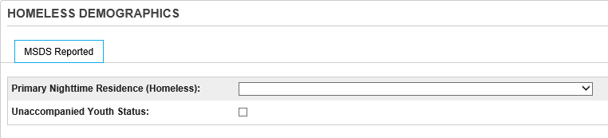

Homeless Status Code:

Homeless data is collected for students who experience a period of homelessness during the current school year. A student who meets the criteria for homelessness for any period of time within the school year is eligible for all homeless services for the entire school year.

Field Name: S_MI_STU_GC_X.homelessStatus

Verify/Clear this field prior to submitting the fall count since a student’s homeless status may have changed from the previous year:

/S_MI_STU_GC_X.homelessStatus#

If you have any students listed, use the List Students function to verify the data.

If you wish to clear the data, use the Student Field Value function.

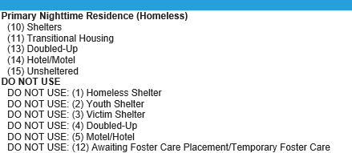

Unaccompanied Youth:

The student's status as an unaccompanied youth under the McKinney-Vento Act. An unaccompanied youth is an individual who is not in the physical custody of a parent or guardian and who fits the McKinney-Vento definition of homeless.

Field Name: S_MI_STU_GC_X.flagUnacYouth

If this field is checked, a value of 1 will export with state reports.

Search for students who have a check in the checkbox:

/S_MI_STU_GC_X.flagUnacYouth=1

If you have any students listed, use the List Students function to verify the data.

If you wish to clear the data, use the Student Field Value function.

## Initial IEP Component (F,S,E) – Flows from PSSP

The determination date is not sent in the MSDS Initial IEP component. If the determination date is between the prior count date and the current count date, then the MSDS Initial IEP component is sent in the MSDS collection. The student special education flag does not have to be set to Yes for the initial IEP component to be reported in a MSDS collection. The offer of Free Appropriate Public Education (FAPE) must occur within seven (7) days of the conclusion of the IEP. This date of notice may result in a determination of ineligibility.

The MSDS Collections details manual recommends the following: "When reporting a student from out of state, submit the Initial IEP Component with Result of Initial IEP code "1" (Found Eligible) and timeliness code of "22". In addition, you will submit the Special Education Component with the services provided from the out of state IEP. This is the only time you will report the Initial IEP Component. Once you have conducted your own IEP and the student is found eligible or not eligible, you then submit the Special Education Component in either the SRM Collection or next General Collection. Within that submission report the newer IEP date and whatever services they will be receiving or the exit information if they were not found eligible for services. Do not resubmit the Initial IEP Component."

When the student is from out of state, it is suggested a SRM is sent to MSDS, ensuring the out of state initial IEP and out of state IEP data is saved. After the SRM collection is completed, reset the determination date to spaces, insuring the initial IEP data is not sent a second time.

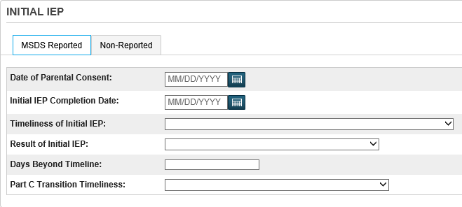

Note: The Determination Date Information is on the Non-Reported tab.

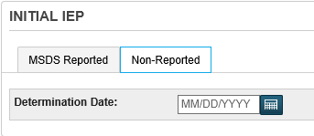

## Initial IFSP Component (F,S,E)

The Initial IFSP Component is used to collect data about children from birth to age 3 who are receiving early intervention services which may or may not include special education services. An Individualized Family Service Plan is developed by parents and early intervention service providers to meet the special needs of young children, birth to age 3.

If the Initial IFSP date is between the prior count date and the current count date, then the MSDS Initial IFSP component is sent in the MSDS collection. The new result code (created as of school year 2016) reports parents declining Part C services, when the services were offered to the student.

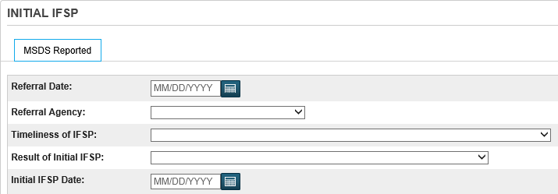

## Membership Component (F,S,E)

This field is used for the determination of residency and eligibility for full-time equivalency (FTE). This data exports with the General Collections (Fall, Spring, EOY) and the Student Record Maintenance Collection (SRM). It also prints on our county Pupil Share Code reports and our STUFTE Membership report.

Field Name: S_MI_STU_GC_X.residentMembership

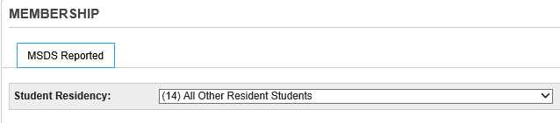

This field is located on two pages:

* PowerSchool Demographics
* State/Province-MI > Membership Component tab

It is a good practice to verify that all students have a residency and verify that residency codes are accurate. For example, a student that may have been living outside of your district last year, may be living in your district this year so their code would have to be changed from non-resident to resident.

There are several ways to search on this code:

1. Run the Official Enrollment Student Roster report (System Reports > State Reporting Tab). Look at the Res Code column. You may want to run this at a building level since the report can be lengthy.
2. Search for students without a residency code (equal to blank):  
   /S_MI_STU_GC_X.residentmembership=

If students are listed, you can change the student’s residency code individually or use the Student Field Value function to mass change the code if you are certain all of the students should receive the same code.

1. Search for students with a residency code other than 14:  
   /S_MI_STU_GC_X.residentmembership#14

If students are listed, verify the data using the List Students function.

**Non-Resident and Resident Codes:**

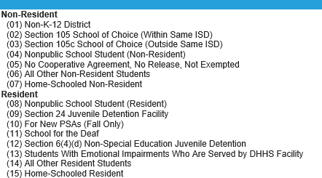

**Tuition Funded Enrollment**

Per CEPI: Definition: “A charge or fee is required to be paid by the student’s family in order to attend the public school.” (pg. 194 of the 2020-2021 CEPI Manual)

To report this component to CEPI,

* Choose whether a charge/fee was paid by the student’s family for the student to attend a public K-12 school.
* This characteristic does not apply to the following:
  + Dual-enrollment tuition and fees.
  + Charges/fees paid between the resident district and enrolling district.
* If you have questions about this characteristic, please contact CEPI Customer Support.

## Part B Referral Component (F,S,E)

The Part B Referral Component is required for records submitted with an Early On Component and a Special Education Component between the ages of 2 years 3 months and 2 years 9 months. ISD staff should work with their local districts providing the special education services to ensure the ISD has the necessary data to submit.

**The Early On Component must be reported when this component is submitted. Therefore, this component may only be submitted by an ISD.**

This component may only be submitted if the child is 2 or older as of the collection count day (or June 30 for the EOY General Collection).

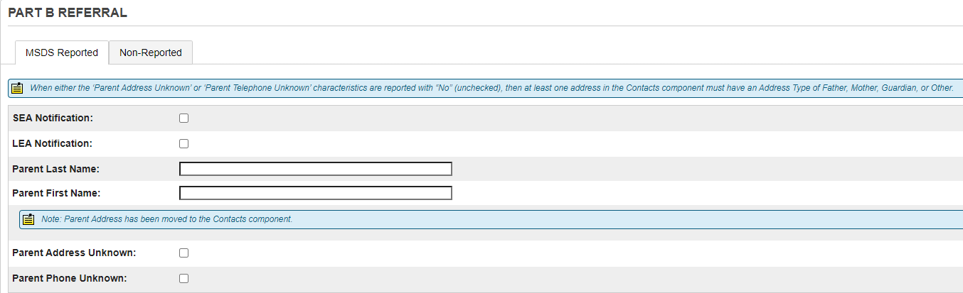

Note: The SEA Notification Date and LEA Notification Date Information is on the Non-Reported tab.

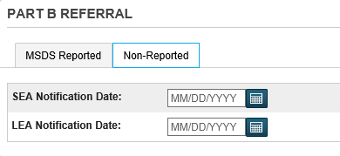

## Part C Assessment Component (F,S,E)

The Part C Assessment Component is used to collect the entry, exit and annual assessment data for Early On children.

These data are reported in the General Collections and may also be reported in the Student Record Maintenance Collection.

**In Macomb this data is maintained in PowerSchool Special Ed and uploaded to the state by the MISD Special Education department.**

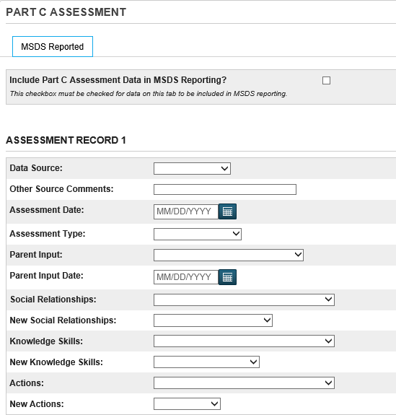

Part C Student Assessment, Field Name: S_MI_STU_GC_X.flagEOAssess

The following search will display students who have this field checked:

/S_MI_STU_GC_X.flagEOAssess=1

## Personal Core (F,S,E)

You are required to submit the Personal Core Component for all MSDS data collections.

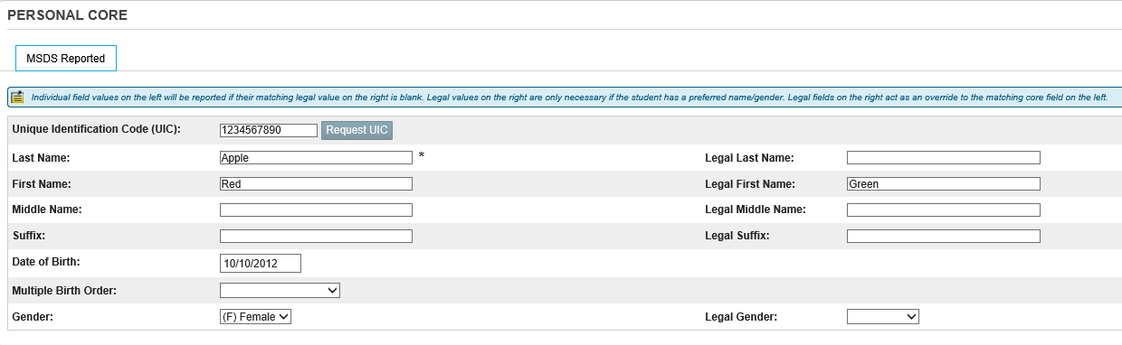

**Michigan Unique Identification Code (UIC) (run regularly)**

If you are submitting the student’s record to the state, they must have a UIC number. Refer to the section above titled “UIC Numbers” for more information.

Field Name: State_StudentNumber

**Name and Address Section**

Note: some of these fields are also located on the PowerSchool Demographics page. Changes made to fields in this section, appear in the PowerSchool Demographics page since they are shared fields.

**Fields in this section are:**

| **Field Label** | **Field Name** |
| --- | --- |
| Last Name | Last_Name |
| First Name | First_Name |
| Middle Name | Middle_Name |
| Suffix | S_MI_STU_GC_X.stuNameSuffix |
| Date of Birth | DOB |
| Multiple Birth Order | S_MI_STU_GC_X.multipleBirth |
| Gender Code | Gender |
| Legal Last Name | [StudentCoreFields]PSCore_Legal_Last_Name |
| Legal First Name | [StudentCoreFields]PSCore_Legal_First_Name |
| Legal Middle Name | [StudentCoreFields]PSCore_Legal_Middle_Name |
| Legal Suffix | [StudentCoreFields]PSCore_Legal_Suffix |
| Legal Gender Code | [StudentCoreFields]PSCore_Legal_Gender |

## Personal Curriculum Component (F,S,E)

You must identify students participating in a personal curriculum to modify the graduation requirements for the Michigan Merit Curriculum (MMC) in the Program Participation Component and report them with the Personal Curriculum Component.

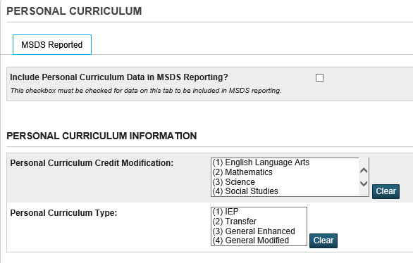

**Fields in this section are:**

| **Field Label** | **Field Name** | **Explanation** |
| --- | --- | --- |
| Student has a personal curriculum program | S_MI_STU_GC_X.flagPersonalCurr | A checkbox in this field indicates that the student’s Personal Curriculum will be exported. |
| Curriculum Credit Modifications In: | S_MI_STU_GC_X.pcModification | The academic area that is being modified by the personal curriculum. |
| Personal Curriculum Type | S_MI_STU_GC_X.pcType | The criteria under which the personal curriculum modification is allowed. |

## Personal Demographics Component (F,S,E)

You are required to submit the Personal Demographics Component when you submit a student record in the Early Childhood, General (Fall, Spring or EOY) and Student Record Maintenance collections. It is optional in the Early Roster and Request for UIC Collections. This component is not allowed in the Teacher Student Data Link Collection. There are business rules that will generate errors when data in another component is dependent on any of the characteristics included in the Personal Demographics Component.

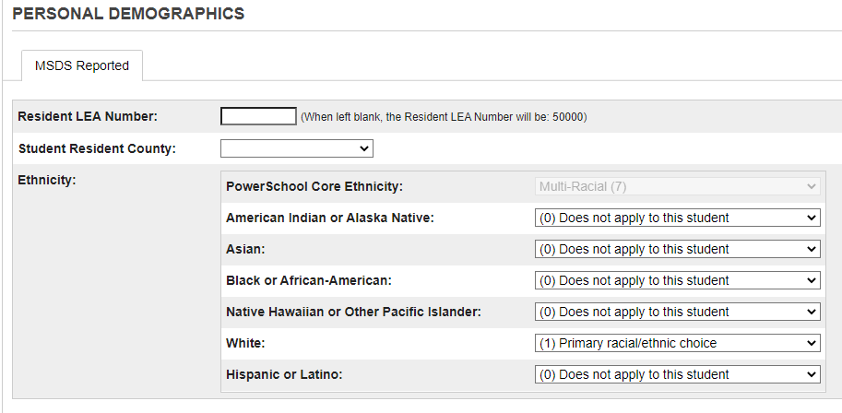

**Fields in this section are:**

| Field Label | Field Name |
| --- | --- |
| Resident LEA Number | S_MI_STU_GC_X.residentLEA |
| Student Resident County | S_MI_STU_GC_X.residentCounty |
| Ethnicity | Street |

### Resident LEA Number (F,S,E)

When enrolling a new student, the LEA number should be selected from the District of Residence dropdown menu. If this field is not selected at the time of enrollment, you can select the LEA number from the District of Residence dropdown menu in the student’s Transfer Info page (click on the Entry Date, select the appropriate District of Residence from the dropdown menu, Submit). (See next section titled “Resident District Number)

The 5-digit LEA number will appear to the right of the Resident LEA Number field and will export with state reporting collections and will print on state reports. If a number is entered into this field, then that number will override the number shown to the right of the field.

Field Name: S_MI_STU_GC_X.residentLEA

Search for students who have a value in this field that is not equal to blank:

/S_MI_STU_GC_X.residentLEA#

If students are listed, verify the data using the List Students function.

If you choose the clear the data, use the Student Field Value function.

### District of Residence (F,S,E)

The 5-digit LEA Number is usually selected from the District of Residence dropdown menu when a student is first enrolled. If this number was not selected at the time of enrollment, it can be selected in the student’s Transfer Info page (click on the Entry Date, select the proper District of Residence, Submit).

This number appears to the right of the Resident LEA Number field box located on the state Demographics tab. This is the number that exports with all state collection reports. If a number is entered in the Resident LEA Number field, then that number will override the number that is displayed to the right of the field box and that is the number that will be exported.

Field Name: DistrictOfResidence

This field is located on two pages:

* Enroll New Student page
* Edit Current Enrollment page (Transfer Info)

Search for students with a blank District of Residence code:

DistrictOfResidence=

If students are listed, enter a district of residence code for each student in their Transfer Info page.

You can also search for students who are non-residents:

DistrictOfResidence#XXXXX (where XXXXX is your 5-digit district code)

If students are listed, verify data individually or use the List Students function.

If the district you are looking for is not in the dropdown menu, you will need to navigate to District > District > District of Residence > and click New.

**Resident County Code (F,S,E)**

When a student is enrolled, this field does not autofill from anywhere in the system so it needs to be selected from the dropdown menu.

This field only exports with the Early Childhood collection, but will error on the page if left blank because it is used for the TIEnet/PowerSchool data exchange, page validation errors and warning, reports.

Field Name: S_MI_STU_GC_X.residentCounty

The following search will display students who do not have a value in this field:

/S_MI_STU_GC_X.residentCounty=

If students are listed you can enter a resident county code for each student individually, or use Student Field Value function to do a mass change.

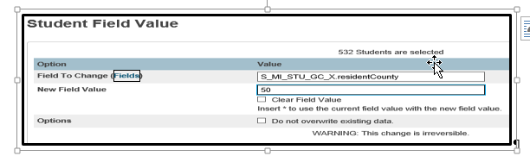

**Ethnic Codes (verify regularly)**

Ethnic codes are located in two different places in PowerSchool:

* PowerSchool Demographics page
* State/Province-MI > Personal Demographics tab

**PowerSchool Demographics page:**

All students should have an ethnic code selected on the PowerSchool Demographics page in order for the Enrollment Summary report to report data accurately. This field is also used in scheduling and preconfigured reporting. It is NOT used in state reporting. This field should be coded when enrolling a student.

Field Name: Ethnicity

This field holds a single numeric value of: 1, 2, 3, 4, 5, 6, 7 (see screenshot shown below)

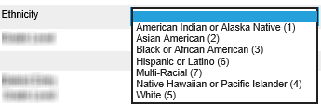

**Personal Demographics Component tab:**

All student MUST have an ethnic codes selected on the State Demographics page for state reporting requirements.

A best practice would be for the school registrar to enter student’s ethnicity in the state demographics page right after entering data in the students PowerSchool demographics page.

**Tip!**

At the bottom of the PowerSchool Demographics page, there is a button titled “State of Michigan”. This button will take you directly to the State Demographics tab where you can continue entering student state related information.

Since it is so important to have both of these fields filled out, the following steps provide you with multiple searches to help identify missing data and help mass change data.

**Fields in this section are:**

| **Field Label** | **Field Name** |
| --- | --- |
| American Indian or Alaskan Native | S_MI_STU_GC_X.ethnicIndian |
| Asian | S_MI_STU_GC_X.ethnicAsian |
| Black | S_MI_STU_GC_X.ethnicBlack |
| Native Hawaiian or Pacific Islander | S_MI_STU_GC_X.ethnicPacific |
| White | S_MI_STU_GC_X.ethnicWhite |
| Hispanic or Latino | S_MI_STU_GC_X.ethnicHispanic |

The following process will allow you to search for students without an ethnic code on the PowerSchool Demographics page:

/Ethnicity=

This command will search for all active and inactive students who have an ethnicity equal to blank.

For each student listed, go to their PowerSchool Demographics page and select an Ethnicity from the dropdown menu.

Now that all of your students have an ethnicity coded on the PowerSchool Demographics page, you can use this code to mass change the ethnicity code on the State Demographics page. The exception for this is for the Multi-Racial code which will need to be manually entered into the State ethnicity fields.

Search for Multi-Racial:

/Ethnicity=7

* For each student listed, go to their State Demographics page and select the appropriate ethnic codes. Note: (1)Primary racial/ethnic choice is usually used for multiple ethnic codes.

**Important information regarding Hispanic or Latino students:**

Federal Guidelines dictate that if a student is of Hispanic or Latino descent, then they are considered Hispanic for state reporting purposes. Therefore, if a student coded as multi-racial is Hispanic or Latino, you must code them on the PowerSchool Demographics page as Hispanic or Latino (6) and on the State Demographics page as Hispanic or Latino (1)Primary racial/ethnic choice.

Search for American Indian or Alaska Native:

* /Ethnicity=1
* If students are listed use the Student Field Value function:
* Field To Change: S_MI_STU_GC_X.ethnicindian
* New Field Value: 1
* Submit

Search for Asian American:

* /Ethnicity=2
* If students are listed use the Student Field Value function:
* Field To Change: S_MI_STU_GC_X.ethnicasian
* New Field Value: 1
* Submit

Search for Black or African American:

* /Ethnicity=3
* If students are listed use the Student Field Value function:
* Field To Change: S_MI_STU_GC_X.ethnicblack
* New Field Value: 1
* Submit

Search for Native Hawaiian or Pacific Islander:

* /Ethnicity=4
* If students are listed use the Student Field Value function:
* Field To Change: S_MI_STU_GC_X.ethnicpacific
* New Field Value: 1
* Submit

Search for White:

* /Ethnicity=5
* If students are listed use the Student Field Value function:
* Field To Change: S_MI_STU_GC_X.ethnicwhite
* New Field Value: 1
* Submit

Search for Hispanic or Latino:

* /Ethnicity=6
* If students are listed use the Student Field Value function:
* Field To Change: S_MI_STU_GC_X.ethnichispanic
* New Field Value: 1
* Submit

## Program Participation Component (F,S,E)

The Program Participation Component contains data related to the student’s eligibility and/or participation in specialized programs or services. Students who may be eligible for program-level allocations and are required to be reported for compliance and/or program monitoring must be reported with the appropriate program codes. These data are also important for the accurate identification of subgroup participation required for federal reporting.

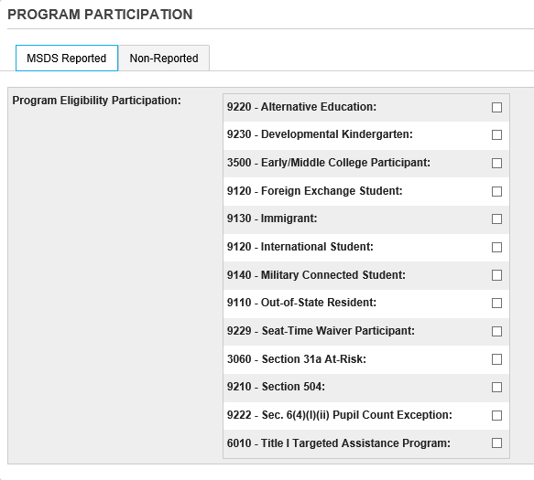

### Alternative Education Program (F,S,E)

Student is currently participating in an alternative education program (including seat-time waiver programs). Use Grade or Setting to report the appropriate grade level.

If this field is checked, a value of 9220 will export with all state reporting collections.

Field Name: S_MI_STU_GC_X.flagAlternateEd

The following search will display students who have this field checked:

/S_MI_STU_GC_X.flagAlternateEd=1

If students are listed, you can verify the data using the List Students function.

If you choose the clear the data, use the Student Field Value function.

### Developmental Kindergarten (F,S,E)

Developmental Kindergarten (a defined two-year Kindergarten program that precedes entry into first grade)

Program Participation code "9230" (Developmental Kindergarten) **should be submitted** when:

* The Grade or Setting characteristic in the School Demographics Component must contain code "00" (Kindergarten).

Program Participation code "9230" (Developmental Kindergarten) **should NOT be submitted** when:

A student is in the second year of a planned two-year Developmental Kindergarten program, OR

A student attends a regular one-year kindergarten program, but then is retained in that grade for an additional year or more.

If this field is checked, a value of 9230 will export with all state reporting collections.

Field Name: S_MI_STU_GC_X.flagDevRetKinder

The following search will display students who have this field checked:

/S_MI_STU_GC_X.flagDevRetKinder=1

If students are listed, you can verify the data using the List Students function.

If you choose the clear the data, use the Student Field Value function.

### Early Middle College Participant (F,S,E)

The student is enrolled in an early/middle college program. This program could reside at a public high school, community college or a state public university. Students may attend as early as ninth grade.

When reporting early/middle college participants, **it is very important to always report Program Participation code "3500" (Early/Middle College Participant) in all collections**; otherwise, a student's cohort year may be adversely affected. Students reported with Program Participation code "3500" will have their cohort year increased by one. If a student was reported with code "3500" in the previous collection but not reported with this code in the current collection, the student's cohort year will be decreased by one. In addition, early/middle college participants must be reported as a full-time student at the early/middle college school or facility.

When you submit this characteristic with code "3500":

* The student record must contain code "09", "10", "11" or "12" in the characteristic Grade or Setting in the School Demographics Component or the system will generate an error.
* Do not report the student record with code "01", "02", "03", "04", "18" or "30" in the characteristic District Exit Status in the Enrollment Component or the system will generate an error.
* The entity reported in the characteristic School or Facility in the School Demographics Component must be identified as an Early/Middle College (EMC) or have an EMC program in the Educational Entity Master (EEM).

If this field is checked, a value of 3500 will export with all state reporting collections.

Field Name: S_MI_STU_GC_X.flagEarlyCollege

The following search will display students who have this field checked:

/S_MI_STU_GC_X.flagEarlyCollege=1

If students are listed, you can verify the data using the List Students function.

If you choose the clear the data, use the Student Field Value function.

### Foreign Exchange Student (F,S,E)

If this field is checked, a value of 9120 (International Student) will export with all state reporting collections.

Note: you must also check the Immigrant Funding checkbox on the state Demographics or on the LEP tab.

CEPI Rule: When you submit this characteristic with code “9120” (International Student), you must also report the record with another occurrence of the Program Eligibility Participation characteristic that contains code “9130” (Immigrant).

Field Name: S_MI_STU_GC_X.flagExchangeStu

The following search will display students who have this field checked:

/S_MI_STU_GC_X.flagExhangeStu=1

If students are listed, you can verify the data using the List Students function.

If you choose the clear the data, use the Student Field Value function.

### Immigrant Funding (F,S,E)

The student has immigrated to the United States from another country and is aged 3 through 21 years, was not born in any state in America and has not attended one or more schools in any one or more states for more than three full academic years. NOTE: The United States Department of Education includes foreign exchange students as eligible for Title III immigrant programs.

If this field is checked, a value of 9130 will export with state reports.

Field Name: S_MI_STU_GC_X.flagImmFunding

Search for students who have a check in the checkbox:

/S_MI_STU_GC_X.flagImmFunding=1

If you have any students listed, use the List Students function to verify the data.

If you wish to clear the data, use the Student Field Value function.

### International Student (F,S,E)

Student is an international student participating in a foreign exchange program. NOTE: Foreign exchange students should also be reported as eligible for immigrant programs if they meet USED definitions of Immigrant.

If this field is checked, a value of 9120 will export with all state reporting collections.

Note: you must also check the Immigrant Funding checkbox on the state Demographics or on the LEP tab.

CEPI Rule: When you submit this characteristic with code “9120” (International Student), you must also report the record with another occurrence of the Program Eligibility Participation characteristic that contains code “9130” (Immigrant).

Field Name: S_MI_STU_GC_X.flagInternational

The following search will display students who have this field checked:

/S_MI_STU_GC_X.flagInternational=1

If students are listed, you can verify the data using the List Students function.

If you choose the clear the data, use the Student Field Value function.

### Military Connected Student (F,S,E)

The student has at least one parent who is a member of the Armed Forces on active duty.

When you submit this characteristic with code “9140”:

* The term “Armed Forces” means the Army, Navy, Air Force, Marine Corps and Coast Guard.
* The term “active duty” means full-time duty in the active military service of the United States. Such term includes full-time training duty, annual training duty, and attendance, while in the active military service, at a school designated as a service school by law or by the Secretary of the military department concerned. Such term does not include full-time National Guard duty.
* The term “full-time National Guard duty” means training or other duty, other than inactive duty, performed by a member of the Army National Guard of the United States or the Air National Guard of the United States in the member's status as a member of the National Guard of a State or territory, the Commonwealth of Puerto Rico, or the District of Columbia under section 316, 502, 503, 504, or 505 of title 32 for which the member is entitled to pay from the United States or for which the member has waived pay from the United States.
* When a student is submitted with code “9140”, they are considered a military connected student for the entire school year.

If this field is checked, a value of 9140 will export with all state reporting collections.

Field Name: S_MI_STU_GC_X.militaryConnStudent

The following search will display students who have this field checked:

/S_MI_STU_GC_X.militaryConnStudent=1

If students are listed, you can verify the data using the List Students function.

If you choose the clear the data, use the Student Field Value function.

### Out of State Resident Student (F,S,E)

Student attends the district from a state or a province other than Michigan. (No FTE may be claimed)

When you submit this characteristic with code "9110":

the Resident LEA Number characteristic in the Personal Demographics Component must be blank and

the sum of the values submitted in General Ed FTE, Section 52 FTE and Section 53 FTE must not be greater than zero. (Total FTE claimed = 0.00)

If this field is checked, a value of 9110 will export with all state reporting collections.

Field Name: S_MI_STU_GC_X.flagOutOfState

The following search will display students who have this field checked:

/S_MI_STU_GC_X.flagOutOfState =1

If students are listed, you can verify the data using the List Students function.

If you choose the clear the data, use the Student Field Value function.

### Seat-Time Waiver Participants (F,S,E)

*NOTE: These might be project based – verify this information

The student is receiving his/her instruction for three or more courses through a virtual education program.

Note: alternative education is usually required with a seat-time waiver participant. Seat time waivers are generally approved for grades 9-12.

When you submit this characteristic with code "9229":

You must also report the record with another occurrence of the Program Eligibility Participation characteristic that contains code "9220".

A warning will occur if the characteristic Grade or Setting in the School Demographics Component contains a code other than "09", "10", "11" or "12".

If this field is checked, a value of 9229 will export with all state reporting collections.

Field Name: S_MI_STU_GC_X.flagSeatTimeWaiver

The following search will display students who have this field checked:

/S_MI_STU_GC_X.flagSeatTimeWaiver =1

If students are listed, you can verify the data using the List Students function.

If you choose the clear the data, use the Student Field Value function.

### Section 31a At-Risk Student (F,S,E)

Program Participation code 3060 provides a means of identifying a student that is eligible for at-risk (31a) funding. For information about determining eligibility, please refer to <http://www.michigan.gov/mde/0,1607,7-140-6530_30334-43638--,00.html>.

If this field is checked, a value of 3060 will export with all state reporting collections.

Field Name: S_MI_STU_GC_X.flagAtRisk

The following search will display students who have this field checked:

/S_MI_STU_GC_X.flagAtRisk=1

If students are listed, you can verify the data using the List Students function.

If you choose the clear the data, use the Student Field Value function.

### Section 504 (F,S,E)

This student is considered disabled under Section 504 of the Rehabilitation Act of 1973. Information on Section 504 is available at <http://www.wrightslaw.com/info/sec504.index.htm>

If this field is checked, a value of 9210 will export with all state reporting collections.

Field Name: S_MI_STU_GC_X.flagSection504

The following search will display students who have this field checked:

/S_MI_STU_GC_X.flagSection504=1

If students are listed, you can verify the data using the List Students function.

If you choose the clear the data, use the Student Field Value function.

### Sec. 6(4)(l)(ii) Pupil Count Exception (F,S,E)

If this field is checked, a value of 9222 will export with all state reporting collections. Pupils that meet all of the following criteria, as stated in Section 6(4)(1)(ii) of the State School Aid Act:

1. If General Ed FTE if greater than 0 and the student’s age is greater than 20, but less than 22 as of September 1 of the current school year, the Program Eligibility Participation must contain code “9222”.
2. The pupil is less than 22 years of age as of September 1 of the current school year, had dropped out of school, and is enrolled in a public school academy or an alternative education high school diploma program that is primarily focused on educating pupils with extreme barriers to education, such as being homeless as defined under 42 USC 11302.
3. The entity reported in the School or Facility characteristics in the School Demographics Component must be identified in the EEM as serving students under this exception (via the “PCE” educational setting).

Field Name: S_MI_STU_GC_X.homelessSchool

If this field is checked, a value of 9222 will export with state reports.

Search for students who have a check in the checkbox:

/S_MI_STU_GC_X.homelessSchool=1

If you have any students listed, use the List Students function to verify the data.

If you wish to clear the data, use the Student Field Value function.

**Important!** In the Schools\School Info page, you should have the “Sec. 6(4)(l)(ii) Pupil Count Exception in Educational Entity Master field set to Yes.

Screenshot of the School Info page option for Sec. 6(4) Pupil Count Exception

### Title 1 Targeted Assistance Program (F,S,E)

If this field is checked, a value of 6010 will export with all state reporting collections.

Students reported in this field are either currently participating in a targeted assistance school program or have participated in a TAS program during the current school year. This is not for students in Title I school-wide programs.

Field Name: S_MI_STU_GC_X.flagTitle1

If this field is checked, a value of 6010 will export with state reports.

Search for students who have a check in the checkbox:

/S_MI_STU_GC_X. flagTitle1=1

If you have any students listed, use the List Students function to verify the data.

If you wish to clear the data, use the Student Field Value function.

Note: There are additional Program Participation items that are not included in MSDS Reporting, Advanced and Accelerated, Foster Care, and Migrant Student on the Non-Reported tab. These items are used to assist with other reporting requirements such as TSDL and CRDC.

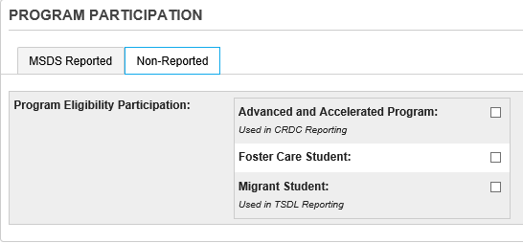

### Advanced and Accelerated Program (CRDC)

This field is not used for MSDS reporting but it will be used in CRDC reporting. If this field is checked, a value of 1 will export with the CRDC collection. Please refer to the CRDC Guide for more detailed information.

Field Name: S_MI_STU_GC_X.flagAdvanced

The following search will display students who have this field checked:

/S_MI_STU_GC_X.flagAdvanced=1

If students are listed, you can verify the data using the List Students function.

If you choose the clear the data, use the Student Field Value function.

Under the Program Participation component on the Non-Reported tab, the checkbox for the CRDC for the Advanced and Accelerated Program is housed here.

### Foster Care Student

This field is not used for MSDS reporting and is available for tracking purposes only.

Field Name: S_MI_STU_GC_X.flagFosterCare

The following search will display students who have this field checked:

/S_MI_STU_GC_X.flagFosterCare=1

If students are listed, you can verify the data using the List Students function.

If you choose the clear the data, use the Student Field Value function.

Under the Program Participation component on the Non-Reported tab, this checkbox is housed here.

### Migrant Student (TSDL)

This field is not used for MSDS reporting but it will be used in TSDL reporting. If this field is checked, a value of 1 will export with the TSDL collection. Please refer to the TSDL User Guide for more detailed information.

Field Name: S_MI_STU_GC_X.flagMigrant

The following search will display students who have this field checked:

/S_MI_STU_GC_X.flagMigrant=1

If students are listed, you can verify the data using the List Students function.

If you choose the clear the data, use the Student Field Value function.

Under the Program Participation component, on the Non-Reported tab, the checkbox to include Migrant Students in TSDL is housed here.

## School Demographics Component

The data collected in the School Demographics Component reflect the student's current relationship within the district. The School Demographics Component is required in all collections except Early Childhood and Request for UIC.

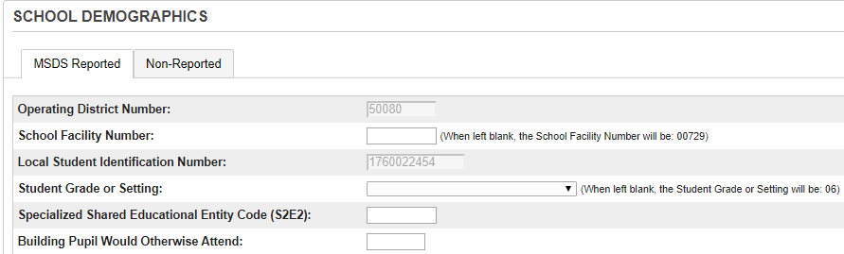

Operating District Number (F,S,E)

The state-assigned five-digit number, as recorded in EEM, which identifies the public school district responsible for providing education to the reported student. It is the district to which any applicable funds (state or federal) will be sent.

Field Name: [Pref]DistrictNumber

School Facility Number (F,S,E)

This field is set with a 5-digit state assigned building number in the Schools/School Info page which displays to the right of the MSDS School or Facility Number field and exports with all state reporting collections and prints on several state reports.

Field Name: S_MI_STU_GC_X.adminUnit

**IAM students** should have the number 09886 entered in this field and this number will export with all state collections.

**ECM students** should be reported with their local high school state assigned number which displays to the right of this field.

Search for students who have a value in this field:

/S_MI_STU_GC_X.adminunit#

If you have any students listed, use the List Students function to verify the data, or use the Student Field Value function to clear the data.

Local Student Identification Number (F,S,E)

The code given by the educating entity to identify the student. NOTE: This is different from the UIC generated by CEPI. Do not use the student's Social Security Number.

Field Name: [Students]Student­_Number

### Student Grade or Setting (F,S,E)

This field indicates the grade level or the educational setting in which the student is enrolled.

14 – Special Education Transition

A special program where the student might not be age-appropriately placed in a grade level. It is to be used for students 18 years or older who are participating in transitional services.

20 – Adult Education

A full-time-equated participant enrolled and attending a department-approved, adult basic-education program.

30 – Early Childhood / Early On

Children receiving early childhood special education or Early On services which are below the level of kindergarten. This does not include developmental kindergarten.



Field Name: S_MI_STU_GC_X.educSetting

Verify this field at the beginning of each school year since the student will most likely be in a new grade level in the new school year. The exception to this might be for students coded as grade 14.

Search for students that have any values other than 14, 20, or 30:

/S_MI_STU_GC_X.educsetting #14; S_MI_STU_GC_X.educsetting #20; S_MI_STU_GC_X.educsetting #30; S_MI_STU_GC_X.educsetting #

If students are listed, you can verify the data using the List Students function.

If you choose the clear the data, use the Student Field Value function.

Specialized Shared Educational Entity Code (EEM S2E2 code) (F,S,E)

If your district is a member of a Shared Educational Entity (SEE) or Specialized Shared Educational Entity (S2E2), there are some special reporting requirements. Refer to the CEPI Collection Details Manual for more information.

Field Name: S_MI_STU_GC_X.S2E2code

Search for students who have a value in this field that is not equal to blank:

/S_MI_STU_GC_X.S2E2code#

If you have any students listed, you can use the List Students function to verify the data or use the Student Field Value function to clear the data.

For Macomb County, please use the 03819 code in the S2E2 field for Early College of Macomb (ECM) students.

This needs to be completed due to the fact that the Early Middle College was made an S2E2 to separate/categorize the ECM from other programs at the state level.

How to verify that you have put in the “Specialized Shared Educational Entity Code (S2E2):” in the appropriate box. (It is **03819**.) Go to the student’s State/Province- MI Page > Click on School Demographics > Is the field filled in?

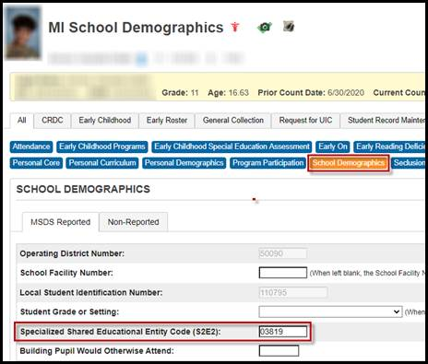

### Building Pupil Would Otherwise Attend (BPWOA)

**This is the building that a pupil would otherwise attend as specified in Sec. 104b (16) of the State School Aid Act.**

**PLEASE NOTE:**

For your **International Academy of Macomb (IAM) and Shared-Time students,** you will need to fill out the School Facility Number **AND** the Building Pupil Would Otherwise Attend fields in order for your school(s) to participate in the Sending Scores Back Program.

For ***IAM*** students for the School Facility Number, you will need to key in 09886 (09886 is the IAM’s #).

Why does the Building Pupil Would Otherwise Attend field need to be filled in for IAM students?

Because: 1. The students are receiving their education at another building. 2. If you want your students’ test scores sent back to their home district, the Building Pupil Would Otherwise Attend field needs to be filled in with the **BUILDING number that the student would attend if they attended a school within your district full-time**.

IAM Example: If you have a student that attends the IAM, the school facility number field would be filled in with 09886 and then the Building Pupil Would Otherwise Attend field would be filled in with your local High School’s school facility number. (**Please see the *two red rectangles* in the screenshot below**)

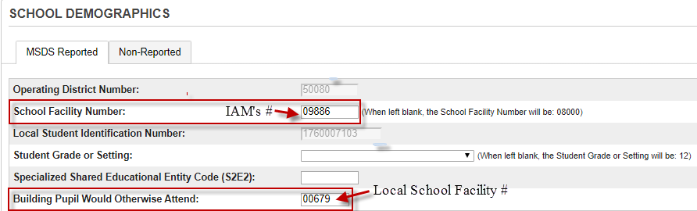

For ***Special Education*** *students for the* School Facility Number, you can leave this field blank since the field will **default** to the displayed School Facility Number on the screen. (Please see the two red rectangles in the screenshot below) **NOTE: This number is different per district**)

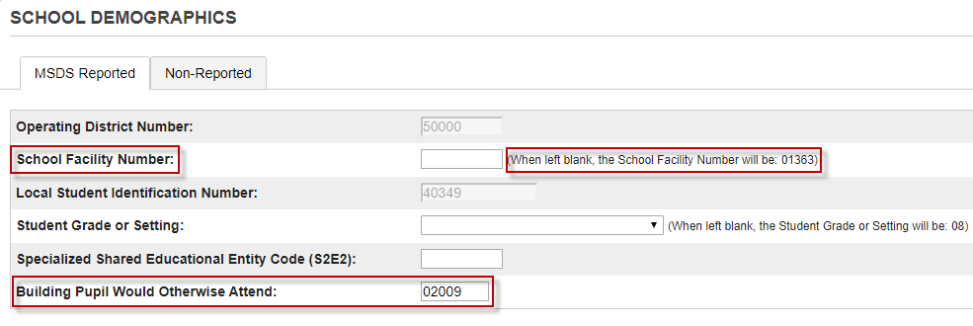

Why does the Building Pupil Would Otherwise Attend field need to be filled in for Special Education Students?

Because: 1. The students are receiving their education for a certain amount of an FTE at another building. 2. If you want your students’ test scores sent back to your home district, the Building Pupil Would Otherwise Attend field needs to be filled in with the **BUILDING number that the student would attend if they attended a school within your district full-time**.

**TIPS!**

Always communicate with the school that the Center based Program is housed in.

**If you still have questions about this field and how to report it to the state, please contact CEPI Customer Support at** [CEPI@michigan.gov](mailto:CEPI@michigan.gov) **or 517-335-0505 X3**

Operating ISD/ESA Number

*NO LONGER USED AS OF 2016-17 FOR STATE COLLECTIONS*

This field is set with a value of 50 in the District Information page which displays to the right of the Operating ISD/ESA Number field. Selecting another value from the dropdown menu will override the default value of 50. This field will remain on the state demographics tab, but will no longer be exported with state collections.

Field Name: S_MI_STU_GC_X.operISDESA

Note: The Operating ISD/ESA Number is no longer collected for state reporting and is located on the Non-Reported tab.

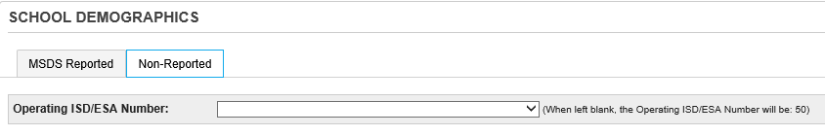

### Seclusion and Restraint Component (F,S,E)

The Seclusion and Restraint Component is used to collect data related to the use of emergency restraint and seclusion in the school district, public school academy, or intermediate school district program and is required to be reported when a student is secluded and/or restrained.

This component is submitted in the General and Early Childhood Collections. Under the statute, preschool pupils shall not be secluded, even in an emergency and therefore only restraints should be submitted. You must report the number of times in a day that a student was either restrained or secluded.

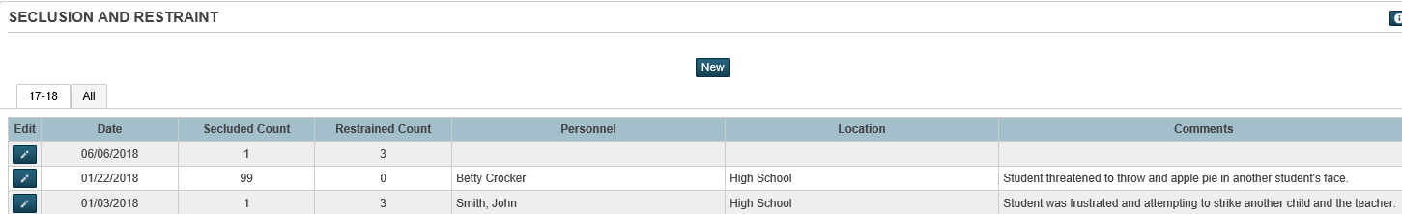

Note: Click on the pencil next to a Seclusion and Restraint record to edit the record, click the New button to enter a new Seclusion and Restraint record.

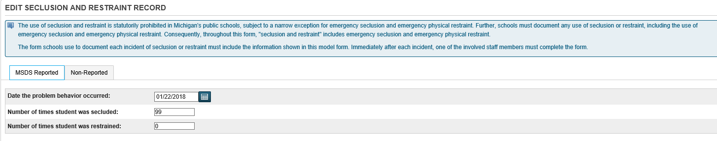

Note: The Non-Reported tab contains data entry fields for data that is not reported in MSDS, but may be used for additional reporting requirements.

## Section 23a Component

The Section 23a Component is used to claim one-twelfth (1/12) of a full-time equivalency for each month that an eligible student was enrolled in a Dropout Recovery Program. Only students who meet the requirements as outlined in the legislation (Public Act No. 465, Section 6(4)(dd) and Section 23a) may be claimed for Section 23a funding.

The Section 23A component is only submitted in the Student Record Maintenance (SRM) collection. For documentation, go to [http://powerschool.misd.net](http://powerschool.misd.net/) > STATE > State Reports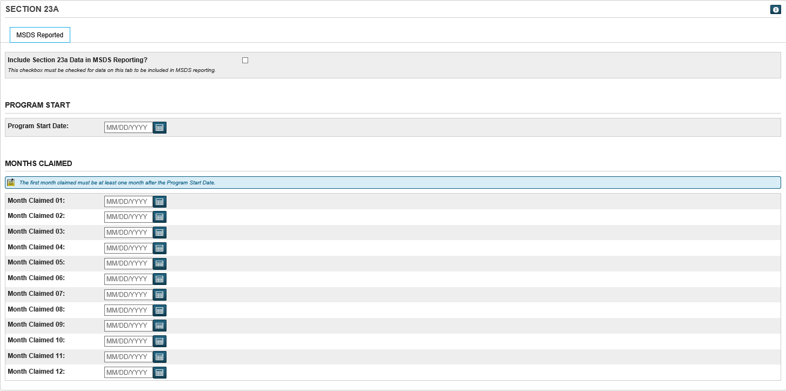

## Section 25 Component

The Section 25 Component is used to request a pro-rated share FTE for pupils who enrolled into your district between the Fall Pupil Membership and Spring Supplemental count dates.

This field is used for Section 25 students and should contain the date that the student first entered the district. This date is exported with the SRM collection.

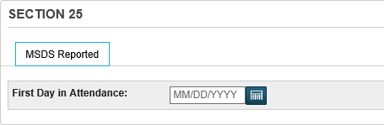

Field Name: S_MI_STU_GC_X.firstAttendDate

Search for students who have a value in this field that is not equal to blank:

/S_MI_STU_GC_X.firstAttendDate#

If you have any students listed, use the List Students function to verify the data.

If you wish to clear the data, use the Student Field Value function.

Refer to the Section 25 SRM State Reporting Procedures document posted on our knowledge base for details on how to submit an SRM for Section 25 students [http://powerschool.misd.net](http://powerschool.misd.net/) > STATE

## Supplemental Nutrition Eligibility Component (SNE) (F,S,E)

The SNE Component is used to report the student's eligibility for free or reduced-price milk or meals through the National School Lunch Program. Data reported in this component is used to identify economically disadvantaged students. These data are used for categorical funding allocations, such as e-rate and Section 31a at risk, as well as in a multitude of state and federal reports. It must be submitted for each student who is determined to meet eligibility requirements for free or reduced-price meals.

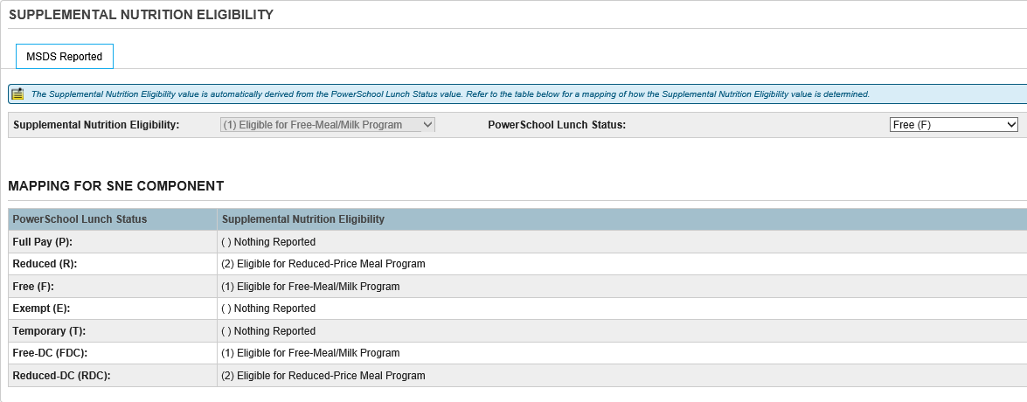

Field Name: LunchStatus

Search for students who have a value in this field that is not equal to blank:

/LunchStatus#

If you have any students listed, use the List Students function to verify and correct the data.

If you wish to clear the data at the beginning of the school year, use the Student Field Value function.

## Special Education Component (F,S,E)

The Special Education Component is used to collect data related to the student's participation in special education programming or services. This component must be reported for any student with an active IEP or who has been exited from special education services since last being reported. The data collected via this component in the Fall General Collection are used to complete the federal Special Education Child Count.

**Special Education Student Field Name: S_MI_STU_GC_X.flagSpecEd**

The following search will display students who have this field checked:

/S_MI_STU_GC_X.flagSpecEd=1

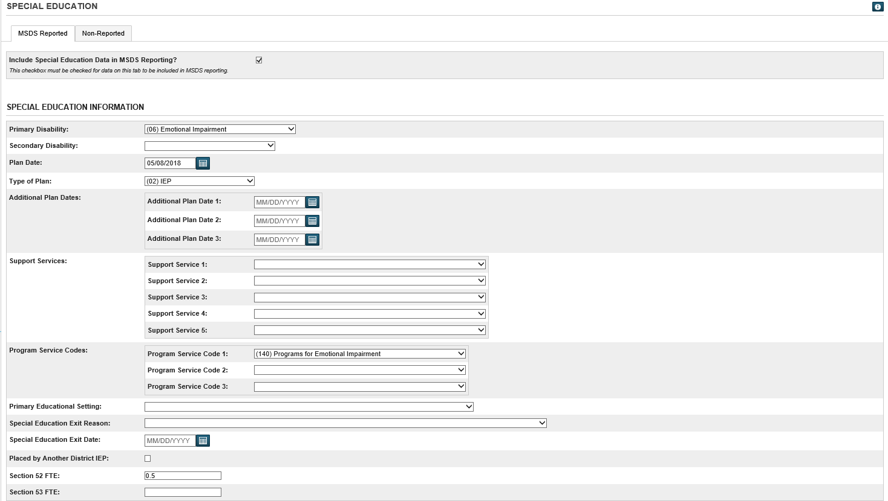

Plan Dates will only be exported if they occur between the previous count date and the current count date fields that are entered in the MI General/SRM/Early Childhood report interface.

In Macomb, the Spec Ed tab is populated daily though an AutoComm process from PowerSchool Special Ed.

Fields that import from PowerSchool SE are as follows:

Student_Number (PowerSchool student number)

S_MI_STU_GC_X.FTE (general ed fte)

S_MI_STU_GC_X.FTE52 (spec ed section 52 fte)

S_MI_STU_GC_X.FTE53 (spec ed section 53 fte)

S_MI_STU_GC_X.FLAGSPECED (MSDS special education student flag/checkbox)

S_MI_STU_GC_X.SECONSENTDATE (parent consent date)

S_MI_STU_GC_X.SEINITIALRESULTDATE (determination date)

S_MI_STU_GC_X.SEINITIALTIMELY (timeliness of initial IEP)

S_MI_STU_GC_X.SEINITIALTIMEPC (part c transition timeliness)

S_MI_STU_GC_X.SEINITIALRESULT (result of initial IEP)

S_MI_STU_GC_X.SEINITIALDAYS (calendar days beyond allowed time period)

S_MI_STU_GC_X.SEFAPEDATE (initial FAPE date)

S_MI_STU_GC_X.SEPRIDISABILITY (primary disability code)

S_MI_STU_GC_X.SEADDDISABILITY (additional disability code)

S_MI_STU_GC_X.SEIEPDATE (plan date) (current IEP date)

S_MI_STU_GC_X.SEADDPLANDATE1 (additional plan date 1)

S_MI_STU_GC_X.SEADDPLANDATE2 (additional plan date 2)

S_MI_STU_GC_X.SEADDPLANDATE3 (additional plan date 3)

S_MI_STU_GC_X.SESERVICE1 (support service code 1)

S_MI_STU_GC_X.SESERVICE2 (support service code 2)

S_MI_STU_GC_X.SESERVICE3 (support service code 3)

S_MI_STU_GC_X.SESERVICE4 (support service code 4)

S_MI_STU_GC_X.SESERVICE5 (support service code 5)

S_MI_STU_GC_X.SEPRGM1 (program service code 1)

S_MI_STU_GC_X.SEPRGM2 (program service code 2)

S_MI_STU_GC_X.SEPRGM3 (program service code 3)

S_MI_STU_GC_X.SEPRISETTING (primary educational setting)

S_MI_STU_GC_X.SEIEPANOTHERDIST (placed in district by another district IEP)

S_MI_STU_GC_X.SEEXITCODE (exit code)

S_MI_STU_GC_X.SEEXITDATE (spec ed exit date)

S_MI_STU_GC_X.SEPEPE (district in charge)

S_MI_STU_GC_X.SEPLANTYPE (plan type) (new Fall 2016)

**Tips!**

The PowerSchool Special Ed to PowerSchool import program runs at 10:00am, 12:00pm, 2:00pm, and 4:00pm. This process is NOT the automatic process that kicks-off each evening but is a process where a file is copied to the server at different times during the day.

If you are troubleshooting an issue and do not want to wait overnight for the data to be imported into PowerSchool, then you can import the data into PowerSchool manually using the TIEnet Reset and TIEnet Import “Run Now” commands.

The TIEnet Reset should be run first, followed by the TIEnet Import

**The Non-Reported tab contains additional Special Education information that is not reported in MSDS, but is used in other reports, such as the Worksheet A and Worksheet B.**

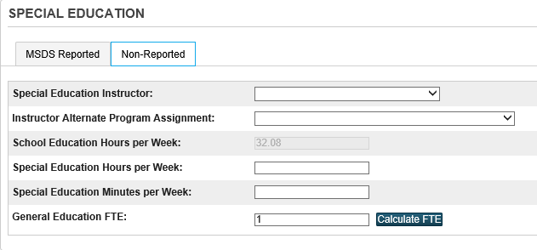

Prior to the Fall and Spring counts, you can clear FTE values for inactive students. Use the following searches to identify exited students who have FTE values:

Search for inactive students:

/enroll_status=2

If students are listed, you can clear the data using the Student Field Value function:

Field to Change: S_MI_STU_GC_X.FTE52

Check the “Clear Field Value” checkbox

Submit

Your inactive student selection should still be active so use the Student Field Value function:

Field to Change: S_MI_STU_GC_X.FTE53

Check the “Clear Field Value” checkbox

Submit

## Student Record Maintenance Component

The date in this field usually indicates the date the change took place in a student’s record. If this field is left blank, then the Current Count Date that is entered in the SRM report interface will export as the As of Date in the student’s record.

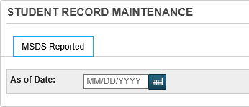

Field Name: S_MI_STU_GC_X.SRMDate

You may want to clear this field after an SRM submission is done.

Refer to the Student Record Maintenance (SRM) Best Practices documentation located on our MISD Knowledge Base:

http://powerschool.misd.net/statereporting/state-reports/

## Title 1 Services Component (F,S,E)

The Title I support service(s) received by the student in a Targeted Assistance Schools program. Include only those support services provided in whole or in part with Title I funds. Schoolwide programs (SWP) are collected via the Michigan Electronic Grants System (MEGS).

This component is required for any student who receives instructional or support services provided in whole or in part with Title I funds as part of a Targeted Assistance School program. This component may be submitted though a General (Fall, Spring or EOY) or Student Record Maintenance Collection.

Note: students that are initially found eligible in the Fall for Title 1 services and are reported in the Fall General Collection should remain coded for the rest of the year.

**Title 1 Student Participant Field Name: S_MI_STU_GC_X.flagTitle1**

The following search will display students who have this field checked:

/S_MI_STU_GC_X.flagTitle1=1

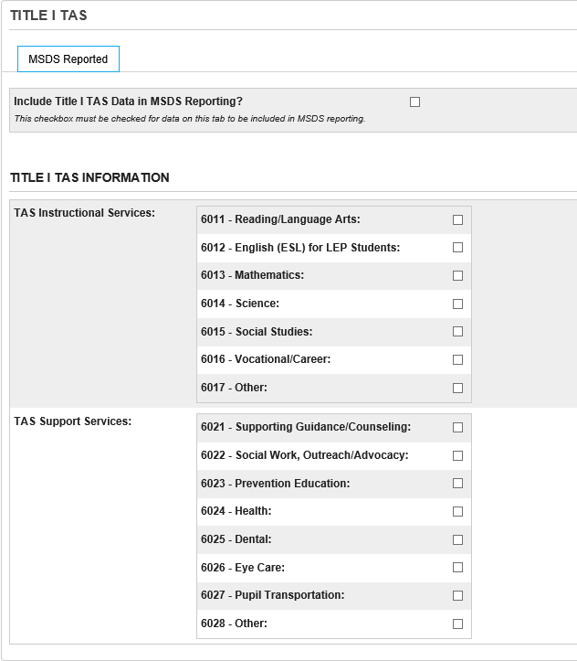

**TAS (Targeted Assistance Schools) Instructional Services**

The Title I instructional service(s) received by the student in a Targeted Assistance Schools program. Include only those instructional services provided in whole or in part with Title I funds. Schoolwide programs (SWP) are collected via Michigan Electronic Grants System (MEGS).

Choose the code that represents the instructional program in which the student participates or participated.

This characteristic must be reported when the Title I TAS Component is submitted and at least one occurrence of the TAS Support Services characteristic is not included.

This characteristic may be submitted up to seven times (one per code) within the Title I TAS Component when the student receives multiple services.

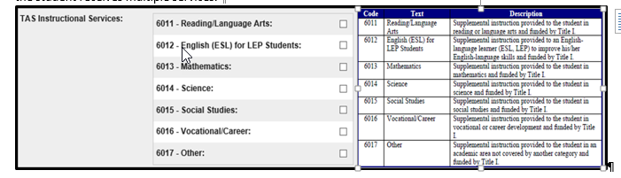

**AS (Targeted Assistance Schools) Support Services**

The Title I support service(s) received by the student in a Targeted Assistance Schools program. Include only those support services provided in whole or in part with Title I funds. Schoolwide programs (SWP) are collected via the Michigan Electronic Grants System (MEGS).

Choose/enter the code that represents the support service the student receives.

This characteristic may be submitted up to eight times (one per code) within the Title I TAS Component when the student receives multiple services.

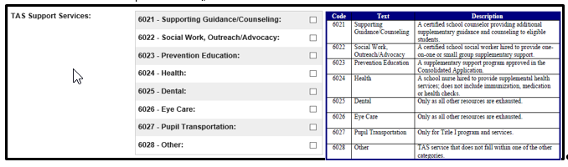

## Title III English Learner and Immigrant (F,S,E)

This component is required when a student has been identified as EL and is eligible for services and to ensure eligibility for Title III funding. If a student has been reported as EL eligible in the past 12 months and has not been reported with a LEP exit date, an error will occur if the Title III EL component is not submitted. Additionally, if a student has been exited and it is determined later that they need further EL services, they can be resubmitted, but must be reported with a LEP Re-Entry Date. If no re-entry date is reported, an error will occur.

It is also required when an English Learner student is identified as Immigrant and is eligible to receive Immigrant services, they must be reported with code 9130 in the Program Participation Component.

**Exiting EL Students**

NEW:Upon completion of the MSDS EOY General collection, the State of Michigan will automatically exit WIDA proficient students in grades 3-12 with an EL Exit date of June 30 of the current school year.

Manual exits will still be required for EL students in grades K-2 and for migrant students that tested proficient in another state.

EL students may be exited from EL eligibility and/or services either by testing Proficient on the WIDA assessment test or when they graduate from the district. If a student tests proficient they should be exited using the LEP Exit Date within the EL Component. If a student is graduating, but hasn’t passed the WIDA, they will only be exited in the Enrollment Component. If a student tests proficient and is graduating, it is expected that both the LEP Exit Date within the EL Component and the District Exit Status & District Exit Date within the Enrollment Component would be completed.

**Limited English Proficiency Student Field Name: S_MI_STU_GC_X.flagLEP**

The following search will display students who have this field checked:

/S_MI_STU_GC_X.flagLEP=1

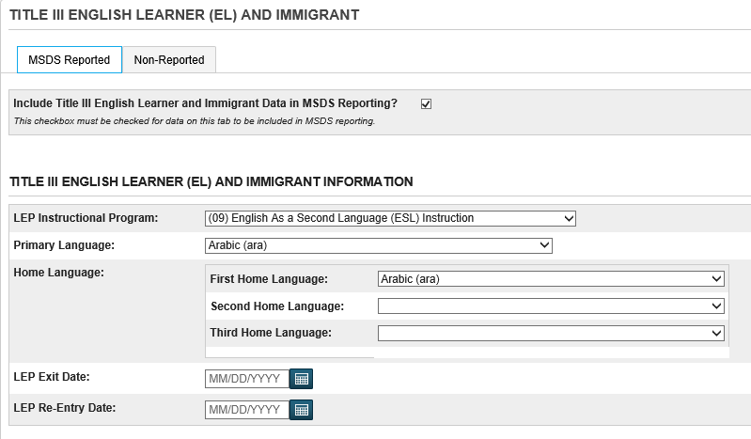

Students cannot have more than one occurrence of a language in the First language spoken, Second language spoken, and Language spoken by adults (parents) dropdown fields.

Note: The Non-Reported tab contains information that is not reported in MSDS submissions but may be useful for district information.

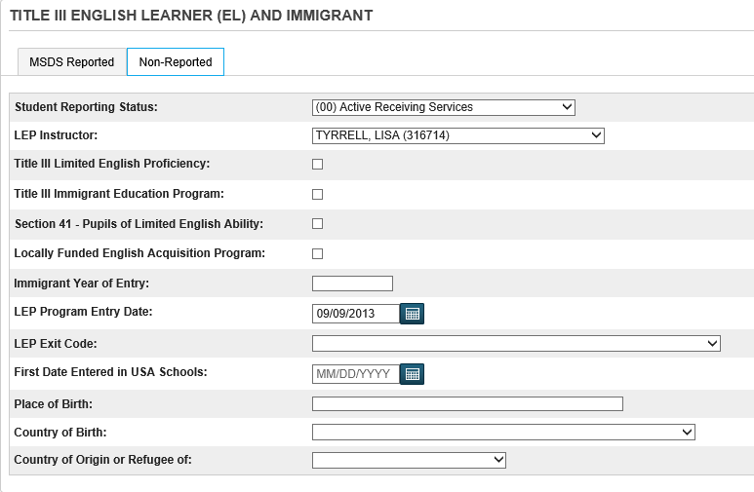

## Obsolete tab (Adult Ed)

Beginning in the 2016-2017 school year, the funding model for Adult Education is now 100% grant funded and not based on pupil FTE counts. As a result, the Adult Education Component and corresponding characteristics have been retired and are no longer being collected in MSDS submissions.

Students being reported in Grade 20 can only be submitted to MSDS for purposes of updating the student’s exit status. Students in Grade 20 submitted without an Exit Date will result in an error in MSDS. PowerSchool will only export students in Grade 20 with an Exit Date within the current count period in the General Collection and SRM Collection. Students in Grade 20 without an Exit Date will automatically be excluded.

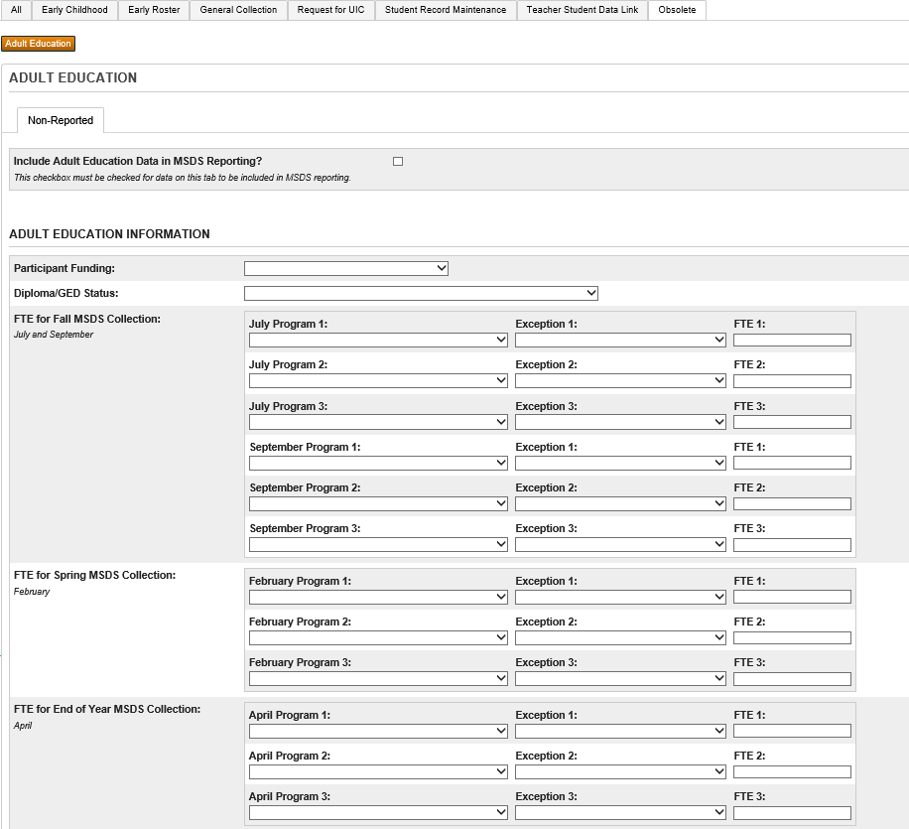

# On Count Day

## Teacher Attendance on Count Day (F,S)

Verify throughout the day and by the end of count day that **all** teachers have taken attendance.

* Attendance > Teacher Attendance Submission Status
* Date: enter count date
* Sort: Alpha
* Show All
* Print Screen (should see all green icons; Elementary Schools will see yellow icons)

## Weekly Teacher Attendance Reports (F,S)

**Important! Need to have weekly attendance reports signed by the teacher – the week before count day, the week of count day, and weekly for the following 4 weeks.**

OFFICE STAFF – Print Class Attendance Audit Report

* System Reports > Class Attendance Audit Report
* Enter the weekly range
* All Teachers
* All Periods
* Submit

TEACHERS – Print Weekly Attendance Review from PowerTeacher

* Student Information (Backpack)
* Weekly Attendance Review – Menu on the left
* **Print and sign the report – full signatures in INK**

## Class Rosters (F,S)

Print Class Rosters:

System Reports > Class Rosters (PDF)

Print rosters for: Select All Teachers

Include students who: were enrolled on xx/xx/xxxx (use count date)

Heading text (fields):

* + Count Day xx/xx/xxxx Class Rosters (use correct count date)
  + ^(teachername)
  + ^(expression)
  + Teacher Signature:________________________Date:___________
  + Student Enrollment ~(count)
* Roster columns:
  + LastFirst
  + DOB
  + Grade_level

Options:

Check if Absent

Watermark text:

Custom

Enter in Official Count Day xx/xx/xxxx (use correct count date)

Watermark mode: Watermark

* Submit

## Student Schedules (F,S) - Student Schedule Listing

**Note: Be aware of the term duration when running this report**

Print Student Schedule Listing:

*enrolled_on=##/##/20## (enter in the count date)

System Reports > Student Schedule Listing

Students to Include: The selected #### students

Report Title: enter in Student Schedules as of ##/##/20## (count date)

Include for Each Class: select Room, Course, Teacher options

**Scan Enrollments active on this Date: leave blank (If you do not leave this field blank, it will not run.)**

Range of Periods – select period range

Range of Days – select day range

How many students between breaks: select 15 or whatever works best for your school

Schedules render to the screen. To save paper, print to a PDF printer. This is a best practice since Roberta will want these schedules given to her electronically. If printing, use your browser Windows Page Setup to adjust scale and orientation.

## Student Schedules (F,S) - Student Schedule Report

**Note: Be aware of the term duration when running this report**

Print Student Schedule Report:

*enrolled_on=##/##/20## (enter in the count date)

Functions > Student Schedule Report

Report Title: enter in Student Schedules as of ##/##/20## (count date)

Students to scan: the selected #### students

Max Students per Page: 2

Sort Order: Last Name

Includes Active Enrollments As Of: enter in count date

Show Dropped Enrollments in Separate List: leave blank

Bell Schedule for Period Start/End Times: leave blank

Color Sections By: your choice

## Student Schedules (F,S) – Student Schedule – v2.0

Print Individual Student Schedules:

*enrolled_on=##/##/20## (enter in the count date)

Functions > Print Reports

Which report would you like to print? Select Student Schedule – v. 2.0

For which students? Your selection of students should appear to the right of the question. All records in a single batch will be selected by default - leave as is.

In what order? Alphabetical

If printing student schedules, use…: courses actively enrolled in during current term

If printing fee list… leave blank

Watermark Text: select Custom from the menu. In the box below type: Count Day ##/##/20##

Watermark Mode: select Watermark

When to print: ASAP

Submit

Schedules render to the Report Queue (System). Click on the View link and open to review schedules, or you right click on the View link to save the file.

## Master Schedule (F,S)

Print Master Schedule / Teacher Schedules:

Start Page > Master Schedule

Periods: select period(s)

Days: select days

Rooms: select room(s)

Teachers: select teacher(s)

Sort by: choose sort order

View By: choose view preference

## Building Calendar (F,S)

Print the Calendar:

Verify that you are in the building and full year

School > Calendar Setup

Scroll to bottom of screen and select Verify # of school days in the current term

Print

## Bell Schedules (F,S)

Print Bell Schedules:

* Please reference the documentation that was provided by Roberta Farina in regards to what schedules are accepted and submitted in Macomb.
* School > Bell Schedules. Choose the printer icon to print the screen showing all bell schedules.
* To print individual bell schedules, select the bell schedule name, choose the printer icon to print the screen for the individual bell schedule.

Use MPAAA FTE Calculator Form to calculate total minutes available at  
<http://mpaaa.org/downloads.php>

## Attendance Codes (F,S)

Print Attendance Codes:

Attendance Codes for Auditors Report

System Reports > sqlReports4 > State Reporting > Attendance Codes for Auditors

## Enrollment Summary Report (F,S,E)

Print Enrollment Summary:

Verify that you are in the building

Start Page > Enrollment Summary (make sure the count day is correct)

## Monthly Exit/Transfer In Report (gain/loss report) (F,S,E)

Print MI Monthly Exit/Transfer-In Report:

System Reports > State Tab > MI Monthly Exit/Transfer-In Report

Enter the previous count date for Start Date of the Reporting Period

Enter the current count date for End Date of the Reporting Period

Enter an As Of Date

Submit

## Code 10 Day Rule on Pupil Accounting Screen (F,S)

Code the 10 Day Rule on the Pupil Accounting Screen:

Attendance > Reports tab > Absentee Report

Use Ctrl key to select all the **unexcused absence codes for the 10 day rule**

**Do not include tardies**

Date to Scan: enter in the count date

Submit

Report Queue > View Report

Select Functions at bottom of page

Select Student Field Value

Field to Change: U_MISD.Pupil_1030DayRule

New Field Value: **10**

Submit

## Code 30 Day Rule on Pupil Accounting Screen (F,S)

Code the 30 Day Rule on the Pupil Accounting Screen:

Attendance > Reports tab > Absentee Report

Use Ctrl key to select all the **excused absence codes for the 30 day rule**

**Do not include tardies**

Date to Scan: enter in the count date

Submit

Report Queue > View Report

Select Functions at bottom of page

Select Student Field Value

Field to Change: U_MISD.Pupil_1030DayRule

New Field Value: **30**

Submit

## Code 45 Day Rule on Pupil Accounting Screen (F,S)

Code the 45 Day Rule on the Pupil Accounting Screen:

Attendance > Reports tab > Absentee Report

Use Ctrl key to select all the **suspension absence codes for the 45 day rule**

**Do not include tardies**

Date to Scan: enter in the count date

Submit

Report Queue > View Report

Select Functions at bottom of page

Select Student Field Value

Field to Change: U_MISD.Pupil_1030DayRule

New Field Value: **45**

Submit

## PowerSchool SE – Nightly Update to PowerSchool (F,S,E)

The Management Technology Department creates a frozen PowerSchool Special Ed database at approximately 6:00am the morning after count day. The MISD Special Ed and Management Tech departments will distribute documentation describing this process and the steps you will need to take to manage the data that is imported from PowerSchool SE into PowerSchool each evening.

Steps to Flow Snapshot Data – “TIEnet Reset”

1. Within PowerSchool SIS, navigate to: District Office > System > AutoComm Setup
2. Select the **TIEnet Reset** link.
3. Verify that the “Turn Execution Off” checkbox is **NOT** selected.
4. In the Path field, add “**YYS**” after the word Reset.   
   Example: TIEnet_50000_Reset18S.txt (note: 50000 represents the MISD district).  
   Note: In the screenshot above, **YY** = Year; **?** = F for Fall or S for Spring
5. Click Submit at the bottom of the page.

Steps to Flow Snapshot Data – “TIEnet Import”

1. Within PowerSchool SIS, navigate to: District Office > System > AutoComm Setup
2. Select the **TIEnet Import** link.
3. Verify that the “Turn Execution Off” checkbox is **NOT** selected.
4. In the Path field, add “**YYS**” after the word Output.   
   Example: TIEnet_50000_Output18S.txt (note: 50000 represents the MISD district)  
   Note: In the screenshot above, **YY** = Year; **?** = F for Fall or S for Spring
5. Click Submit at the bottom of the page.

**Please refer to the PowerSchool Special Education to PowerSchool Student Information System Data Flow documentation that describes this process in detail.**

## Free/Reduced Lunch (F,S)

The Free/Reduced Lunch status information can be maintained using several different methods:

Manual Entry on the Lunch page in PowerSchool (see screenshot)

MISD Import Utility Enhancement – refer to MISD Enhancement documentation

Quick Import using the Direct Cert file from CEPI – refer to PowerSchool Knowledgebase

Updated via Meal Magic AutoComm

Reminder: Verify Lunch Status for your students using the List Students function and include the LunchStatus field.

LunchStatus=F is Free, LunchStatus=R is Reduced, and LunchStatus=P is Full Pay.

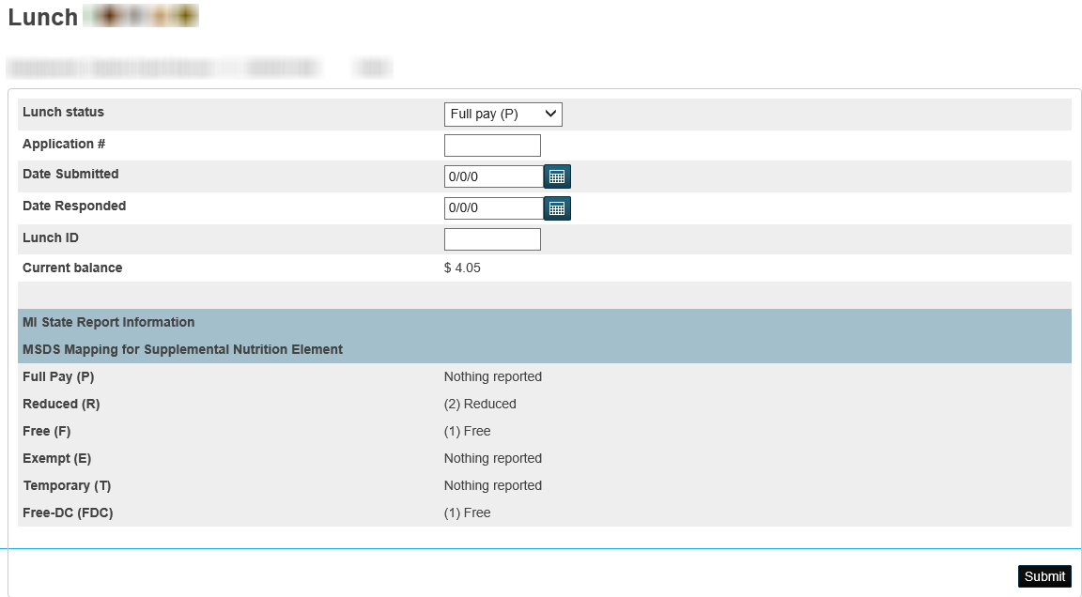

## Discipline (F,S,E)

According to the [www.michigan.gov](http://www.michigan.gov/) website,

“Under the current law, MDE cannot require districts to submit suspension data for students without an Individual Education Plan. MDE will continue to encourage all districts to voluntarily submit this important data for all students so Michigan can focus all levels of the education system on improving school climate and equitable access to high-quality learning environments. MDE will also continue to report data provided by participating districts on its website for transparency purposes and to use this data in collaboration with partners to offer targeted supports to participating districts. MDE will not take adverse action if a district chooses not to submit suspension data for students without an IEP”.

Use Log Entries to record student discipline.

Discipline types required for state reporting:

In-School Suspensions (SPECIAL EDUCATION STUDENTS)

Out-of-School Suspensions (SPECIAL EDUCATION STUDENTS)

Removals (SPECIAL ED STUDENTS ONLY)

Expulsions (ALL STUDENTS)

Discipline is automatically exported when you run a Fall, Spring or EOY General Collection as well as a Student Record Maintenance (SRM) collection. Note: These collections will export discipline for the entire year. For example, in the Spring General Collection, discipline will be exported from the beginning of the school year and not just for the spring count period.

Student disciplines will overwrite in MSDS if they are submitted with the same UIC and Incident ID, they will NOT add additional discipline records for the student. With the discipline being cumulative over the course of the year, the MSDS General Collection was updated to include ALL incidents to assist districts identify students with more than 10 days of suspensions for the purpose of recording the required follow up for these students.

**Note - Follow-up is required for All expulsions and for Special Education students with more than 10 cumulative days of In-School Suspensions, Out-of-School Suspensions, and/or Removals.

**As of the January 2018 PowerSchool State Reporting Release, fields were made available to track the Disciplinary Factors required to be considered before administering suspensions or expulsions.**

**Section 1310d Disciplinary Factors, MCL 380.1310d otherwise referred to as “Disciplinary Factors” is used to meet the requirement of school officials, before suspending or expelling a student, to consider a number of situation-specific factors, including whether a lesser intervention or restorative practices would address the pupil’s violation or behavior.**

**The Disciplinary Factors section is located in the Michigan State Information area of the Log Entry page within PowerSchool. This data is not submitted or reported to MSDS and is provided as a tool to make meeting the requirement of tracking and considering these factors easier.**

Use Log Entries to Record All Student Discipline

Start Page > Select a Student

Log Entries

Click the New button

Log Type - select Discipline from the dropdown menu. This is important to reveal state specific fields at the bottom of the page.

Incident Date - this date is included in the export. It defaults to the current dates and can be modified.

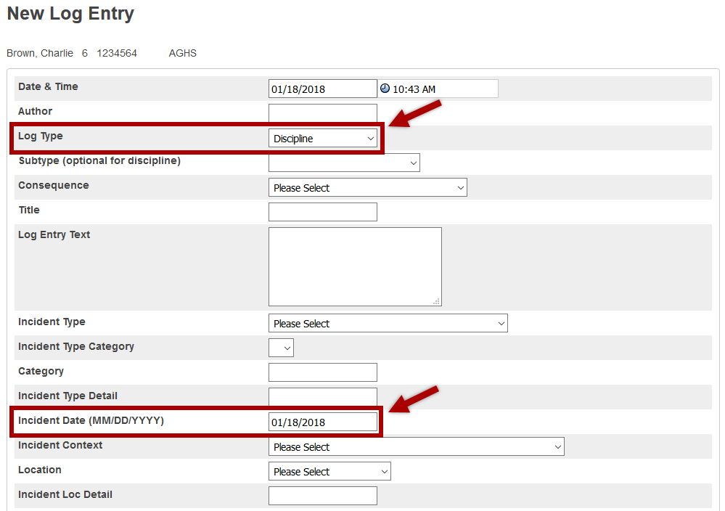

Michigan State Information

Include in State Reporting - select Yes.

Incident ID – click the Generate ID button to assign an Incident ID.

Incident Type – click on an incident type to select it. Use Ctrl-Click to select one or more incident types for the log entry.

The Incident Caused Bodily Injury – check the box if applicable. Note: serious bodily injury can only be submitted with incident type 60(Physical Violence with Injury)

The Incident was a Sexual Assault – check the box if applicable. Note: sexual assault can only be submitted with incident types 60(Physical Violence with Injury) and 61(Physical Violence without Injury)

Estimated Cost of Property Damage – SID reporting only.

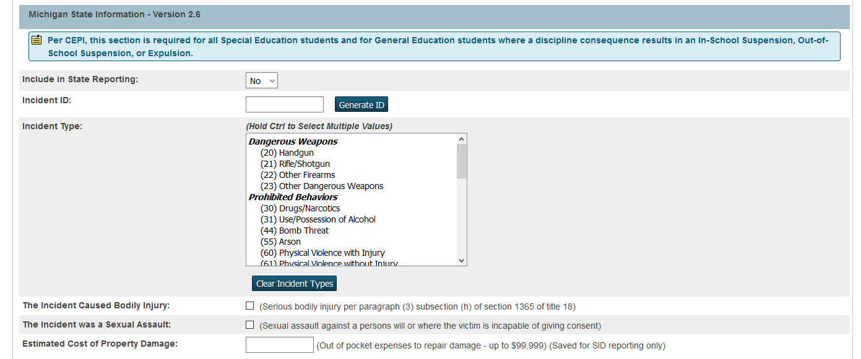

Section 1310d Disciplinary Factors

**Before suspending or expelling a student, building administration must complete this section. Section 1310d requires school officials to consider the following factors:**

* Did the student possess a firearm on school property or at a school event?
  + If Yes, there is no need to complete the remainder of the Disciplinary Factors section. Selecting YES will hide the remainder of this section.
* Does student have a disciplinary history?
  + If Yes, two factors are available:
    - Briefly describe the relevant discipline.
    - Is the current misconduct similar to past misconduct?
  + If No, one factor is available:
    - Is the current misconduct similar to past misconduct?
* Is the student a student with a disability? – Select Yes or No.
* Did the misconduct threaten the safety of any student or staff member? – Select Yes or No.
* Will restorative practices be used to address the misconduct? – Select Yes or No. If YES, briefly describe the restorative practices that will be used. Restorative practices must be considered in addition to, or in lieu of, suspension or expulsion.
* Is there an intervention other than suspension/expulsion that would address the misconduct?
  + If No, one factor is available:
    - Why not? Briefly describe the misconduct.
  + If Yes, one factor is available:
    - Will the lesser intervention be used? Select Yes or No.

**If the above factors, and the seriousness of the misconduct have been considered, proceed with administering appropriate disciplinary action.**

Proceed with Consequence Section

Action Taken – select Initial Consequence, Secondary Consequence, Other Consequence (select only one for each consequence)

Consequence Days in Half Day Increments – enter in Initial, Secondary, Other

Start Date of Student Serving the Consequence – enter in Initial, Secondary, Other

Follow-Up Expulsion Codes – follow-up is required for any expelled student and for Special Education students removed from the educational setting for more than 10 days

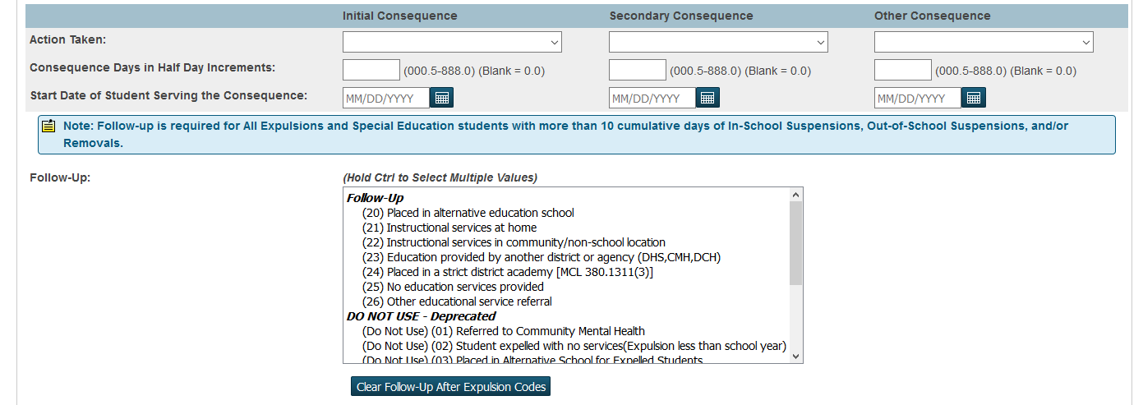

To search for Special Education students with disciplines and print the log report:

S_MI_STU_GC_X.SePriDisability#

System Reports > Discipline Log Report

Check radio button for the selected students only

Fill in Date Range

All Sub-Types

Submit

To verify discipline records that are tagged to be included in state reporting:

System Reports > State Tab > MI Discipline

Choose the Selected students are All students

Fill in Previous Count Date

Fill in Count Date

Submit

Note: This report will include a notation indicating that the student is a General Education Student by displaying (GE) after the student’s UIC number. This report also contains a column that totals the number of expulsions a student has that may need follow up.

## StuFTE – Membership Report (F,S,E)

Use the following steps to run the StuFTE Membership report:

**Note: This report MUST be run at the building level and it is recommended that you run the Refresh Premier Attendance Views Data function prior to running the report.**

1. Navigate to: *System Reports > State Reporting*



1. Select the StuFTE - Membership Report
2. On the report interface, enter the Count Date and choose whether to run for All Students or for Selected Students.

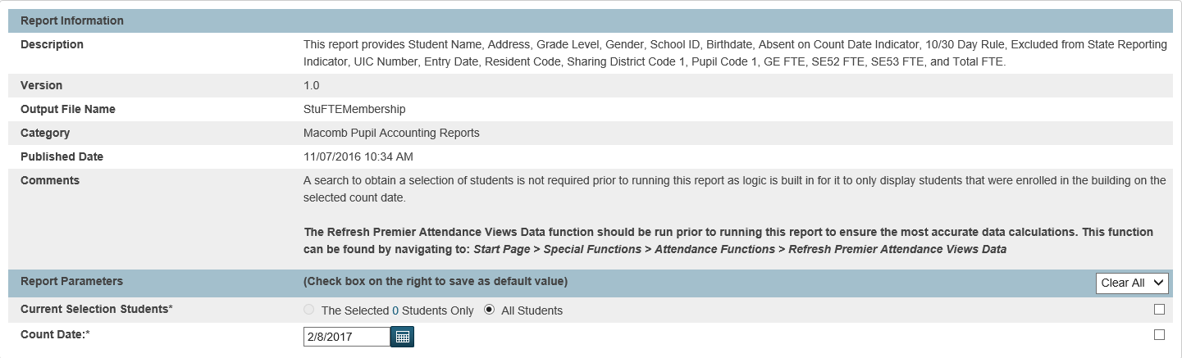

## Pupil Share Code Reports (F,S)

Use the following steps to run the Pupil Share Code Reports from the State Reporting Tab:

**Note: These reports MUST be run at the building level.**

1. Navigate to: *System Reports > State Reporting*



1. Select the desired Pupil Share Code Report
2. On the report interface, enter the Count Date and choose whether to run for All Students or for Selected Students.

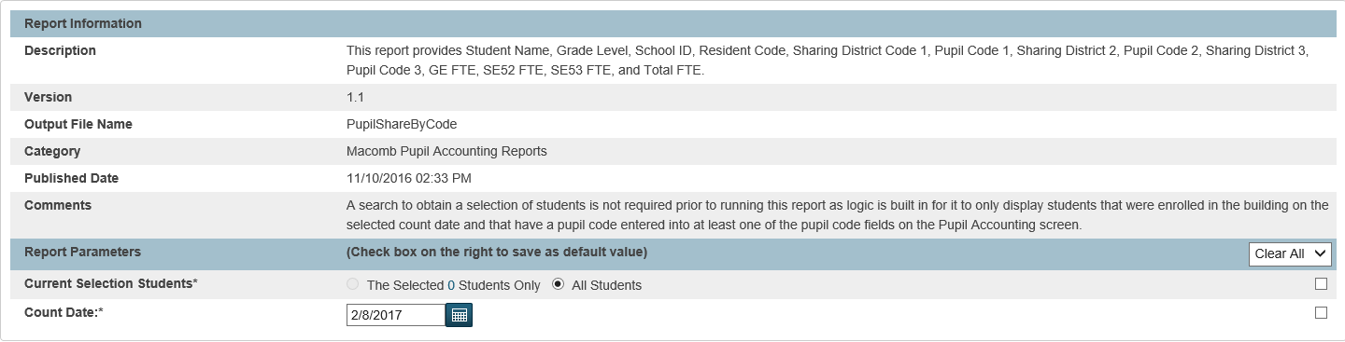

## Official Enrollment Student Roster (F,S,E)

Print the MI Official Enrollment Student Roster Report:

Can be run at the district or building level

System Reports > State Reporting > MI Official Enrollment Student Roster Report

Current Selection Student: The Selected ### Students Only or All Students

Count Date: enter the current count date

Submit

## 4061 FTE (F,S)

Print the MI 4061 FTE Report:

Can be run at the district or building level

System Reports > State Reporting > MI 4061 FTE

Count Date

Calculate Age Date: use September 1st of the current school year. Note: this date is used to calculate the age of alternative education students.

Reporting Period: select appropriate reporting period (Fall, Spring)

Submit

Note: This report is also available in PowerSchool Special Ed.

## Worksheet A (F,S) (Macomb runs out of PowerSchool SE)

To ensure that the Worksheet A reports your district data accurately, make sure that teacher information is coded correctly in the Staff page and students are coded correctly on the State/Province Special Education tab. Refer to the Worksheet A Setup instructions at the back of this document. **For students who change buildings after count day, do not update the teacher on the Special Ed tab of the State/Province-MI page for the student until after the Worksheet A has been printed.**

Print the MI Worksheet A Report:

Can be run at the district or building level

System Reports > State Reporting > MI Worksheet A

Count Date: enter in count date

Enter the District Name if the proper district name is not displayed

Submit

Note: This report is also available in PowerSchool Special Ed.

## Worksheet B (F,S) (Macomb runs out of PowerSchool SE)

To ensure that the Worksheet A reports your district data accurately, make sure that teacher information is coded correctly in the Staff page and students are coded correctly on the State/Province Special Education tab. Refer to the Worksheet B Setup instructions at the back of this document. **For students who change buildings after count day, do not update the teacher on the Special Ed tab of the State/Province-MI page for the student until after the Worksheet B has been printed.**

Print the Worksheet B Report:

Can be run at the district or building level

System Reports > State Reporting > Michigan Worksheet B

Count Date: enter in count date

Enter the District Name if the proper district name is not displayed

Submit

Note: This report is also available in PowerSchool Special Ed. The report numbers from PSSP and PS SIS do not match.

## Third Grade Retention Collection (EOY / Summer)

Per CEPI: “The Third Grade Retention Decision Component is used to capture district retention decisions for third grade students who are subject to retention per the Read by Grade Three law (State School Aid Act, Sec. 1280f).

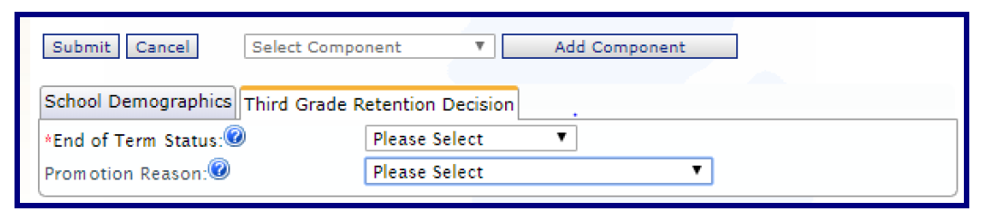

When is this Component Required?

Per CEPI: “If your district has third grade students who are subject to retention per the Read by Grade Three law, then this Component is required to be submitted in the Third Grade Retention Collection, occurring the first time during the **summer of 2021**”.

EndofTermStatus

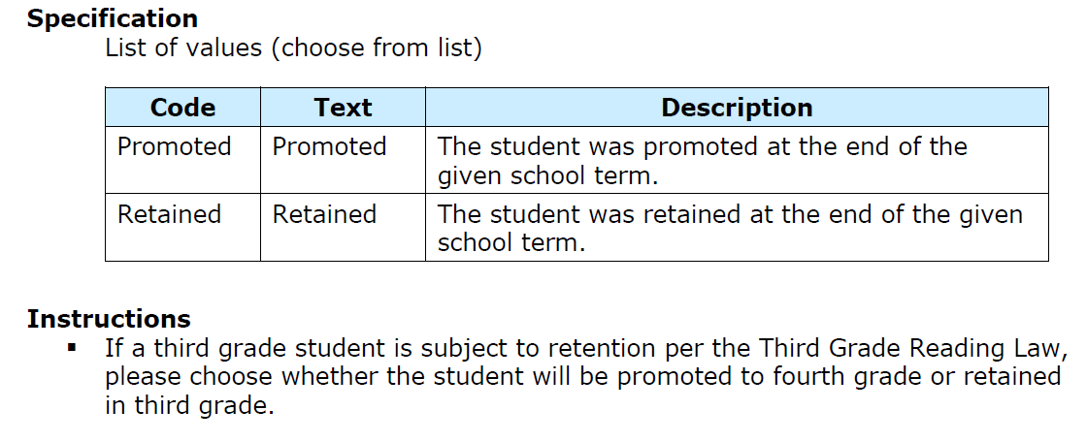

PromotionReason

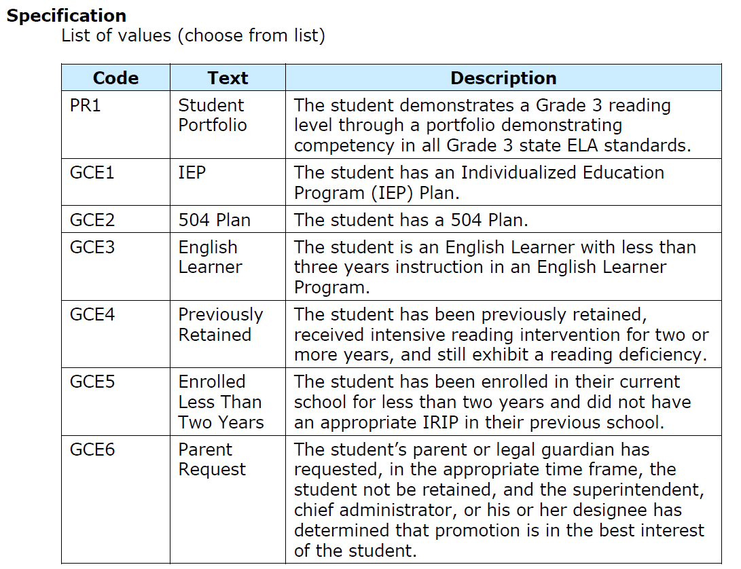

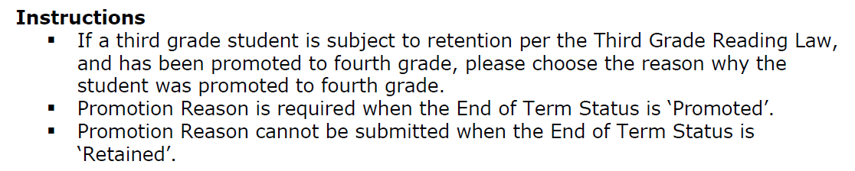

# After Count Day

## Weekly Teacher Attendance Reports (F,S)

**Need to have weekly attendance reports signed by the teacher – the week before count day, the week of count day, and weekly for the following 4 weeks.**

OFFICE STAFF – Print Class Attendance Audit Report

* System Reports > Class Attendance Audit
* Enter the weekly range
* All Teachers
* All Periods
* Submit

TEACHERS – Print Weekly Attendance Review from PowerTeacher

* Student Information (Backpack)
* Weekly Attendance Review – Menu on the left
* **Print, sign, and date the report – full signatures in INK**

## MI 10/30 Day – By Class (F,S)

**Use this report if your school runs a rotation schedule (i.e., A Day/B Day)**

**The MI 10/30 Day – By Class report generates a report file for students who were absent on the count date. Only students that were absent from at least one class on the count date will be listed in this report and only those classes that the student was absent from on the count date will be listed. A class will not show as returned on the report until the day after the student returns to class, but will display the correct return date. If a student does not return in the required amount of time, an “X” will appear in the Return Date column.**

Use the following steps to run the MI 10/30 Day – By Class Report:

1. Login to a school. This report can only be run at the building level.
2. Run the Refresh Premier Attendance Views Data function (Start Page > Special Functions > Attendance Functions).
3. Navigate to: System Reports > State Reporting
4. Select the MI 10/30 Day - By Class Report.

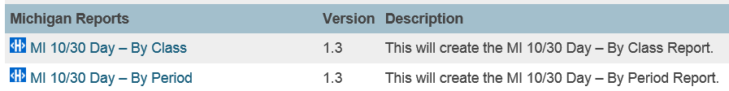

1. Enter in the following parameters in the report interface:

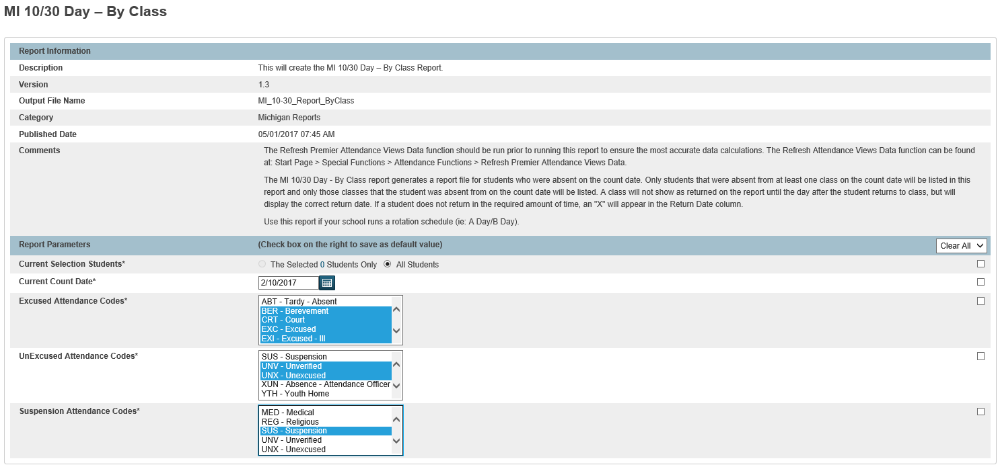

1. Current Selection Students: choose to run for The Selected # Students Only or for All Students
2. Current Count Date: enter the Count Date
3. Excused Attendance Codes: select excused codes
4. Unexcused Attendance Codes: select unexcused codes
5. Suspension Attendance Codes: select suspension code
6. Submit

## MI 10/30 Day – By Period (F,S)

**The MI 10/30 Day – By Period report generates a report file for students who were absent on the count date. Only students that were absent from at least one class on the count date will be listed in this report and only those classes that the student was absent from on the count date will be listed. A class will not show as returned on the report until the day after the student returns to class, but will display the correct return date. If a student does not return in the required amount of time, an “X” will appear in the Return Date column.**

Use the following steps to run the MI 10/30 Day – By Period Report:

1. Login to a school. This report can only be run at the building level.
2. Run the Refresh Premier Attendance Views Data function (Start Page > Special Functions > Attendance Functions).
3. Navigate to: System Reports > State Reporting
4. Select the MI 10/30 Day - By Period Report.



1. Enter in the following parameters in the report interface:

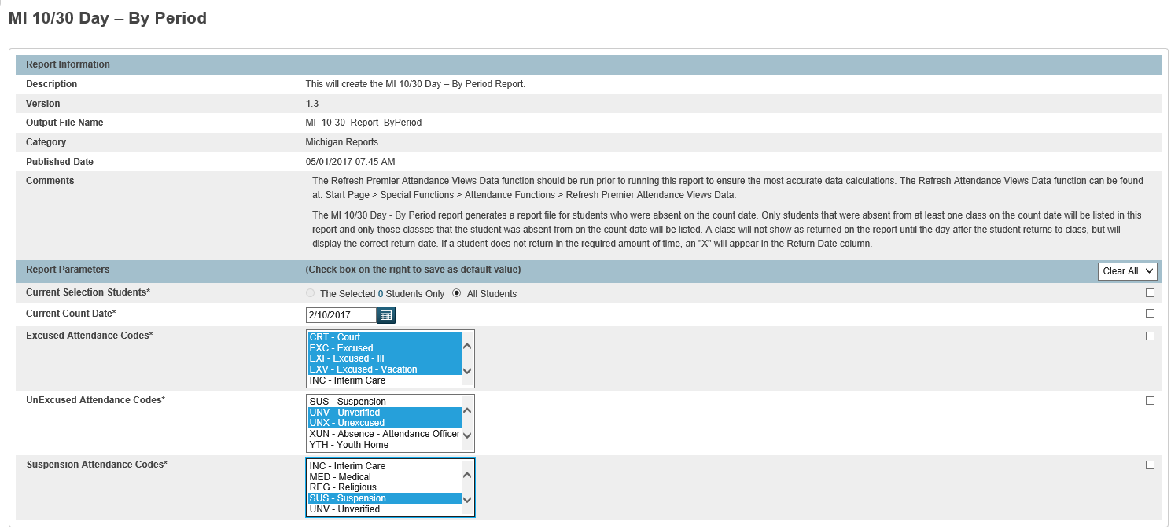

1. Current Selection Students: choose to run for The Selected # Students Only or for All Students
2. Current Count Date: enter the Count Date
3. Excused Attendance Codes: select excused codes
4. Unexcused Attendance Codes: select unexcused codes
5. Suspension Attendance Codes: select suspension code
6. Submit

## Export Data from PowerSchool

Run the General Collection Report to export your general collection data, but run the Refresh Premier function first to ensure that attendance for students is correctly calculated.

### Refresh Premier Attendance Views Data function

This function should be run at the building level.

Special Functions > Attendance Functions > Refresh Premier Attendance Views Data

Students to Include: if you are running the report for a selection of students, choose “The selected ### students only” or choose “All Students”.

Begin Date and Ending Date: enter in a beginning data and an ending date.

Submit

The report completes under the System tab

Click on the View link to view the results. If the process completed successfully, you should see a message that reads: “Attendance views refresh complete for school #### for date range MM/DD/YYYY to MM/DD/YYYY.

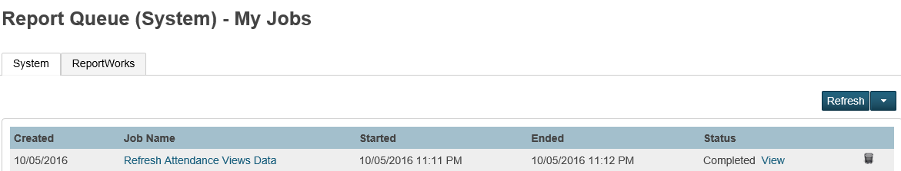

### MI General/SRM/Early Childhood Collection

This report can be run at the district or building level.

System Reports > State Reporting Tab > MI General/SRM/Early Childhood

Current Selection Students: choose the selection of students

Collection Type: choose General Collection (either Fall, Spring or EOY)

Entity Type Code: select District Number

Entity Code: enter in your 5 digit district number (example 50000)

Reporting District’s State Assigned Number: enter in your 5 digit district number (example 50000)

First Day of School: enter in the first day of school

Previous Count Date: enter in the previous count date

Current Count Date: enter in the current count date

District Office>All Students>Select the School

Select school to export. If none are selected the export will run for the entire district.

Include attendance for all Students: if No is selected the report will automatically calculate and export attendance for exited students for the Fall and Spring General Collections and will automatically calculate attendance for ALL students for the EOY General Collection. The Yes option is used to calculate attendance for ALL students regardless of the count collection that is selected. This option was requested by a few of our districts that need to export attendance for reasons other than state reporting.

This report will complete under the ReportWorks tab. To save the file, right click on the Completed link that shows under the Status column, choose Save Target As, file will save as msdsGeneral_50XXX.xml.

This file can be uploaded directly to the state but you might want to run it through the MISDmsds error checker program first to help identify errors.

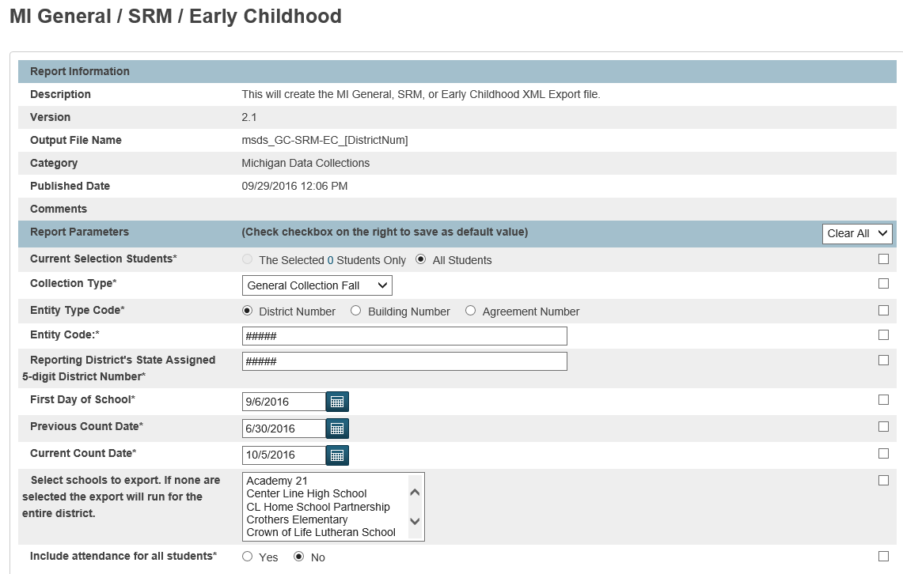

## Use the MISDmsds Error Checker Program

The MISDmsds program is a collector program and incorporates all of the error checking, field validation, field interdependencies as written in the State’s MSDS Manual.

* Reference the MISDmsds Documentation which will guide you through installing and using the program
* Download the program from the MISD Website: [www.misd.net](http://www.misd.net/)
  + Select MISD Departments
  + Select Management Technology
  + Select the MISDmsds Collection Program link

From PowerSchool, run the General Collection and save the XML file to a location of your choice.

Import the file into MISDmsds.

Data errors and warnings will appear in red and yellow on the individual student records. There are many reports that will assist you with identifying data issues which are located under the Reports menu.

Note: making corrections in the MISDmsds program DOES NOT automatically correct the data in PowerSchool. It is recommended that you use MISDmsds to error check your data, then make corrections in PowerSchool, run a new General Collection and import once again into MISDmsds. You may have to do this several times.

## Upload General Collection File to CEPI

Upload a file from PowerSchool – if your data is clean in PowerSchool, you can run a General Collection and upload the XML file to the state.

Upload a file from MISDmsds – if your data is clean in MISDmsds, the MISDmsds program has the ability to export General Collection data in an XML format which can be uploaded to the state. You will need to become an authorized user of the CEPI application.

Refer to the CEPI website for more information:

[http://www.michigan.gov/cepi](http://www.michigan.gov/cepi/0,4546,7-113-986_50502---,00.html)

# End of Year General Collection

The End of Year General Collection is used to export all active students and those students who have exited the district since the Spring General Collection. You may include students who have enrolled and subsequently exited within the reporting period.

## FTEs (General Ed, Section 52, Section 53)

The EOY General Collection is **not** a membership collection. You may include FTE data in this collection; however, MDE will not use these data to determine State Aid Foundation payments.

## Attendance

**You are required to report Attendance for ALL non-exempt students submitted in the EOY General Collection.** Remember that attendance data are cumulative for the entire school year, not only for the reporting period. Failure to include this component will result in record-level errors.

## Graduates and Completers

**Who should be reported as graduated?**

Students who receive a high school diploma on or before the collection certification deadline should be reported with an exit status code indicating graduation (01-04 or 40/41 if enrolled at an Early/Middle College) in the EOY General Collection.

Failing to report graduated students with the correct exit status code will negatively impact your district's graduation rates. Graduation rates are an important part of accountability calculations, including your accountability scorecard, school accreditation status, and Persistently Lowest Achieving and statewide Top to Bottom ranking lists.

**Who should NOT be reported as graduated?**

Students who receive a GED, certificate of completion, other certificate or are otherwise continuing in school.

Students who are completing kindergarten, 5th grade, middle school or any other type of unofficial "graduation."

Students with Individualized Education Programs (IEPs) who are given an "unofficial" diploma or certificate of completion and allowed to walk with their classmates. Report these students as follows:

* + If the student is leaving public education and meets the district’s local criteria for a certificate of completion, exit status “20” may be used.
  + If the student will participate in a transition program in the same district s/he has been attending, use exit status “19” (expected to continue).
  + If the student will participate in a transition program in another district, use exit status “08” (enrolled in another public school district in Michigan).

Students who will not graduate by the certification deadline, but may graduate in the summer. These students should be reported in the EOY General Collection with exit status "19" (expected to continue). If and when the students graduate, report this information in the Graduation Rate Appeals Window (occurring in the SRM Collection from mid-July through mid-September).

**Remember: The MSDS will generate a field-level error if a student with a "Graduate" cohort status is submitted with an exit status of Continuing (with or without FTE) in any future collection by any district.**

**Which MSDS reports will help me confirm that I have reported the correct exit status code for each student?**

• **12th Grade Graduate Summary** – lists the total number of 12th grade students for each reported Exit Status code. This report is available from both the Staging Area and Certified Data Reports and includes the drill-down format for viewing student-level detail.

• **Exit Status Count** – lists the total number of students for each reported District Exit Status code. Use this report to determine if any students in grades other than 12th were reported with an exit status code indicating graduation. This report is available from both the Staging Area and Certified Data Reports and includes the drill-down format for viewing student-level detail.

After reviewing these reports, if you discover that one or more students have an incorrect exit status code, please correct the data in your EOY General Collection by the July 1 certification deadline.

**End of Year Graduates and Completers – Macomb County Best Practices**

In PowerSchool:

Changing the data as described in these steps will ensure that the student’s record will be coded correctly in the Scheduling Setup page in preparation for the End of year Rollover Process. In addition, by modifying the student’s exit code and exit date in the Transfer Info page, this keeps the student active in the system so they will be recognized by the End of Year Rollover Process.

Scheduling Setup Page

* + Mass change the Next Year Grade and the Next School Indicator for all seniors to be 99 using the Student Field Value function. Change the exceptions for those who are not graduating or graduated with a different exit status manually.

Transfer Info Page

* + Modify the Exit Date and Exit Code on the Transfer Info page. This does not inactive the student and the student will still have an enroll status as 0=active. They will not show as “Transferred Out”.
  + The student will not count in enrollment totals if you run the Enrollment Summary report because the student has an exit date.
  + The student will still be included in the End of Year Rollover Process because they have an enroll status of 0=active, which means they will transfer to the Graduated Students school.

Graduation Information Page (custom page used in Macomb). Fill in the appropriate fields so this information will be available to print on the transcript.

* Let the student export with the End of Year General Collection.
* Let the student export with the Teacher Student Data Link (TSDL) Collection.

In MISDmsds (Macomb’s Error Checker Program):

Some liaisons choose to change the graduates or completers exit status information in the MISDmsds program using the mass change utility.

Mass change all 12th graders to an exit status of 01.

Mass change all 12th graders exit date after the day after their “official” graduation date.

Mass change General and Special Education FTEs to 0.

* + Note: You will have to reverse these to original status if you are retaining the student.

Change the exceptions - those who are not graduating or completing with a different exit status need to be manually changed.

Submit your file to the state.

Export your General Collection

Upload your file to the state.

# Audit Reports

## Monthly Exit/Transfer-In Report (gain/loss report)

IF required for a Desk Audit

Run the Monthly Exit/Transfer In Report:

System Reports > State Tab > Michigan Monthly Exit/Transfer In Report

Enter the 2nd day of school for Start Date of Reporting Period. If you enter the 1st day of school, all students will be included in the report.

Enter the current count date for End Date of the Reporting Period

Submit

## 75% Membership

The MI 75% Membership report generates daily attendance, type of day, and notes for a specified date range. The report will include all students enrolled in classes that have potential minutes of instruction on each specific date within the specified date range. This will determine the "Enrolled" count. The "Enrolled" count may not match the number enrolled for a specific date in reports such as the ADA/ADM reports or the Enrollment Summary Reports. (ie: Students enrolled in school but not in any classes.)

If the Enrolled, Absent, and Percent Present are all zeros for a specific date, check the calendar setup for missing information on that date (Day, Schedule, etc.). Verify that the day is a valid date of instruction and that students are enrolled in classes.

If your building chooses to specifically remove the "Day" and/or "Schedule" fields from the calendar setup page in order to disable attendance from being taken on a specific date in the case of a snow day, power outage, etc., the report will generate all zeros for that date, but will still display the data entered in the "Type" and "Note" fields from the calendar setup page.

An absence in calculated based upon if a student was absent for all scheduled periods of a school day.

**The Refresh Premier Attendance Views Data function should be run prior to running this report to ensure the most accurate data calculations.**

**Run the Refresh Premier Attendance Views Data function:**

**Start Page > Special Functions > Attendance Functions > Refresh Premier attendance Views Data**

To ensure that attendance for students is correctly calculated, **run the Refresh Premier Attendance Views Data function** found under Special Functions > Attendance Functions. This function is only available to run at the building level.

Print the MI 75% Membership Report:

Can be run at the district or building level.

System Reports > State Tab

MI 75% Membership

Enter a report start date

Enter a report end date

Select school to export: use the Ctrl or Shift keys to select. Keep in mind that when you run this report again, your selected schools will still be selected so you may have to deselect as needed.

Submit

## Delayed Start Days

**School > Bell Schedules**

Create a Bell Schedule for Delayed start based on periods met

Modify the lunch period in the Bell Schedule if necessary

**School > Attendance Conversions**

Create an Attendance Conversion based on the Bell Schedule above

**School > Calendar Setup**

Assign the Delayed Start Bell Schedule to the appropriate date in the calendar

## Forgiven Days/Unforgiven Days

As of the January 2018 State Reporting Release, the capability of flagging a calendar day as “MI Forgiven Day” and “MI Unforgiven Day” became available. MI Forgiven Day would be used for any day that can be counted as forgiven by the state. MI Unforgiven Day would be used for those days that are over the forgiven amount or cannot be considered forgiven by the state.

The MI Forgiven and MI Unforgiven Day Procedures documentation is at:

[http://powerschool.misd.net](http://powerschool.misd.net/) > STATE > State Reports

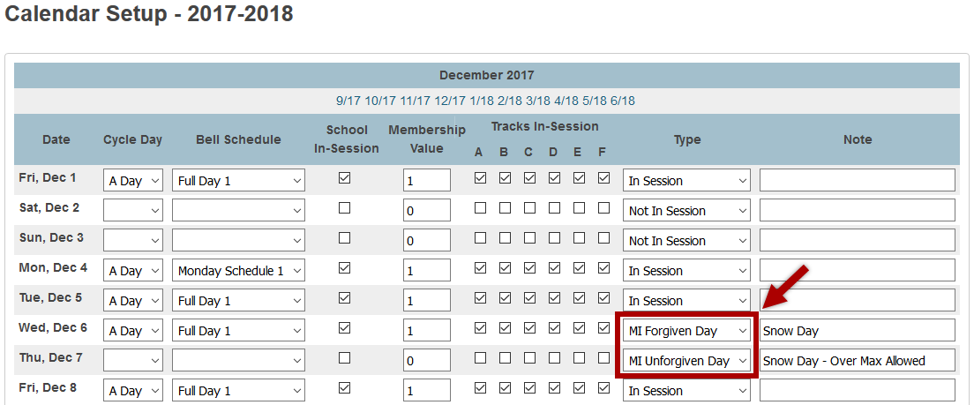



Macomb Intermediate School District

Board of Education

John A. Bozymowski President

Theresa J. Genest Vice President

Edward V. Farley. Treasurer

Donald R. Hubler Secretary

Brian White Trustee

Michael R. DeVault Superintendent

Mark E. Cummins Assistant Superintendent – Technology/CIO

Kristina Martin Director, Management Technology

We’re the Macomb Intermediate School District. We exist to provide our clients quality service, high caliber support and cutting edge leadership.

Our primary clients are the 21 school districts of Macomb County. They are our most important customers--indeed, our reason for being.

Within these districts we focus our efforts on school staff. We work to increase their skills and capabilities so their students can experience more effective educational programs.

We also serve students with disabilities. In fact, we are committed to working directly with youngsters with disabilities who reside in Macomb County’s school districts.

And we are involved with the educational community across the country. Many of our staff members are deeply involved in state and national programs. Many are working with colleges and universities. Still others are exchanging information with their professional colleagues. All these activities have a single purpose: to identify and develop techniques and programs which improve learning opportunities in Macomb County.

This is the professional focus which makes the Macomb Intermediate School District one of America’s premier regional education agencies.

The MISD is an equal opportunity employer. It is the policy of the MISD that no person on the basis of race, creed, color, religion, national origin, age, sex, height, weight, marital status, or disability shall be discriminated against, excluded from participation in, denied the benefits of, or otherwise be subjected to discrimination in any program or activity for which the MISD is responsible.

The MISD will provide, upon request with advance notice, appropriate auxiliary aids and services necessary to afford a qualified individual with a disability equal opportunity to participate in the services, programs and activities conducted by the MISD. To request auxiliary aids or services, contact Rosetta Mullen, 586/228-3309. MISD Text Telephone (TTY) 586/286-8040.