I made a customization that lets you toggle the visibility of the admin login fields/server maintenance message. Users can access the sign-in by using a custom URL.

Right now it’s enabled on ps-dev

Failure/block users test: <https://ps-dev/admin/pw.html> OR <https://ps-dev/admin>   
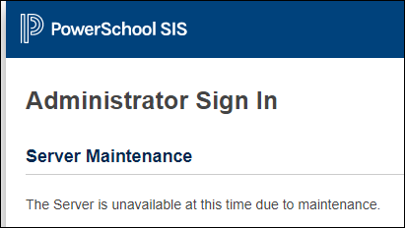

Success test: <https://ps-dev/admin/pw.html?login=EOY2020>  
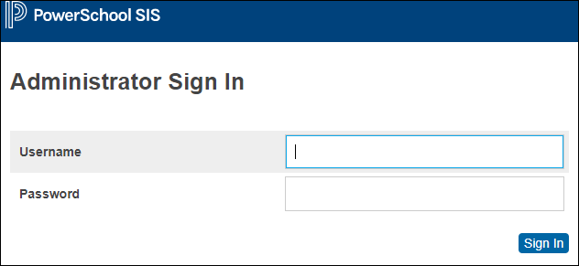

Here’s the steps to set it up.

1. Sync the custom to any ps servers you want. Right now it’s on PS-dev and backed up in TFS
2. Log in to ps admin ps-dev/admin
3. From the left navigation menu go to Setup -> District  
   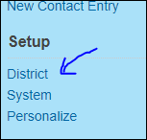
4. Scroll to the bottom where I have a section for MISD Customizations preferences
5. Click Hide Admin Login  
   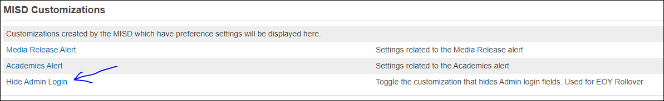
6. Change the settings if necessary  
   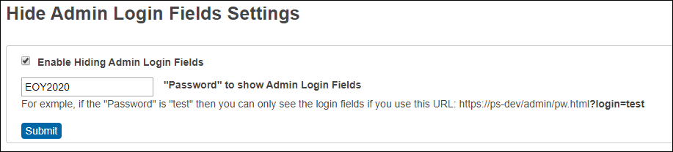

If there’s a need to toggle visibility of the login fields without a password:

Open the developer view of the browser and find the circled section, then click the checkbox next to "display: none;" to toggle the visibility.

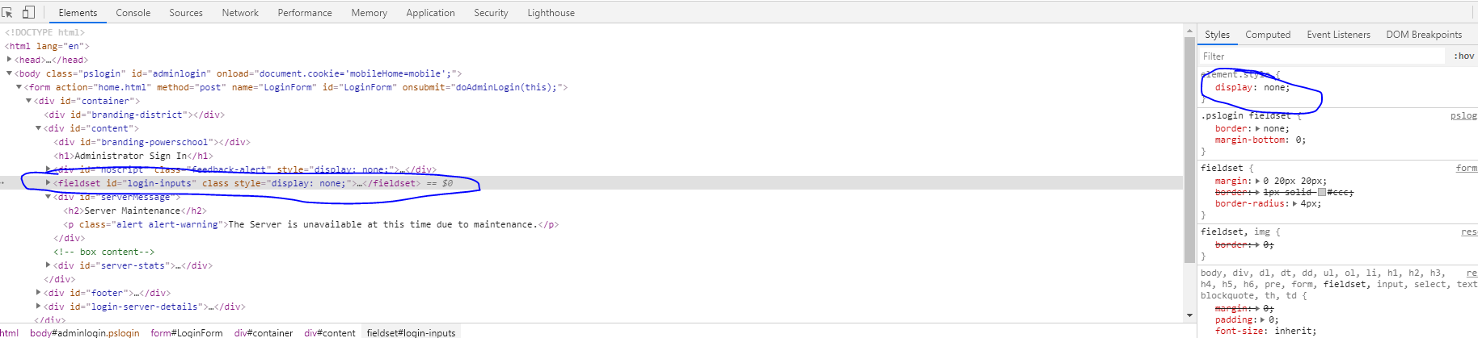

**Ben Drafta** (*Macomb Intermediate School District)*